TRƯỜNG THCS PHAN CÔNG HỚN
TỔ TIẾNG ANH
TIẾNG ANH 7
TUẦN 23 (TỪ 17/2 ĐẾN 22/2)
PHIẾU TỰ HỌC
Period 67: Unit 7– Lesson 2-1 (New words & Reading)
Period 68: Unit 7 – Lesson 2-2 (Grammar)
Period 69: Unit 7 – Lesson 2-3 (Pronunciation)
New words (SGK trang 55)
1. frequent
2. comfortable
3. reliable
4. ticket
5. eco-friendly
6. public
7. convenient
Reading (SGK trang 55)
a. 2. Traveling in Vietnam
b. 1. fastest
2. eco-friendly
3. fast
4. online
5. quickly
Grammar (SGK trang 56)
b. 2. My suitcase is as big as yours.
3. Your sunglasses are as expensive as mine.
4. Trains are as comfortable as buses.
5. My ticket isn’t as cheap as your ticket.

c. 2. Trains aren’t as frequentcy as buses.
3. Taxis are more expensive than buses.
4. The bus is cheaper than the train.
5. The car is as fast as a taxi.

SỬA BÀI TẬP TUẦN 22
UNIT 7: TRANSPORTATION
LESSON 1-1 (New words)
II. Write the suitable word for each picture
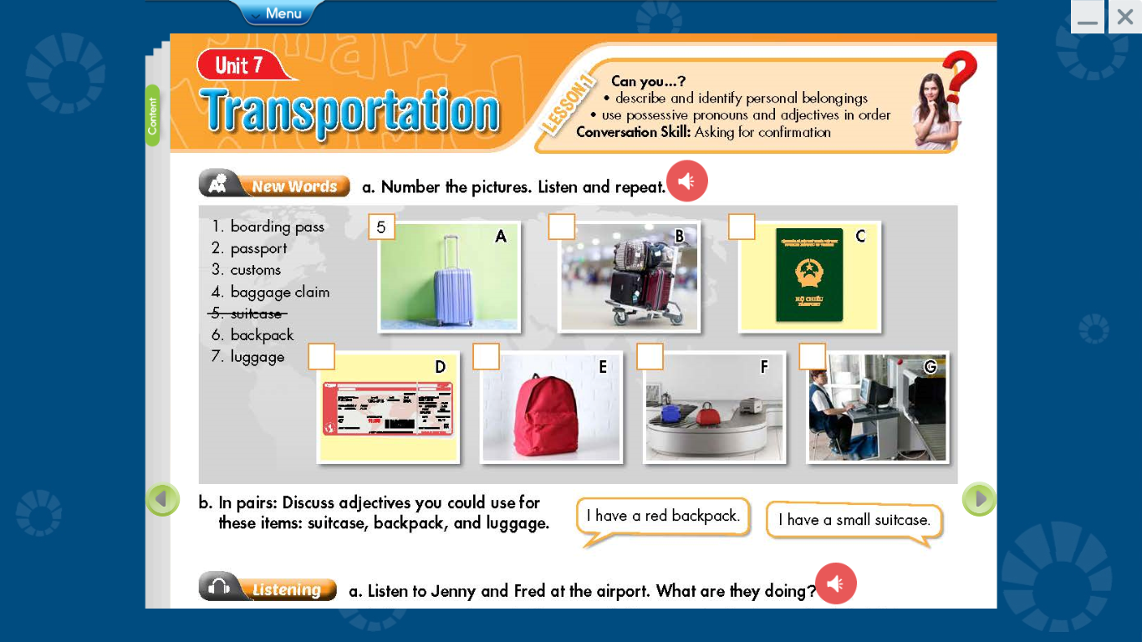

_____suitcase____ _____luggage_____ ____passport_____
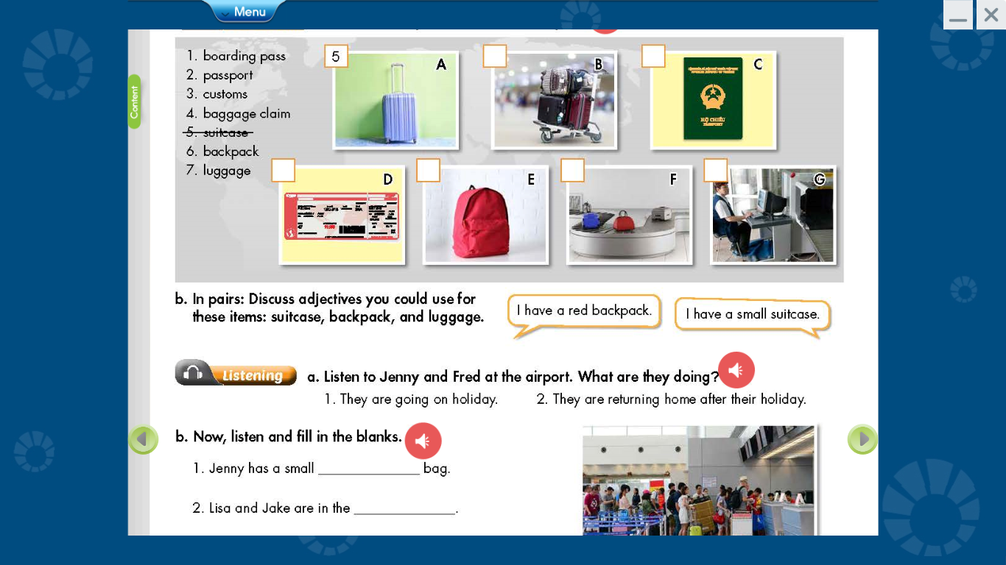

____boarding pass____ ___backpack____ _____baggage claim____ ____customs______
III. Choose the word or phrase (A, B, C or D) that best fits the space in each sentence.
1. People have to show the______________ before they get on an airplane
A. book B. suitcase C. money D. boarding pass
2. So remember, heavy hand _______________ can be a safety hazard.
A. passport B. luggage C. book report D. textbook
3. The visa is then stamped into their _____________
A. suitcase B. airplane C. passport D backpack
4. Whose passports are these ? They’re ______________
A. our B ours C. their D. they
5. How long does it take to get through __________ when we come into a country ?
A. customs B yard C. report D. card
6. How do you like to go on vacation ?
A. to plane B on plane C. by plane D. at plane
7. What luggage does Mary have? She has a small green ___________
A. apartment B. backpack C. class D. book
8. A large case which people put their clothes in when they’re traveling. What is it?
A. passport B. school bag C. textbook D. suitcase
9. A place at an airport where you get your luggage back after. Where is it?
A. school B. baggage claim C. abroad D. gym
10. Nam and Binh are ____________ home after their holiday
A. return B returns C. to return D. returning

UNIT 7: TRANSPORTATION
LESSON 1-2 (Grammar)
I. Grammar :
1. Ordering adjectives: trật tự của các tính từ
*Fill in the blanks with the correct order of adjectives:
1. He was to buy a ___large new orange____ suitcase ( new / orange / large)
2. I have a ___small old blue___ house. (small / blue / old)
3. Minh has ___long curly black____ hair. (black / long / curly)
2. Possessive Pronouns: đại từ sở hữu
*Fill in the blanks with the correct possessive pronouns/ adjectives:
1. That luggage is __yours___ ( you)
2. The small new red suitcases are ___theirs___ (they)
3. No, __hers____ is dark brown. (she)
4. __Mine___ is a large old house. ( I )
5. This apartment is ___ours___ (we)
6. This is __his__ passport (he)
7. I have a blue suitcase. Look! That's __mine___. ( I )
8. This isn’t her skirt. __Hers__ is blue. (she)
9. Linda is ___my__ sister ( I )
10. These luggages are __yours___ (you)

UNIT 7: TRANSPORTATION
LESSON 1-3 (Pronunciation)
I. Find the word whose underlined part differs from the other three in pronunciation.
1. A. wishes B. practices C. introduces D. leaves
2. A. grasses B. stretches C. potatoes D. suitcases
3. A. chores B. oranges C. experiences D. dishes
4. A. houses B. faces C. hates D. places
5. A. names B. dances C. lives D. tables
II. Find the word that differs from the other three in the position of primary stress.
1. A. luggage B. between C. although D. abroad
2. A. backpack B. passport C. picture D. conform
3. A. abroad B. alone C. customs D. instead
4. A. belong B. airport C. ticket D. baggage
5. A. partner B. piano C. passport D. pronoun
III. Choose the word (A, B, C or D) that best fits the space in the following passage.
John: Is this yours?
Tim: No, ____________(1) is light brown. Can you Mary’s luggage ?
John: Is this blue backpack hers ?
Tim: No, she _____________ (2) a dark blue backpack.
John: Do you have our passports ?
Tim: Yes, I have ours in my bag. Don’t ______________(3).
John: What color is your sister’s suitcase ?
Tim: Hers is orange.
John: Whose orange bag is this ?
Tim: It’s got my name ________________(4) it, so it’s mine.
John: This suitcase has Lucy and Jack’s names on it, so it must be ______________(5).
1. A. her B. his C. mine D. hers
2. A. has B. have C. is D. are
3. A. happy B. sad C. worry D. great
4. A. in B. on C. at D. of
5. A. their B. his C. hers D. theirs
IV. Unscramble the sentences
1. to buy / new /a large / she / wants / orange / suitcase /
She wants to buy a large new orange suitcase.
2. small / mine / dark blue / is / new / backpack / a
Mine is a small new dark blue backpack.
3. Mary / skirt / old / is / pink / wearing / an
Mary is wearing an old pink skirt.
4. new / medium-sized / has / suitcase / He / a / dark red
He has a medium-sized new dark red suitcase.
5. are / school bags / blue / ours / the / and white
The blue and white school bags are ours.

