TRƯỜNG THCS PHAN CÔNG HỚN
TỔ TIẾNG ANH
TIẾNG ANH 7
TUẦN 19 (TỪ 06/01 ĐẾN 11/01)
Period 55
UNIT 6: EDUCATION
LESSON 1-1 (New words)
I. New words
- essay (n) /ˈɛˌseɪ/ : bài tiểu luận
- homework (n) /ˈhoʊmˌwɜrk/ : bài tập về nhà
- presentation (n) /ˌprɛzənˈteɪʃən/ : buổi thuyết trình, bài thuyết trình
- project (n) /ˈprɑʤɛkt/ : dự án, đồ án
- report (n) /rɪˈpɔrt/ : bài báo cáo
- test (n) /tɛst/ : bài kiểm tra
II. Write the suitable word for each picture
2
3
1
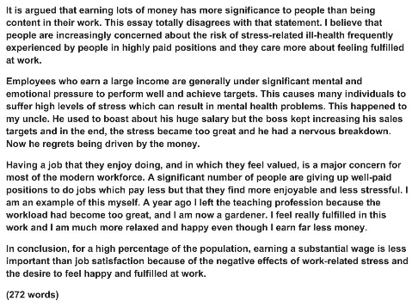

1._________ 2._________ 3._________
4
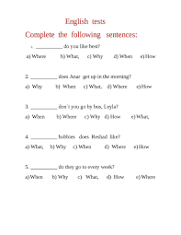
5
6

4._________ 5._________ 6._________

III. Choose the word or phrase (A, B, C or D) that best fits the space in each sentence.
1. I have to write an ____ this weekend.
A. essay B. letter C. homework D. test
2. My English teacher always sets a lot of _____
A. housework B. homework C. work D. hometown
3. She have to send in weekly ___ for her boss on weekends.
A. report B. test C. essay D. apartment
4. Students have to give a _______ in my Math class.
A. essay B. presentation C. mark D. homework
5. Does the hotel have a ________?
A. apartment B. pool C. class D. book
6. My next_______ is decorating the kitchen.
A. test B. essay C. project D. presentation
7. Can you give us a _______ on what happened at the meeting?
A. essay B. homework C. report D. information
8. I always do my ______ on the bus.
A. homework B. essay C. housework D. presentation
9. Where can I get COVID _______ near me?
A. test B. homework C. essay D. pool
10. This is for the development a new ________ of agriculture.
A. homework B. test C. project D. letter

Period 56
UNIT 6: EDUCATION
LESSON 1-2 (Grammar)
- Grammar :
a/ Have to is used to explain responsibilities, often things we do not want to do. For examples,
- Children have to go to school. ( trẻ em phải đi học)
- John has to wear a tie at work. ( John phải đeo cà vạt ở chỗ làm việc)
Positive form: S + have to/has to + V+…
b/ Don’t have to/ Doesn’t have to is used to express lack of responsibility. We use this for activities that we can reasonably be expected to do. For examples:
- I don’t have to to go to work today. ( Tôi không phải đi làm hôm nay.)
- He doesn’t have to take out the garbage tonight. ( Anh ấy không phải đi quăng rác tối nay.)
- You don’t have to pay me back. ( Bạn không cần phải trả lại tôi.)
Negative form: Don’t have to / Doesn’t have to + V
c/ Questions ( Information) : WH-question + do/does + S + have to + V ?
is used to ask about someone’s responsibilities.
- What do you have to to do today? ( Bạn phải làm cái gì tối nay ?)
- Where does she have to go ? ( Cô ấy phải đi đâu ?)
- Who do we have to meet ? ( Chúng ta phải gặp ai ?)
d/ Questions (Confirmation) : Don’t + S + have to + V?
Doesn’t + S + have to + V?
Ex: * Don’t you have to leave ?( Bạn có phải rời khỏi không)
- Yes, I do ( have to leave)
- No. I don’t .
**Doesn’t she have to finish his homework ?( Cô ấy có phải làm bài tập về nhà không ?)
- Yes, she does. ( She finished already)
- No, She doesn’t.
***Don’t we have to get up early ? ( Chúng ta có phải dậy sớm không?)
- Yes, We do.
- No, We don’t
II. Fill in the blanks with the correct form of the verbs.
1. My pen is out of ink. I have to ________ a new one. (get)
2. Kate has a doctor's appointment, so she has to_______ class early. (leave)
3. Justin has to______________ a presentation tomorrow. (give)
4. _____ Alan ________ to finish his science project after school? (have)
5. _______students _____ to wear uniforms at our school? (have)
6. How about _________ to the mall on Friday night? (go)
7. Let’s ____________ for the Math test tomorrow. (study)
8. We should __________ plenty of fruit and vegetables. (eat)
9. I don't have class tomorrow, so I ______________ to go to school. (not, have)
10. Jisoo __________ to give her presentation tomorrow. The teacher allowed her to do it next week. (not, have)

Period 57
UNIT 6: EDUCATION
LESSON 1-3 (Pronunciation)
I. Find the word whose underlined part differs from the other three in pronunciation.
1. A. desks B. maps C. tests D. chairs
2. A. recycled B. raised C. planted D. cleaned
3. A. donated B. picked C. finished D. stopped
4. A. lively B. kind C. driven D. kite
5. A. report B. essay C. chef D. test
II. Find the word that differs from the other three in the position of primary stress.
1. A. project B. cartoon C. vitamin D. fantasy
2. A. education B. community C. development D. recycle
3. A. sincere B. finish C. excited D. remember
4. A. cafeteria B. collect C. invitation D. presentation
5. A. homework B. market C. tomato D. country
III. Choose the word (A, B, C or D) that best fits the space in the following passage.
Lucy: Hey Alan. Would you like (1) _________ a movie after school?
Alan: I’d love to, but I can't. I (2) _________ finish my science project.
Lucy: Oh, no problem. What about Thursday? Sue (3) _______ a party.
Alan: I’m sorry, I can’t. I have to study for a math test.
Lucy: So when are you free?
Alan: Well, this Saturday, I'm going bowling with my brother. Do you want to come with us?
Lucy: Oh no! I'm sorry, I can't. I have to give a (4) _________ for my History class.
Alan: I know! Let's go (5) ________ Sunday.
Lucy: Yeah!
1. A. seeing B. to see C. see D. sees
2. A. doesn’t have to B. don’t have to C. has to D. have to
3. A. is having B. had C. having D. have
4. A. presentation B. test C. homework D. essay
5. A. at B. in C. of D. on
IV. Rewrite each of the following sentences in another way so that it means almost the same as the
sentence printed before it.
1. There is no need for you to finish a book report today.
You don’t .
2. There is no need for Taylor to complete her assignments by Monday.
Taylor doesn’t .
3. It isn’t necessary for us to do our homework tonight.
We don’t .
4. It is necessary for Sulli to study for an English test tomorrow.
Sulli has .
5. It is necessary for them to work on a school project.
They have .

