TRƯỜNG THCS PHAN CÔNG HỚN
TỔ TIẾNG ANH
TIẾNG ANH 7
TUẦN 22 (TỪ 10/2 ĐẾN 15/2)
Period 64
UNIT 7: TRANSPORTATION
LESSON 1-1 (New words)
I. New words
- boarding pass (n) /ˈbɔːrdɪŋ pæs/ thẻ lên máy bay/tàu
- passport (n) /ˈpæspɔːrt/ hộ chiếu
- customs (n) /ˈkʌstəmz/ hải quan
- baggage claim (n) /ˈbæɡɪdʒ kleɪm/ khu vực lấy hành lý (ở sân bay)
- suitcase (n) / ˈsuːt.keɪs / va-li
- backpack (n) / 'bækpæk/ ba lô
- luggage (n) / 'lʌgiʤ / hành lý

II. Write the suitable word for each picture
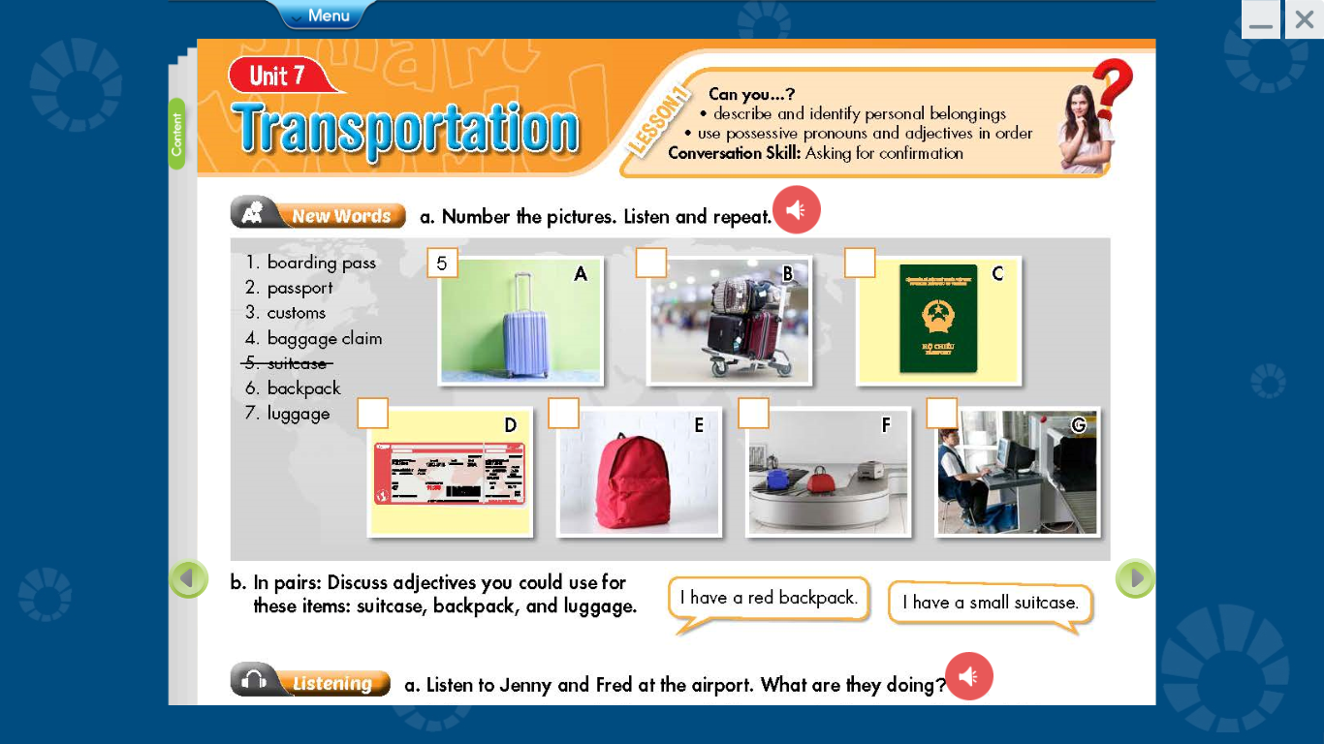

__________________ __________________ __________________
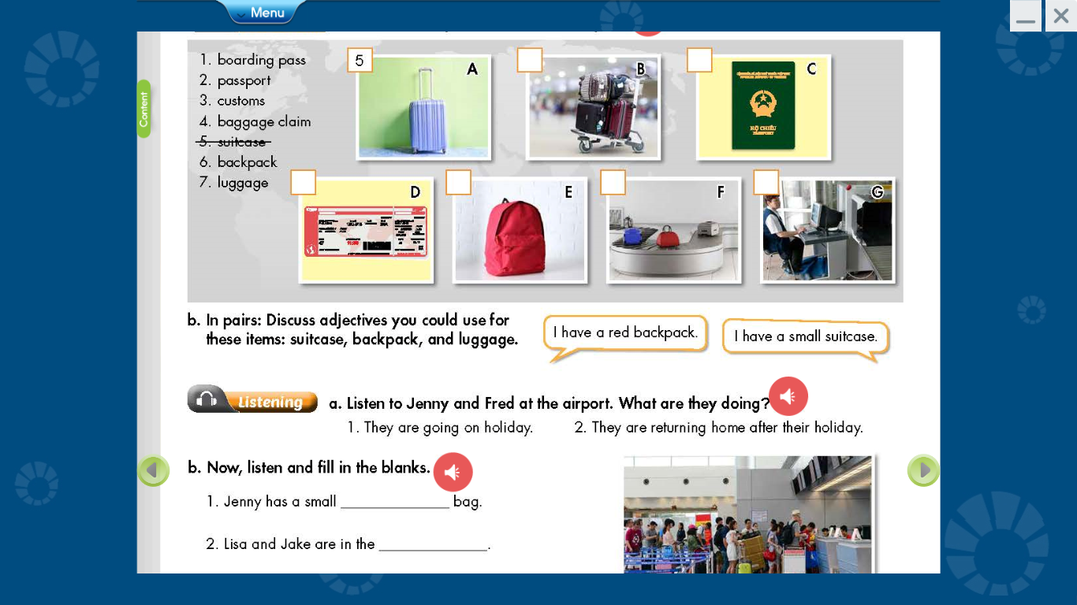

__________________ __________________ __________________ _________________
III. Choose the word or phrase (A, B, C or D) that best fits the space in each sentence.
1. People have to show the______________ before they get on an airplane
A. book B. suitcase C. money D. boarding pass
2. So remember, heavy hand _______________ can be a safety hazard.
A. passport B. luggage C. book report D. textbook
3. The visa is then stamped into their _____________
A. suitcase B. airplane C. passport D backpack
4. Whose passports are these ? They’re ______________
A. our B ours C. their D. they
5. How long does it take to get through __________ when we come into a country ?
A. customs B yard C. report D. card

6. How do you like to go on vacation ?
A. to plane B on plane C. by plane D. at plane
7. What luggage does Mary have? She has a small green ___________
A. apartment B. backpack C. class D. book
8. A large case which people put their clothes in when they’re traveling. What is it?
A. passport B. school bag C. textbook D. suitcase
9. A place at an airport where you get your luggage back after. Where is it?
A. school B. baggage claim C. abroad D. gym
10. Nam and Binh are ____________ home after their holiday
A. return B returns C. to return D. returning

------------------------------------------------------------------------------------------------------------------

Period 65
UNIT 7: TRANSPORTATION
LESSON 1-2 (Grammar)
I. Grammar :
1. Ordering adjectives: trật tự của các tính từ
Chúng ta đặt các tính lần lượt theo trật tự KÍCH CỠ, ĐỘ TUỔI, MÀU SẮC
e.g: My bag is a small new yellow.
I have a big new red backpack.
*Fill in the blanks with the correct order of adjectives:
1. He was to buy a _______________ suitcase ( new / orange / large)
2. I have a _______________ house. (small / blue / old)
3. Minh has ______________ hair. (black / long / curly)
2. Possessive Pronouns: đại từ sở hữu
Đại từ sở hữu dùng để nói về những gì chúng ta sở hữu hoặc những gì thuộc về chúng ta.
Chúng ta có các đại từ sau: mine, yours, his, hers, ours , theirs.
Chúng ta có thể dùng đại từ sở hữu thay cho một tính từ sở hữu + danh từ (khi đã rõ chúng ta đang nói về cái gì)
Ex: Is that blue backpack yours?
My backpack is red. Mine is red.

Whose passports are these?
They're our passports. They're ours.

Is this her backpack?
No, her backpack is dark brown. No, hers is dark brown.
*Fill in the blanks with the correct possessive pronouns/ adjectives:
1. That luggage is ________________ ( you)
2. The small new red suitcases are _______________ (they)
3. No, ____________ is dark brown. (she)
4. _________ is a large old house. ( I )
5. This apartment is _____________ (we)
6. This is __________ passport (he)
7. I have a blue suitcase. Look! That's ____________. ( I )
8. This isn’t her skirt. _________ is blue. (she)
9. Linda is _________ sister ( I )
10. These luggages are _____________ (you)

------------------------------------------------------------------------------------------------------------------

Period 66
UNIT 7: TRANSPORTATION
LESSON 1-3 (Pronunciation)
I. Find the word whose underlined part differs from the other three in pronunciation.
1. A. wishes B. practices C. introduces D. leaves
2. A. grasses B. stretches C. potatoes D. suitcases
3. A. chores B. oranges C. experiences D. dishes
4. A. houses B. faces C. hates D. places
5. A. names B. dances C. lives D. tables
II. Find the word that differs from the other three in the position of primary stress.
1. A. luggage B. between C. although D. abroad
2. A. backpack B. passport C. picture D. conform
3. A. abroad B. alone C. customs D. instead
4. A. belong B. airport C. ticket D. baggage
5. A. partner B. piano C. passport D. pronoun
III. Choose the word (A, B, C or D) that best fits the space in the following passage.
John: Is this yours?
Tim: No, ____________(1) is light brown. Can you Mary’s luggage ?
John: Is this blue backpack hers ?
Tim: No, she _____________ (2) a dark blue backpack.
John: Do you have our passports ?
Tim: Yes, I have ours in my bag. Don’t ______________(3).
John: What color is your sister’s suitcase ?
Tim: Hers is orange.
John: Whose orange bag is this ?
Tim: It’s got my name ________________(4) it, so it’s mine.
John: This suitcase has Lucy and Jack’s names on it, so it must be ______________(5).
1. A. her B. his C. mine D. hers
2. A. has B. have C. is D. are
3. A. happy B. sad C. worry D. great
4. A. in B. on C. at D. of
5. A. their B. his C. hers D. theirs
IV. Unscramble the sentences
1. to buy / new /a large / she / wants / orange / suitcase /
She
2. small / mine / dark blue / is / new / backpack / a
Mine

3. Mary / skirt / old / is / pink / wearing / an
Mary
4. new / medium-sized / has / suitcase / He / a / dark red
He
5. are / school bags / blue / ours / the / and white
Ours

------------------------------------------------------------------------------------------------------------------

