TRƯỜNG THCS PHAN CÔNG HỚN
TỔ TIẾNG ANH
TIẾNG ANH 7
TUẦN 25 (TỪ 03/03 ĐẾN 08/03)
PHIẾU TỰ HỌC
Period 73: Unit 8– Lesson 1-1 (New words)
Period 74: Unit 8 – Lesson 1-2 (Grammar)
Period 75: Unit 8 – Lesson 1-3 (Pronunciation)
New words (SGK trang 60)
1 – B 2 – G
3 – D 4 – A
5 – F 6 – E
7 – C
Reading (SGK trang 60)
a. 2. The Most Interesting Festivals around the World
b. 1. There are 7 days.
2. Both locals and famous artists will make the ice sculptures.
3. It’s video games.
4. It lasts during the Labor Day long weekend.
5. This year will have more children-friendly entertainment, such as the Dance Zone, Dreaming Space, and Kids Yoga.
Grammar (SGK trang 61)
b. 2. will play 3. will be
4. won’t happen 5. Will there be
6. will open
c. 2. wear
3. carry
4. will take place
5. will be
6. will open
7. will see
8. will be

SỬA BÀI TẬP TUẦN 24
Unit 7: TRANSPORTATION.
Lesson 3-1
I. Look at the words in the box and write the suitable word for each picture.
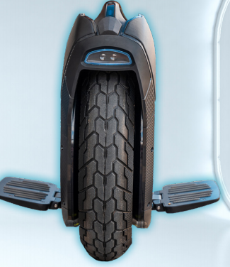 | 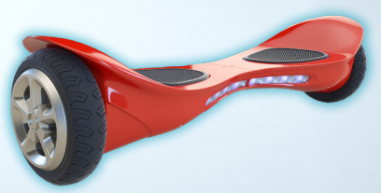 | 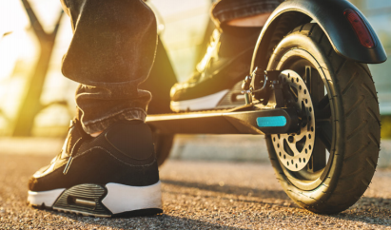
1. The One-wheeler | 2. The Hoover Go | 3. The Wowscoot
II. Choose the best answer:
- The Hover Go is not ____________ to ride because it has two wheels.
- easy B. convenient C. reliable D. difficult
- The Hover Go also has cool lights __________ you can ride at night.
- so B. because C. and D. but
- The Hover Go has a lower speed and it isn’t as _________ as the One Wheeler.
- big B. old C. fast D. new
- The Hover Go and the One Wheeler are both great kinds of ____________ for children.
- transportation B. luggage C. food D. movie
- Everyone can choose their ______ color because both of them come in lots of cool and fun ones.
- frequent B. convenient C. comfortable D. favorite
III. Match the word with the correct meaning:
- Creator(n) | - A person who sells something.
- Owner (n) | - To make one part lies on top of another part.
- Seller (n) | - A person who makes something.
- Fold (v) | - A person who has something.

9. c | 10. d | 11. a | 12. b

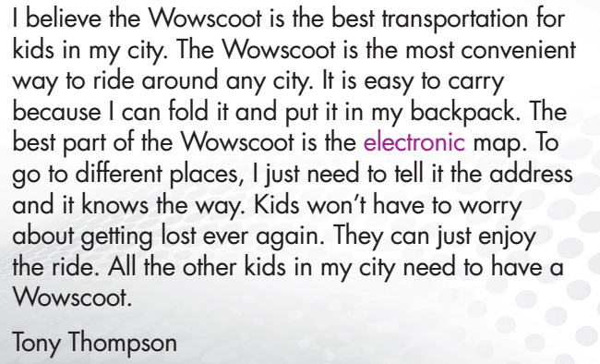
IV. Read the paragraph and fill in the blanks
- The Wowscoot is the best transportation for___kids_____.
- The Wowscoots is____convenient____ to ride around any city.
- You can __fold____ and put it in your backpack.
- To go around, you just need to tell Wowscoot the___address____.
- You don’t have to worry about getting lost because the Wowscoot has the __electronic___ map.
-----------------------------------------------------------------------------------------------------------------

Unit 7: TRANSPORTATION
Lesson 3-2
Exercise 1. Read Tony’s paragraph again and answer the following questions:

- Which sentence does he use to start his main opinion?
- “I believe the Wowscoot … in my city.”
- Which sentence does he use to give the reason he likes it?
- “The Wowscoot is the most … any city.”
- Which sentence does he use to give evidence to support his reasons?
- “It is easy to carry …. backpack.”
- Which sentence does he use to give his opinion again?
- “The best part … electronic map.”
Exercise 2. Put the words in the correct order to make correct sentences.
- A Speed Wheel / have / in my school / all the teens / I think / should / .
- I think all the teens in my school should have A Speed Wheel.
- because / it / a big battery / is / has / reliable / The Speed Wheel /.
- The Speed Wheel is reliable because has a big battery.
- more than / ride it / I / for / 12 hours / can / .
- I can ride it for more than 12 hours.
- need / All of / a Speed Wheel / my classmate / .
- All of my classmate need a Speed Wheel.
Exercise 3. Rearrange these sentences to make a paragraph.
a. I think every adult in my city should drive a Moon Car. 1
b. And you don't have to drive it. The computer can take you anywhere you want to go. 4
c. That's why all the adults should have a Moon Car. 7
d. The Moon Car is comfortable, convenient, and fun. 2
e. Children can watch shows or movies, or play video games. Adults can also use the internet to do their work. 6
f. It has six big seats for the whole family. The seats can turn into a bed for a long trip. 3
g. The best part of the Moon Car is the big TV screen. 5
Exercise 4. Read the paragraph and decide the statements are True or False:
I think every kid in my town should have a Flyboard. The Flyboard is fast and convenient. The Flyboard can travel 30 kilometers per hour. I can go anywhere in a few minutes. The battery lasts for
eight hours. I can ride it to school every day and I don’t have to charge it. The Flyboard has an electronic map, so I won’t get lost. That’s why all kids in my town need a Flyboard.
- The speed of the Flyboard can reach 30 km per hour. ___TRUE____
- You won’t get lost because the Flyboard has an electronic map. ___TRUE____
- You can ride it to anywhere you want. ___TRUE____
- The battery of the Flyboard lasts for more than 8 hours. ___FALSE___
- The Flyboard isn’t convenient so it’s good for children. ___FALSE___

-----------------------------------------------------------------------------------------------------------------
TEST-UNIT 7
I. Find the word whose underlined part differs from the other three in pronunciation.
1. A. stops B. plays C. likes D. acts
2. A. listen B. first C. best D. test
II. Find the word that differs from the other three in the position of primary stress.
3. A. luggage B. suitcase C. passport D. arrive
4. A. wonderful B. convenient C. popular D. interesting
III. Choose the word or phrase (A, B, C or D) that best fits the space in each sentence.
5. You need to buy a__________ to go on public transportation.
A. ticket B. sunglasses C. backpack D. suitcase
6. Whose book is it?- It’s__________.
A. my B. hers C. him D. your
7. _____________are the people at the airport who check your luggage
A. Pilots B. Shop assistants C. Customs D. Visitors
8. Tom has a/an ___________________suitcase.
A. old big blue B. big blue old C. big old blue D. blue old big
9. Gideon is very _________- if he says he'll do something, he'll do it.
A. mean B. generous C. reliable D. happy
10. If you don’t take the map, you can easily get___________
A. lose B. lost C. losing D. loosen
11. The buses aren’t usually ____________as the planes
A. more expensive B.as expensive C. less expensive D. most expensive
12. How do we get to the park? - “________________”
A. In ten minutes B. At the bus stop C. By bus D. With our friends
13. You need to show your ___________before you get on the airplane
A. number B. luggage C. money D. boarding pass
14. Flying is the fastest way to travel ____________Ho Chi minh city and Hanoi.
A. in B. at C. from D. between
IV. Read the signs and choose the best answer.
15. What is this area called? | 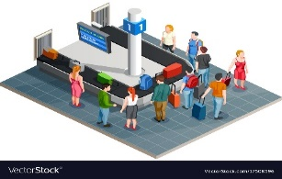 | A. Check-in area  B. Baggage claim  C. Departure  D. Gate
16. What does the sign say? | 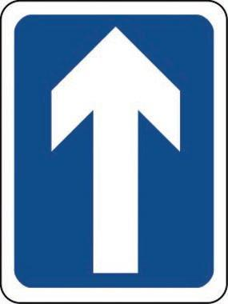 | A. Turn left  B. One way street  C. Two way street  D. No enter
V. Choose the word (A, B, C or D) that best fits the space in the following passage.
I leave for work at about 6.30 a.m. and I walk to the bus stop not too far (17)_______ my house. I catch the bus that comes by around 6.45. The bus isn’t very (18)____ when I get on, but it fills up by the end of the lines. Then I (19)____ the bus and catch the train into town. The train ride lasts about thirty minutes and it’s usually standing-room only. The entire (20)______ takes me about an hour. I buy a monthly (21)______ and I save a lot of money by using (22)_______ transportation instead of my own car.
17. A. in B. on C. at D. from
18. A. empty B. clean C. crowded D. funny
19. A. get off B. turn off C. go off D. put off
20. A. day B. voyage C. journey D. trip
21. A. ticket B. suitcase C. passport D. place
22. A. private B. expensive C. public D. usual
VI. Read the following passage. Decide if the statements from 23 to 26 are True or False and choose the correct answer (A, B, C or D) for the questions 27 and 28.
If you visit Japan, you might choose to travel around the country by “Shinkansen” train. These high-speed trains connect the major cities of Japan. They are nicknamed “bullet trains” because they go very fast and have pointy noses like a bullet. Bullet trains are a good way to travel for several reasons other than their speed. They are very punctual, often leaving on time to the second. They are also comfortable. Most importantly, bullet trains are very safe. In their 35-year history, there have been only a few accidents and no deaths. The only downside to bullet trains is that they are expensive. A ticket to travel to another city can cost almost as much as an airline ticket would. Train stations are usually right in the middle of a city. This means that it is often more convenient to take a bullet train instead of flying, because you will arrive exactly where you want to be.
23. Bullet trains are the slow-speed train. ___FALSE____
24. Bullet trains are usually late. ___FALSE____
25. Travelling by Bullet train is expensive ___TRUE_____
26. Train stations are usually right in the middle of a city ___TRUE_____
27. Why are they nicknamed “Bullet trains”?
A. Because they have big mouth. C. Because they have pointed noes and go very fast
B. Because they have big mouth and go very fast. D. Because they look like a nose.
28. Is it safe to travel by “Bullet train’?
A. No, it isn’t B. Yes, it is C. Yes, I don’t think so D. Never

VII. Use the correct form of the word given in each sentence.
29. I’m not _____comfortable______ speaking in front of lots of people. (comfort)
30. The bus ran so____slowly_______ that we were late. (slow)
31. We need to____fasten____ our seat belt when we go by car (fast)
32. Ho Chi Minh city is an important center for business and __transportation____. (transport)
33. The best part of Wowscoot is the ____electronic____map (electric)
34. My car has six big ___seats___for the whole family (sit)
VIII. Rearrange the groups of words in a correct order to make complete sentences.
35. Buses are / because /more people./carry /eco-friendly/ they/ can
Buses are eco-friendly because they can carry more people.
36. frequent /are / from London / There / to Manchester / trains
There are frequent trains from London to Manchester.
IX. Rewrite each of the following sentences in another way so that it means almost the same as the sentence printed before it.
37. Taxis are more convenient than Buses.
Buses are not as convenient as Taxis.
38. My backpack is big, new and light brown.
I have a big new light brown backpack.
39. Traveling by plane is safe.
It’s safe to travel by plane.
40. My house is not as new as her house
Her house is newer than mine / my house.
THE END

