TRƯỜNG THCS PHAN CÔNG HỚN
TỔ TIẾNG ANH
TIẾNG ANH 7
TUẦN 29 (TỪ 24/03 ĐẾN 29/03)
Period 85
UNIT 9: ENGLISH IN THE WORLD
LESSON 1-1 (New words)
I. New words
- tour guide (n) /tʊr ɡaɪd/ : hướng dẫn viên du lịch
- stadium (n) /ˈsteɪdiəm/ : sân vận động
- flight (n) /flaɪt/ : chuyến bay
- historic (adj) /hɪˈstɔːrɪk/ : nổi tiếng trong lịch sử
- jog (v) /dʒɒɡ/ : chạy bộ chậm
- ferry (n) /ˈferi/ : phà
- hot dog (n) /ˈhɒt dɒɡ/ : bánh mì kẹp xúc xích
- parliament (n) /ˈpɑːrləmənt/ : quốc hội
II. Write the suitable word for each picture

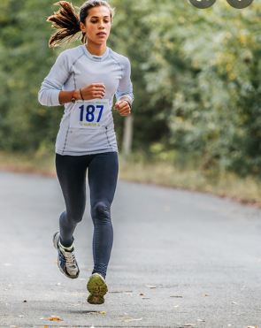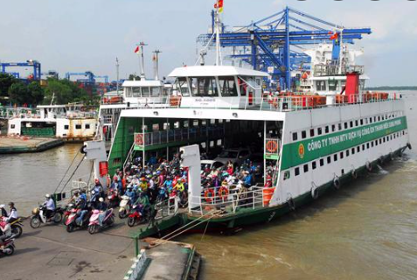

1.___________________ 2.________________________________

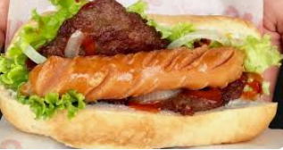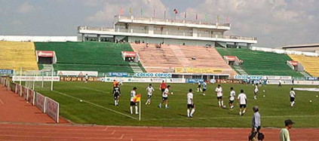

3.____________________ 4.________________________________

III. Choose the word or phrase (A, B, C or D) that best fits the space in each sentence.
1. We went to the __________ and watched a baseball game.
A. airport B. theater C. stadium D. hospital
2. The temple is on a small island. You have to take a __________ across the river to go there.
A. bus B. ferry C. motorbike D. car
3. We went to the airport very early because our _________ was at 6 a.m.
A. flight B. stadium C. ferry D. tour guide
4. Jess likes to _______ in the park by the river. It’s a good way to exercise while enjoying the view.
A. bake B. decorate C. sleep D. jog
5. _________ is a person who shows tourists around an attraction.
A. Tour guide B. Participant C. Superhero D. Sales assistant
6. The town is famous for having many _______ buildings. People built those in the twelfth century.
A. modern B. historic C. frequent D. unhealthy
7. The food here is great. I ate a ________. It’s a traditional American street food.
A. beef noodles B. spaghetti C. Dagwood Dog D. hot dog
8. There isn’t an airport in my town. I had to go to Reno to catch a ________ to New York.
A. suitcase B. ferry C. flight D. ball
9. _________ is a boat that crosses a river.
A. Plane B. Train C. Ferry D. Bus
10. They normally watch football games on TV, but they’re going to the ________ on Saturday.
A. store B. stadium C. airport D. parliament

------------------------------------------------------------------------------------------------------------------
Period 86
UNIT 9: ENGLISH IN THE WORLD
LESSON 1-2 (Grammar)
I. Grammar: Articles : Mạo từ
1/ zero article ($∅$) dùng cho tên của:
streets (đường), parks (công viên), lakes (hồ), rivers (sông), beaches (biển), towns (thị trấn), cities (thành phố), islands (đảo), and most countries (các đất nước)
Examples: Hanoi, Fifth Avenue, Hyde Park,…
2/ article “ The” dùng cho tên của:
- Một số đất nước: the United States of America (US-Hợp chủng quốc Hoa Kỳ); the United Kingdom (UK-Vương quốc Anh); the Netherlands (Hà Lan); the Philippines ( Cộng hòa Philippines) ; the United Arab Emirates (UAE- Các Tiểu vương quốc Ả Rập Thống nhất); the Czech Republic (cộng hòa Séc)
- Những địa điểm nổi tiếng: buildings (tòa nhà), museums (bảo tàng), most hotels (khách sạn) and restaurants (nhà hàng)
Examples: the Empire State Building, the Houses of Parliament, the Ritz Hotel, the White House, the Louvre Museum,…
II. Fill in the blanks using “ the” or $∅$ (zero article)
1. ____ Netherlands is famous for tulips.
2. ______ London is the biggest city in Britain and _____ Oxford street is London’s main shopping centre.
3. My parents are visiting ______ Eiffel Tower.
4. I often go on holiday to_____ Canary Islands.
5. He is going to____ Philippines to study English.
6. ____ Mount Everest is the highest mountain in the world.
7. _____ Independence Palace in Ho Chi Minh City is a historic place.
8. My friends and I will meet together at _____ Changi Airport.
9. ____ Petronas Twins Towers are in Kuala Lumpur, Malaysia.
10. My aunt lives with her family in ____ United States of America.

------------------------------------------------------------------------------------------------------------------
Period 87
UNIT 9: ENGLISH IN THE WORLD
LESSON 1-3 (Pronunciation)
I. Find the word whose underlined part differs from the other three in pronunciation.
1. A. healthy B. weather C. them D. together
2. A. listens B. enjoys C. talks D. wears
3. A. donated B. organized C. collected D. decided
4. A. fun B. but C. run D. put
5. A. make B. car C. skate D. game
II. Find the word that differs from the other three in the position of primary stress.
1. A. event B.talent C. flower D. money
2. A. safety B. market C. public D. report
3. A. subway B. local C. defeat D. ferry
4. A. power B. affect C. village D. noisy
5. A. tasty B. temple C. abroad D. luggage
III. Choose the word (A, B, C or D) that best fits the space in the following passage.
My name is Hung. I went on a vacation to Australia, where the main language is English. I was (1)___________ about speaking English (2)___________I arrived here because it was my first trip outside Viet Nam. People talk to each other (3)___________English. It’s the language used in airports and most tourist (4)_____________around the world. It’s used on all (5)___________ along the streets. At first, I have some difficulties in (6)____________English but I learned so much on that trip.
1. A. interested B. worried C. fond D. scared
2. A. when B. what C. who D. how
3. A. on B. of C. in D. with
4. A. transportation B. attractions C. competition D. stadium
5. A. trees B. flowers C. rivers D. signs
6. A. speak B. speaks C. speaking D. spoke
IV. Rewrite each of the following sentences in another way so that it means almost the same as the
sentence printed before it.
1. We plan to go to Hyde Park on Wednesday.
We are .

2. She plans to eat fish and chips tonight.
She is .
3. Where do you plan to stay?
Where are .
4. I’m excited to go on the Riverside ferry to see the islands.
I’m looking .
5. He is excited to visit the Tower of London.
He’s looking .

------------------------------------------------------------------------------------------------------------------

