TRƯỜNG THCS PHAN CÔNG HỚN
TỔ TIẾNG ANH
TIẾNG ANH 7
TUẦN 30 (TỪ 07/04 ĐẾN 12/04)
PHIẾU TỰ HỌC
Period 88: Unit 9 – Lesson 2-1 (New words)
Period 89: Unit 9 – Lesson 2-2 (Grammar)
Period 90: Unit 9 – Lesson 2-3 (Pronunciation)
New words (SGK trang 71)
B – 5 C – 6
D – 4 E – 2
F – 7 G – 1
Listening (SGK trang 71)
a. Peter enjoyed his holiday more.
b. 1. wallet.
2. mom
3. souvenirs
4. New York
5. beautiful
Grammar (SGK trang 72)
b. 1. were 2. saw
3. went 4. took
5. wore
c. 2. said 3. go 4. went
5. eat 6. eat 7. bring
8. bought 9. wore 10. see

SỬA BÀI TẬP TUẦN 29
UNIT 9: ENGLISH IN THE WORLD
LESSON 1-1 (New words)
II. Write the suitable word for each picture

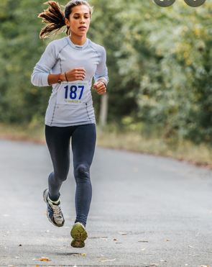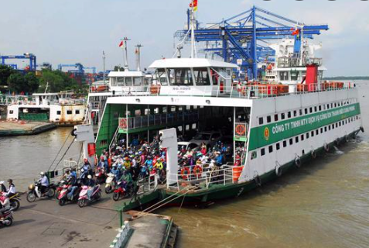
1.______jog________ 2._________ferry__________
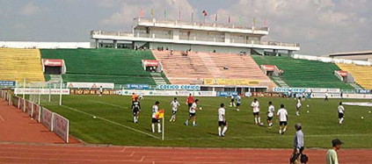
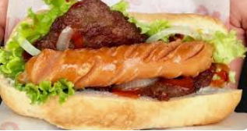

3.______hot dog_______ 4._________stadium_________

III. Choose the word or phrase (A, B, C or D) that best fits the space in each sentence.
1. We went to the __________ and watched a baseball game.
A. airport B. theater C. stadium D. hospital
2. The temple is on a small island. You have to take a __________ across the river to go there.
A. bus B. ferry C. motorbike D. car
3. We went to the airport very early because our _________ was at 6 a.m.
A. flight B. stadium C. ferry D. tour guide
4. Jess likes to _______ in the park by the river. It’s a good way to exercise while enjoying the view.
A. bake B. decorate C. sleep D. jog
5. _________ is a person who shows tourists around an attraction.
A. Tour guide B. Participant C. Superhero D. Sales assistant
6. The town is famous for having many _______ buildings. People built those in the twelfth century.
A. modern B. historic C. frequent D. unhealthy
7. The food here is great. I ate a ________. It’s a traditional American street food.
A. beef noodles B. spaghetti C. Dagwood Dog D. hot dog
8. There isn’t an airport in my town. I had to go to Reno to catch a ________ to New York.
A. suitcase B. ferry C. flight D. ball
9. _________ is a boat that crosses a river.
A. Plane B. Train C. Ferry D. Bus
10. They normally watch football games on TV, but they’re going to the ________ on Saturday.
A. store B. stadium C. airport D. parliament

------------------------------------------------------------------------------------------------------------------
UNIT 9: ENGLISH IN THE WORLD
LESSON 1-2 (Grammar)
II. Fill in the blanks using “ the” or $∅$ (zero article)
1. ___The___ Netherlands is famous for tulips.
2. ___∅___ London is the biggest city in Britain and __∅___ Oxford street is London’s main shopping centre.
3. My parents are visiting __∅____ Eiffel Tower.
4. I often go on holiday to__ the___ Canary Islands.
5. He is going to __ the__ Philippines to study English.
6. __∅__ Mount Everest is the highest mountain in the world.
7. ___The___ Independence Palace in Ho Chi Minh City is a historic place.
8. My friends and I will meet together at __∅___ Changi Airport.
9. ___The___ Petronas Twins Towers are in Kuala Lumpur, Malaysia.
10. My aunt lives with her family in __the__ United States of America.

------------------------------------------------------------------------------------------------------------------
UNIT 9: ENGLISH IN THE WORLD
LESSON 1-3 (Pronunciation)
I. Find the word whose underlined part differs from the other three in pronunciation.
1. A. healthy B. weather C. them D. together
2. A. listens B. enjoys C. talks D. wears
3. A. donated B. organized C. collected D. decided
4. A. fun B. but C. run D. put
5. A. make B. car C. skate D. game
II. Find the word that differs from the other three in the position of primary stress.
1. A. event B.talent C. flower D. money
2. A. safety B. market C. public D. report
3. A. subway B. local C. defeat D. ferry
4. A. power B. affect C. village D. noisy
5. A. tasty B. temple C. abroad D. luggage
III. Choose the word (A, B, C or D) that best fits the space in the following passage.
My name is Hung. I went on a vacation to Australia, where the main language is English. I was (1)___________ about speaking English (2)___________I arrived here because it was my first trip outside Viet Nam. People talk to each other (3)___________English. It’s the language used in airports and most tourist (4)_____________around the world. It’s used on all (5)___________ along the streets. At first, I have some difficulties in (6)____________English but I learned so much on that trip.
1. A. interested B. worried C. fond D. scared
2. A. when B. what C. who D. how
3. A. on B. of C. in D. with
4. A. transportation B. attractions C. competition D. stadium
5. A. trees B. flowers C. rivers D. signs
6. A. speak B. speaks C. speaking D. spoke
IV. Rewrite each of the following sentences in another way so that it means almost the same as the
sentence printed before it.
1. We plan to go to Hyde Park on Wednesday.
We are going to Hyde Park on Wednesday.
2. She plans to eat fish and chips tonight.
She is eating fish and chips tonight.
3. Where do you plan to stay?
Where are you staying?
4. I’m excited to go on the Riverside ferry to see the islands.
I’m looking forward to going on the Riverside ferry to see the islands
5. He is excited to visit the Tower of London.
He’s looking forward to visiting the Tower of London.

------------------------------------------------------------------------------------------------------------------

