TRƯỜNG THCS PHAN CÔNG HỚN
TỔ TIẾNG ANH
TIẾNG ANH 7
TUẦN 31 (TỪ 14/04 ĐẾN 19/04)
PHIẾU TỰ HỌC
Period 91: Unit 9 – Lesson 3-1 (Listening and Reading)
Period 92: Unit 9 – Lesson 3-2 (Writing and Speaking)
Period 93: Unit 9 – Review
Listening (SGK trang 74)
- 2
- 1, 4, 6
Reading (SGK trang 74)
a. Canada
b. 1. True 2. False 3. True 4. True 5. False
Writing (SGK trang 75)
- 5. Wish you were here!
3. Last Thursday, I went shopping in SoHo and oedered lunch ata café. I met an interesting guy from Peru. Wespoke English together.
4. Tomorrow, I’m walking around Central Park with him.
2. I’m having a great time in New York. I’m practicing English every day.
1. Hi Qúy,

Review Unit 9 ( SGK trang 108,109)
Listening (SGK trang 108)
- B 1. A 2. C 3. E 4. G 5. F
Reading (SGK trang 108)
- A 1. B 2. A 3. C 4. B 5. B
Vocabuary (SGK trang 109)
- photos
- flight
- historic
- wallet
- stadium
- souvenirs
- tour guide
- sightseeing
Grammar (SGK trang 109)
a.

- the

- the

b.
1. Did you visit the Empire State Building?
2. We took a flight to Boston the next day.
3. I bought lots of new clothes.
4. She didn’t have a swimsuit.
5. He lost his wallet.
6. They ate at a famous restaurant.
Pronunciation (SGK trang 109)
- 1. A 2. B 3. D
- 4. C 5. B 6. D

SỬA BÀI TẬP TUẦN 30
UNIT 9: ENGLISH IN THE WORLD
LESSON 2-1 (New words)
II. Choose the word or phrase (A, B, C or D) that best fits the space in each sentence.
1. Our trip to New Zealand was great! We took so many _________________.
A. photos B. wallets C. beaches D. holidays
2. We went to the airport very early because our _____________ departed at 6 a.m.
A. day B. tour C. flight D. sightseeing
3. There are many _________ buildings in Vienna. The oldest one is more than one thousand years old.
A. historic B. modern C. new D. cool
4. My brother forgot his _________________ so I had to pay for him.
A. postcard B. wallet C. photo D. flight
5. I like to buy ______when visiting different cities, but I never write on any of them.
A. postcards B. wallets C. photos D. flights
6. I like to decorate my room with the _________________ I bought from my trips. I have a doll from Japan, a small statue from Cambodia, and some paintings from Malaysia.
A. holidays B. tips C. souvenirs D. presents
7. Our _________________ was great. She was very friendly and helpful. She told us a lot about the history of the town.
A. volunteer B. tour guide C. traveler D. goer
8. We went _________________ and then spent a few days by the sea.
A. making B. doing C. cleaning D. swimming
9. John____ in Singapore at 5 pm yesterday
A. reached B. arrived C. departed D. got
10. At the age of 86, Barry traveled around the world_______ his sidecar.
A. at B. on C. from D. with

------------------------------------------------------------------------------------------------------------------
UNIT 9: ENGLISH IN THE WORLD
LESSON 2-2 (Grammar)
II. Fill in the blanks with the Past Simple form of the verbs.
- We ____saw_________ the Sydney Opera House. (see)
- I ______took_______ lots of photos of the castles. (take)
- We _____had_________ many delicious Australian dishes. (have)
- The weather ____was_________ cold so I wore a big jacket. (be)
- We ___didn’t go________ go to the park because it was late when we got back. (not go)
- My friend just _____came_______ back from New Zealand. (come)
- _____Did_______you ____eat________ lots of tasty food in London? (eat)
- I ______bought________ many souvenirs for my friends (buy)
- We _______didn’t visit_______ Sapa last summer vacation. (not visit)
- Last night we ___went_________ to Lan’s birthday. (go)
- We ______moved____________ to this city ten years ago. (move)
- My mother ________bought__________ me a dictionary last week. (buy)
- My parents ______visited____________ my grandparents yesterday. (visit)
III. Read the following passage. Decide if the statements from 1 to 4 are True or False and choose the correct answer (A, B, C or D) for the questions 5 and 6.
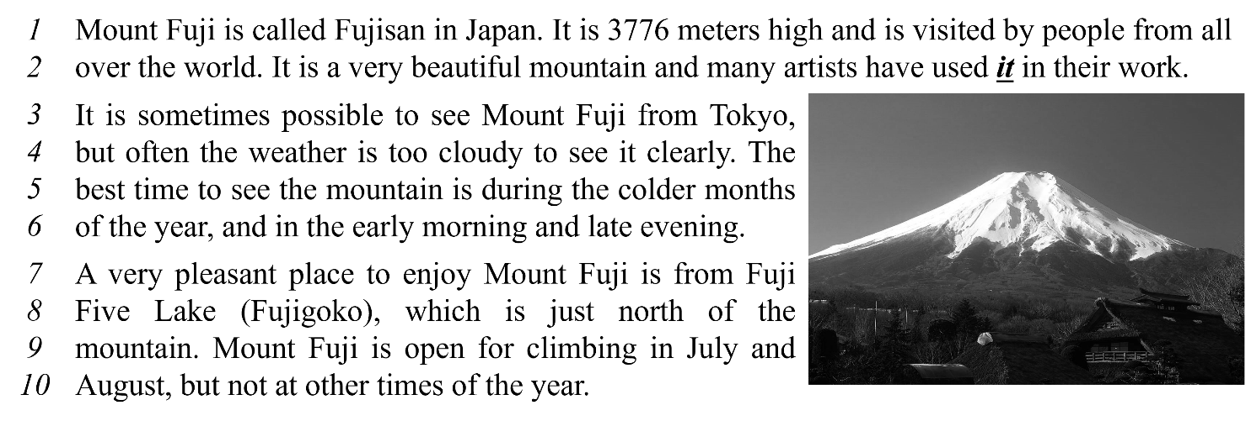
Write TRUE or FALSE.
1. Mount Fuji is a high mountain. ___True_____
2. We can see Mount Fuji clearly every day. ___False_____
3. Fuji Five Lake is in the north of Mount Fuji. ___True_____
4. In December, we can go climbing in Mount Fuji. ___False_____
Choose correct answer for each question.
5. What does the word it in line 2 refer to?
A. the world B. Mount Fuji C. Japan D. artists
6. When is the best time to see Mount Fuji?
A. from Fuji Five Lake B. in August
C. in cold months D. In Summer

----------------------------------------------------------------------------------------------------------------
UNIT 9: ENGLISH IN THE WORLD
LESSON 2-3 (Pronunciation)
I. Find the word whose underlined part differs from the other three in pronunciation.
- A. America B. summer C. postcard D. department
- A. souvenir B. parliament C. ferry D. demon
- A. weather B. wallet C. Australia D. hover
- A. attraction B. decorate C. tradition D. swimsuit
- A. holiday B. muddy C. sculpture D. subway
II. Find the word that differs from the other three in the position of primary stress.
- A. cheesesteak B. stadium C. historic D. muddy
- A. balloon B. participant C. exchange D. roastery
- A. defeat B. temple C. national D. gallery
- A. parliament B. comfortable C. negative D. competition
- A. disappointed B. experience C. transportation D. volunteer
III. Choose the word (A, B, C or D) that best fits the space in the following passage.
Dear Ben,
I’m glad to hear about your trip. Last Sunday, students from my school also (11) ______ on an excursion. We visited Củ Chi tunnel. We came to school at 6:00 AM. Ten big buses (12) ______ us there. All of us (13) ______ excited, so we sang all the way to Củ Chi. We arrived there at 7:00 AM. A tourist guide showed us the historical places: the Củ Chi long tunnel and the kitchen under the ground where people cooked their meals. We made a tour around that place.
Then we went to Bến Dược temple we (14) ______ lots of names of the soldiers on the walls. We admired them very much. Our teacher asked us to write a report. We (15) ______ writing it now. We feel very happy to write what we’ve learned from that trip. We hope to come back to Củ Chi someday.
As I’ve mentioned, I have to finish my report, so I’ll stop now. Hope to hear from you soon.
Jerry
- A. go B. goes C. went D. gone
- A. took B. taked C. take D. taken
- A. are B. were C. was D. is
- A. see B. seed C. sed D. saw
- A. are B. were C. was D. is
IV. Rearrange the groups of words in a correct order to make complete sentences.
- souvenirs / Yesterday, / bought / I /.//
Yesterday,I bought souvenirs.
- We / delicious / Japanese dishes/ had / many /.//
We had many delicous Japanese dishes.
- new food/ try / you / Did / any /?//
Did you try any new food?
- Jimmy / wallet / forgot / his /.//
Jimmy forgot his wallet.
- didn’t visit/ because/ Buckingham Palace/ My mom/ late/ it was /.//
My mom didn’t visit Buckingham Palace because it was late.

