UNIT 13 : FESTIVALS
Read (Trang 124-126 SGK Tiếng Anh 8)
I. OBJECTIVES
By the end of the lesson, students will be able to
- read for information about Christmas celebrations in U.S.A
- develop reading skills.

II. LANGUAGE CONTENT
* Grammar:
- Simple past, Passive forms
* Vocabulary:
(n) Christmas Eve, custom, Europe, tradition, carol, leader, Santa Claus, poem,
character, description
(adj) unsuitable, popular,
(v) decorate, design, perform, complain
III. CONTENT

Christmas is an important festival in many countries around the world.
(Giáng sinh là một ngày lễ quan trọng ở nhiều nước trên thế giới.)
Bài nghe:
Hướng dẫn dịch:
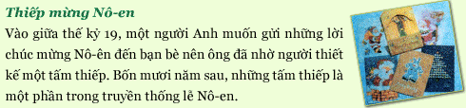
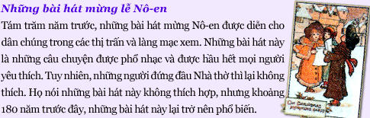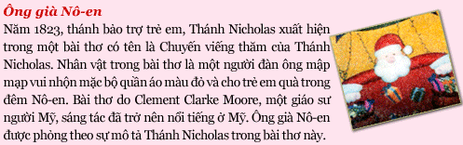
1. Complete the table.
(Hoàn thành bảng.)
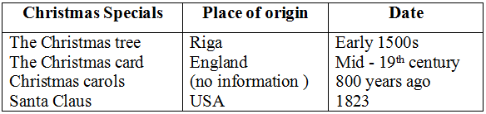
2. Answer the questions.
(Trả lời các câu hỏi.)
a) How long ago did the Christmas tree come to the USA?
=> The Christmas tree came to the USA in the 1800s.
b) Why did the Englishman have someone design a card?
=> Because he wanted to send Christmas greeting to his friends.
c) When were Christmas songs first performed?
=> Christmas songs were first performed 800 years ago.
d) Who wrote the poem A Visit from Saint Nicholas?
=> An American professor named Clement Clarke Moore wrote A visit from Saint Nicholas.
e) What is Santa Claus based on?
=> Santas Claus is based on the description of Saint Nicholas in the poem.

