UNIT 14: WONDERS OF THE WORLDS
Speak (Trang 132-133 SGK Tiếng Anh 8)

I* Vocabulary:
- Empire State Building USA: cao ốc, Great Barrier Reef:vĩ san hô ngầm, Great Wall of China : vạn lý trường thành, Hue Citadel:cố đô, Cave : hang động, Eiffel Tower: Tháp Eiffel, Mount Everest : núi Everest
II. CONTENTS
1. Think of 10 famous places. You may use the names of places listed in the box or you can use your own ideas. Write a Yes/No question about each place. Ask and answe objects.

Answer the questions with a partner.
(Hãy nghĩ đến 10 địa danh nổi tiếng. Em có thể dùng tên những địa danh liệt kê trong khung hoặc theo ý kiến của em. Viết một câu hỏi Có/Không về mỗi địa danh. Hỏi và trả lời với bạn bên cạnh.)
cạnh.)
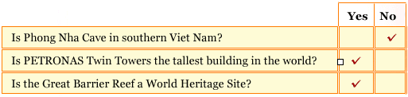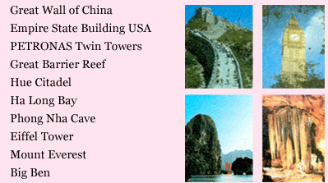
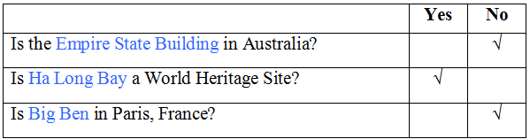
2. Talk about your classmates' answers with your partner.
I asked Hoa if Phong Nha Cave was in southern Viet Nam. She said that it wasn't.
- I asked Hung whether PETRONAS Twin Towers in Malaysia was the highest building in the world. He said that it was.
- I asked Lan if the Great Barrier Reef was a World Heritage Site. She said that it was.
- I asked Ngoc whether the Empire State Building was in Australia. She said that it wasn't.
- I asked Tuan if Ha Long Bay was a World Heritage Site. He said that it was.
- I asked Mai whether Big Ben was in Paris, France. She said that it wasn't.

