Họ và tên: ………………….…….  Lớp: …… Trường:…….……..…………  Ngày :………………………….…… |  | PHÒNG GIÁO DỤC VÀ ĐÀO TẠO QUẬN PHÚ NHUẬN  KIỂM TRA GIỮA HỌC KỲ II  NĂM HỌC : 2020 – 2021  ĐỀ B |  |  | Số thứ tự
Môn : Tiếng Anh – Lớp 7  Thời gian làm bài : 60 phút | Số BD | Chữ ký GT1 | Chữ ký GT2 | Mật mã

Giám khảo | Điểm | Lời phê | Mật mã
Giám khảo | Điểm | Lời phê | Số thứ tự:
- Listening comprehension (The recording will be played three times)
- Listen to Minh’ s story at Dr Lai’ s surgery and write the missing words (1 pt)
Minh is sitting in Dr Lai’s (1)_____________. Dr Lai is checking his teeth.
Dr Lai is kind. She smiles at Minh and says, ‘Don't worry, Minh. You have one small cavity, but it isn't (2)___________. Your other teeth are fine.'
Minh is very happy. Dr Lai fills the cavity in Minh's tooth. She finishes in less than 10 minutes. Minh is very pleased. Then Dr Lai sits down and talks to Minh again.
“How (3)______________ do you brush your teeth, Minh?" she asks. Minh looks worried again.
'Oh, I ... Well, sometimes I forget to brush my teeth.’
‘Try not to forget', Dr Lai says. ‘Brushing your teeth is very important. (4)___________ teeth are healthy teeth!’
- Listen to the dialogue between Mr Tan and Lan and then write TRUE / FALSE (0.5 pt) (Học sinh viết đầy đủ TRUE hoặc FALSE)
- Lan had a terrible cold yesterday. _______________
- He mom wrote a sick note for her. _______________
- Choose the word/ phrase (A, B, C or D) that best fits the space in each sentence. (2,5pts)
- Her job is to cut people’s hair. She is a _____________.
- hairshaper B. hairmaker C. hairdresser D. haircutter
- It won’t be difficult for me to keep __________ with my new foreign friend.
- touching B. in touch C. to touch D. touch
- She talked to her friends ___________ her vacation in Dalat.
- about B. on C. in D. for
- What is Loan’s ___________? - She is 46 kilos.
- weight B. height C. heavy D. tall
- I think you should stop _________ iced water. The doctor said that you had a sore throat.
- drink B. eating C. to drink D.drinking
- My new shoes don’t _________ me very much. They are too big.
- suit B. match C. go with D. fit
- These medicines can make you ___________ better.
- feel B. feels C. feeling D. to feel
- He’s bought a lot of ___________ on his holiday.
- souvenirs B. memories C. anniversaries D. entertainments
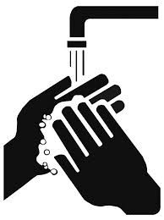
- What does the sign mean?
- You should wash your hands before and after meals.
- You can’t make your hands brighter and whiter.
- You ought to hold your hands together.
- You mustn’t wash up.
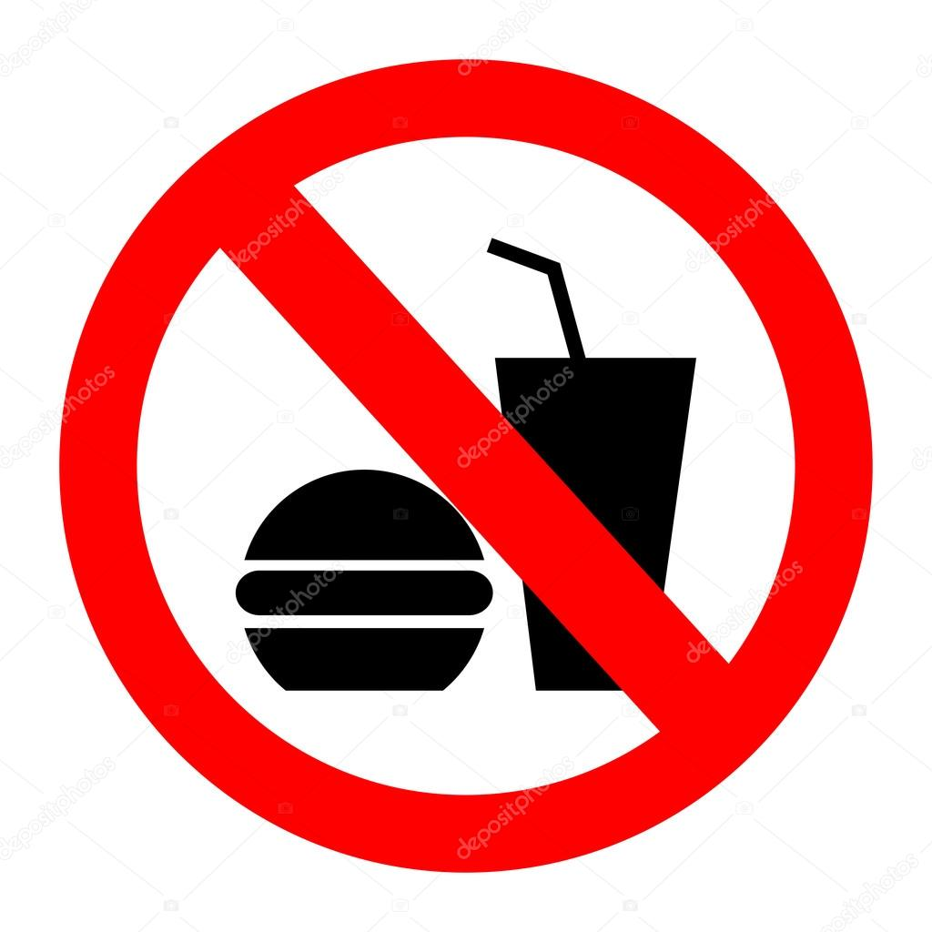
- What does the sign say?
- No fast food.
- No food.
- No drink.
- No food or drink.

Thí sinh không được viết vào đây

_____________________________ Đường rọc phách ___________________________

- Supply the correct verb tenses or forms. (1 pt)
- Tram (visit) ___________ her relatives when she was on holiday last year.
- Would you (send) __________ me a message to inform me when you come, please?
- It’s important (remember)_____________ that dinner doesn’t have to be the largest meal.
- Lucy (not be) ______________ Army Museum with her class last Saturday.
- Put the words / phrases given in their correct order to make meaningful sentences (0.5pt)
- / bought / the dress / the material / neighbor / Lan’s / made / and / for her / . /
___________________________________________________________________________
- / my lifestyle / I’m not / change / very healthy / I should / because / . /
___________________________________________________________________________
- Use the correct form of word given in each sentence. (1 pt)
- When I was young, I was ________ when I went to the hospital. (scary)
- Don’t forget to exercise _____________. (regular)
- To keep the dentist away, we should never touch _________ food. (health)
- He had a pain in his stomach. He is having a ______________. (stomach)
- Read the following passage, and decide if the statements are True or False. (1pt)
Vitamins are very important for the body. There are more than thirteen kinds of vitamins. They help the body take up energy from foods, help the body grow, and help muscles work correctly.
Vitamin A is necessary for our eyes. People who don’t have enough vitamin A often have night blindness, they can’t see well when it is dark. Food such as liver, eggs, milk and cheese have s lot vitamin A.
According to the passage | TRUE/ FALSE
27. Vitamins are necessary for our bodies.
28. We should eat foods which contain vitamins.
29. We ought to have vitamin A so as not to have night blindness.
30. Muscles and body can work without vitamin.
- Choose the word / phrase (A, B, C or D) that best fits the space in the following passage. (1pt)
Bella doesn’t feel very (1)__________, so she isn’t going to school today. She has an earache. Her right ear hurts. The earache started (2)__________Saturday afternoon when she (3)___________ to watch a football match, and her ear hurt after that. It was very cold and it was freezing, (4)___________ she didn’t have a hat. Her doctor
31. A. bad B. happy C. well D. healthy
32. A. at B. on C. in D. as
33. A. to go B. go C. went D. going
34. A. but B. so C. because D. therefore
- Rewrite each of the following sentences in another way so that it means almost the same as the sentence printed before it. (1.5pts)
35. Be sure have a medical check - up every six months.
→ Remember_____________________________________________________________________.
36. Danny didn’t go to school last week because he got a fever.
→ Danny was absent _______________________________________________________________.
37. How much does your son weigh?
→ How___________________________________________________________________?
----- THE END OF THE TEST -----

ANSWER KEY
- Listening comprehension (The recording will be played three times)
- Listen to Minh’ s story at Dr Lai’ s surgery and write the missing words (1 pt)
Minh is sitting in Dr Lai’s (1)____surgery_________. Dr Lai is checking his teeth.
Dr Lai is kind. She smiles at Minh and says, ‘Don't worry, Minh. You have one small cavity, but it isn't (2)__serious_________. Your other teeth are fine.'
Minh is very happy. Dr Lai fills the cavity in Minh's tooth. She finishes in less than 10 minutes. Minh is very pleased. Then Dr Lai sits down and talks to Minh again.
“How (3)_____often_________ do you brush your teeth, Minh?" she asks. Minh looks worried again.
'Oh, I ... Well, sometimes I forget to brush my teeth.’
‘Try not to forget', Dr Lai says. ‘Brushing your teeth is very important. (4)_____Clean______ teeth are healthy teeth!’
- Listen to the dialogue between Mr Tan and Lan and then write TRUE / FALSE (0.5 pt) (Học sinh viết đầy đủ TRUE hoặc FALSE)
- Lan had a terrible cold yesterday. ____TRUE________
- He mom wrote a sick note for her. ______FALSE______
- Choose the word/ phrase (A, B, C or D) that best fits the space in each sentence. (2,5pts)
- Her job is to cut people’s hair. She is a _____________.
- hairshaper B. hairmaker C. hairdresser D. haircutter
- It won’t be difficult for me to keep __________ with my new foreign friend.
- touching B. in touch C. to touch D. touch
- She talked to her friends ___________ her vacation in Dalat.
- about B. on C. in D. for
- What is Loan’s ___________? - She is 46 kilos.
- weight B. height C. heavy D. tall
- I think you should stop _________ iced water. The doctor said that you had a sore throat.
- drink B. eating C. to drink D.drinking
- My new shoes don’t _________ me very much. They are too big.
- suit B. match C. go with D. fit
- These medicines can make you ___________ better.
- feel B. feels C. feeling D. to feel
- He’s bought a lot of ___________ on his holiday.
- souvenirs B. memories C. anniversaries D. entertainments
- What does the sign mean?
- You should wash your hands before and after meals.
- You can’t make your hands brighter and whiter.
- You ought to hold your hands together.
- You mustn’t wash up.
- What does the sign say?
- No fast food.
- No food.
- No drink.
- No food or drink.

Thí sinh không được viết vào đây

_____________________________ Đường rọc phách ___________________________

- Supply the correct verb tenses or forms. (1 pt)
- Tram (visit) _____visited______ her relatives when she was on holiday last year.
- Would you (send) ___send_______ me a message to inform me when you come, please?
- It’s important (remember)____to remember___ that dinner doesn’t have to be the largest meal.
- Lucy (not be) ____wasn’t__________ Army Museum with her class last Saturday.
- Put the words / phrases given in their correct order to make meaningful sentences (0.5pt)
- / bought / the dress / the material / neighbor / Lan’s / made / and / for her / . /
___Lan’s neighbor bought the material and made the dress for her.__________
- / my lifestyle / I’m not / change / very healthy / I should / because / . /
___I should change my lifestyle because I’m not very healthy.___________
- Use the correct form of word given in each sentence. (1 pt)
- When I was young, I was ___scared_____ when I went to the hospital. (scary)
- Don’t forget to exercise _____regularly________. (regular)
- To keep the dentist away, we should never touch ___unhealthy______ food. (health)
- He had a pain in his stomach. He is having a ____stomachache__________. (stomach)
- Read the following passage, and decide if the statements are True or False. (1pt)
Vitamins are very important for the body. There are more than thirteen kinds of vitamins. They help the body take up energy from foods, help the body grow, and help muscles work correctly.
Vitamin A is necessary for our eyes. People who don’t have enough vitamin A often have night blindness, they can’t see well when it is dark. Food such as liver, eggs, milk and cheese have s lot vitamin A.
According to the passage | TRUE/ FALSE
27. Vitamins are necessary for our bodies. | True
28. We should eat foods which contain vitamins. | True
29. We ought to have vitamin A so as not to have night blindness. | True
30. Muscles and body can work without vitamin. | False
- Choose the word / phrase (A, B, C or D) that best fits the space in the following passage. (1pt)
Bella doesn’t feel very (1)__________, so she isn’t going to school today. She has an earache. Her right ear hurts. The earache started (2)__________Saturday afternoon when she (3)___________ to watch a football match, and her ear hurt after that. It was very cold and it was freezing, (4)___________ she didn’t have a hat. Her doctor said: “ Wear a hat so your head doesn’t get cold. ”
31. A. bad B. happy C. well D. healthy
32. A. at B. on C. in D. as
33. A. to go B. go C. went D. going
34. A. but B. so C. because D. therefore
- Rewrite each of the following sentences in another way so that it means almost the same as the sentence printed before it. (1.5pts)
35. Be sure have a medical check - up every six months.
→ Remember to have a medical check - up every six months________________________.
36. Danny didn’t go to school last week because he got a fever.
→ Danny was absent __from school last week because he got a fever_________________________.
37. How much does your son weigh?
→ How_heavy is your son________________________?
----- THE END OF THE TEST -----

