Name:___________________________________________ Class:_____________
UNIT 6 – GRADE 9
- MULTIPLE CHOICE :
1. Many factories emit harmful ……………..into the atmosphere.
A. pollutants B. energy C. polluted D. air
2. To stop global warming we have to use ……………..energy like solar and wind.
A. self - sufficient B. fossil fuel C. renewable D. world
3. You can ……………..organic household waste by having a compost bin in the garden.
A. protect B. renew C.recycle D. fertilize .
4. …………….. is chemical used for killing insects.
A. Pollution B. Dynamite C. Pesticide D. Deforestation
5. I’m disappointed …………….. people have spoiled this area.
A. if B. that C. how D. and
6. ……………… reducing water pollution?.
A. Why not B. Why don’t you C. Won’t you D. How about
7. Mrs. Smith has kindly provided a picnic lunch ……………… us.
A. to B. for C. with D. of
8. Burning fossil fuel can cause …………….to fall from the clouds.
A. smog B. carbon footprints C. smoke D. acid rain
9. The farmers are ……………… their crops with pesticides.
A. spraying B. polluting C. checking D. complaining
10. Customers made ……………… about the way they were treated.
A. treasure B. disappointment C. complaints D. conservations
11. Don’t throw trash …………….. the water.
A. onto B. on C. in D. to
12. We stay at home ……………… it was raining heavily.
A. because B. and C. but D. so
13. Unless you understand, I ……………… explain it again to you.
A. am B. was C. will D. would
14. Waste chemicals and smoke from vehicles and factories pollute not only the air ...................the land and water as well.
A. and B. with C. but D. not
15. What exactly is the influence of air pollution........... human beings?
A. to B. with C. on D. for
16. The society was set up to......…..endangered species from extinction.
A. prevent B. distinguish C. preserve D. survive
17. The factory was fined for...... chemicals into the river.
A. discharging B. dumping C. producing D. exposing
18. David :"It's terrible. I don't think I will be able to pass the exam." – Mary : "______"
A. Let's try it. B. Don't worry. Everything will be all right.
C. OK. What's that? D. Why not pass it?
19. Sue: "You have read that article on the website, haven't you" – Peter : "_______"
A. Sure, thanks. B- Not at all! Go ahead.
C. Not yet. Why? D. Yes, of course, I will.
20. “ Let’s do something interesting this evening !” –“………………………….”
A. Don’t mention it. B.OK,why not ?
C.Not at all. D.You’re welcome.
- CAUTION SIGNS - WARNINGS :
- What should you do if you see these words on the garbage bin?  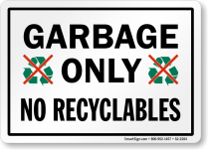 | - put recyclable things into it  - not put recyclable things into it  - not put garbage into it  - put garbage and recyclable things into it
2) What does the sign say ?  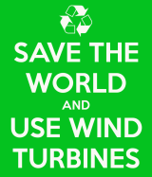 | - Using wind power is one of the ways to save the world.  - We should save the world by the wind.  - We should use wind for the whole world.  - We should save the wind by the world.
3. What is the meaning of the text ?  RECYCLE BIN  Bottles & Cans  Only
  A. This bin is used for tin containers.  B. This bin is used for waste bottles and cans.  C. This bin is used for trash including bottles and cans.  D. Sort out your garbage at this place. |  | RECYCLE BIN  Bottles & Cans  Only
4. What does the sign refer to ?  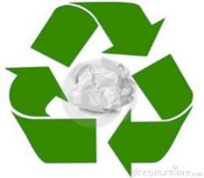 | A. Roundabout  B. Waste Reuse  C. Recycling  D. Safe material
5. What does the sign show ?  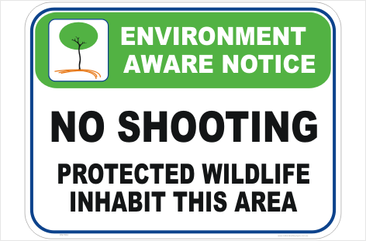 | - Visitors can shoot some kinds of animals here.  - No wild animals can be shot here.  - This area is where all protected wildlife live.  - B & C are correct.
6. What does the sign tell us about?  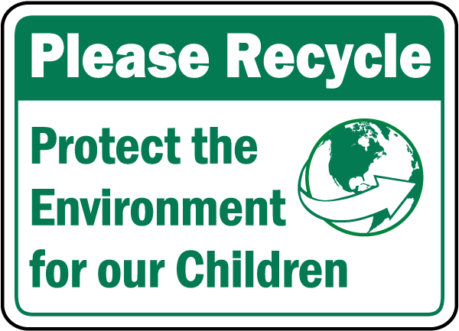 | A.We should recycle to protect the environment.  B. Protecting the environment is responsible for everyone.  C. Children need to protect the environment.  D. Planting more trees is to conserve the natural resources.
7. This sign tells us __________  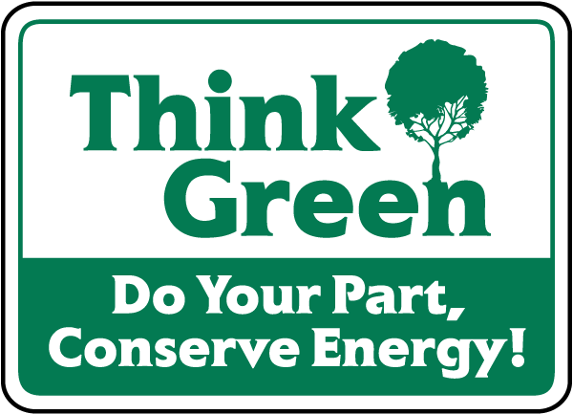 | - Our source of energy is out of order.  - People should use energy economically.  - People should just do their part well.  - People should plant more green trees.
8. This sign means ____________  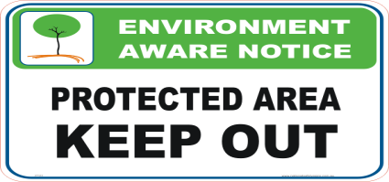 | - Visitors aren’t allowed to enter this area.  - This area is open to everyone.  - This area is only for authorized persons.  - A & C are correct.
9. What does this sign mean?  Do not climb on these rocks as they can be dangerous | A. Stay away because the rocks are unsafe.  B. Be careful of these sharp rocks.  C. Don’t climb these rocks without a guide.  D. A , B & C are not correct.
10.What shouldn’t you use when you see this sign?  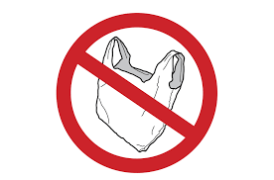 | - Cloth bags  - Wooden bags  C. Plastic bags  D. Leather bag

- CLOZE TEXT :
Read the passage and choose the best answer
The number of vehicles and factories in cities is increasing and the air is becoming more (1)……………. every year . What can we do about it ?
The problem with fumes from cars is that they poison the air and can make people (2)…………….. , especially children. Also, smokes from homes and factories make the air dirtier and smog levels (3)……………. .This makes life in the cities very unpleasant.
There are some solutions (4)………….. this problem .We can use buses and trains to travel around the city .Some cities have already stopped cars from driving in the (5)……………. Also, we should move factories to the countryside and put filters in their chimneys .In these ways, we can reduce the (6)…………… of air pollution and enjoy a healthier life .
1.a. polluted b.polluting c.unpolluted d.fresh
2.a. ill b. pleasant c.tiredness d. sickness
3.a. decrease b. fall c.raises d.increase
4.a. with b. to c. of d.at
5.a. streets b. city center c. neighborhood d. city
6.a. quality b. number c. amount d.increasing

Read the passage and choose the best answer
Nowadays ,people are destroying rainforests of the earth seriously .It is (1)…………….that every year 100,000 (2)………………kilometers of rainforests are destroyed for (3)………….of wood paper and fuel as well as for the residence and (4)…………….land. Rainforests are very important for the world’s climate.They receive the rainfall on the earth and produce a large amount of the world’s oxygen .destroying rainforests ; (5)………….,is destroying our environment .Saving rain forests is a(n) (6)…………….problem. Nations need cooperation to save rain forests ,if not , it will be late.
1. A. exhausted B.pleasure C. interesting D. estimated
2. A. square B. cross C. round D. heart
3. A.bring B.supply C. support D. suggest
4. A. planting B. field C. farming D. rice
5. A. moreover B. however C.so D. therefore
6. A.national B. international C. wideworld D. world
READING COMPREHENSION :
READING 1
Our planet is in danger, and we are responsible for this situation. But it’s not too late. We will have to work together to help save our home .
Did you know that man destroys 50 acres of rainforest every minute? If you throw away two aluminum cans, you waste more energy than one billion of the world’s poorest people use in one day! Air conditioning uses 10 times more energy than a fan and so the pollution it creates is 10 times greater. There are mountains of rubbish everywhere, the Arctic ice cap is melting, animals are becoming extinct.
So what can we do to help? Surprisingly, it’s very easy, but we all have to do every day, otherwise things will never change. Save electricity: turn off the lights, computers, laptops and TVs when you don’t need them. One of the best ways to help the planet is to ride a bike to school. Reuse and recycle and you will help the planet in a positive way.
A. True or False
- Our planet is at risk. ________
- Pollution from a fan is 10 times greater than pollution air conditioning. ________
- Save our planet is difficult if we all do a little every day. ________
- Rubbish ends up on mountain tops . ________
B. Choose the best answer:
- Laptops waste …………………
- natural resource b. electricity c. rubbish d. time
- The passage is mainly about :
- The danger of our planet.
- The ways to help our planet.
- The ways people destroy the earth .
- Save the planet earth now.
READING 2:
Air pollution occurs when wastes dirty the air. People reduce most of the wastes that cause air pollution. Such wastes can be in the form of gases or particles of solid or liquid matter. The substances result chiefly from burning fuel to power motor vehicles and to heat buildings. Industrial processes and the burning of garbage also contribute to air pollution. Besides, there are other polluting substances that exist naturally in the air. They include dust, pollen, soil particle, and naturally occurring gases.
The rapid growth of population and industry and the increasing use of automobiles and airplanes have made air pollution a serious problem. The air we breathe has become so filled with pollutants that it can cause health problems. It also harms plants, animals, building materials and fabrics.
A. True or False
1/ The wastes dirtying the air must always be in the form of solid or liquid matter.
2/ Agricultural and industrial processes also add pollution to the air.
3/ The increasing use of transportation is one of the causes of seriously polluted air.
4/ The air pollution can only do harm to people’s health.
B. Choose the best answer:

5/ When does air pollution happen?
- When wastes are in the form of gases
- When people produce wastes
- When people reduce wastes
- When wastes dirty the air
6/ What has made air pollution a serious problem?
- The rapid growth of population
- The increasing use of automobiles
- The growth of industry
- All are correct

- WORD FORMS:
1/ The food in the restaurant was ………delicious, but the service was ……….poor. (wonder/ awful)
2/ He got an electric shock because of his ……………catching of fish. (care)
3/ Without…………….., some people wouldn’t catch fish. (electric)
4/ Don’t throw away ……bottles, papers and glasses. Take them to the ………..centers. (use/ recycle)
5/ Don’t pump ……………….into seas and rivers or it will pollute them. (sew)
6/ If we keep on …………….the air. More people will suffer from respiratory diseases. (pollution)
7/ The local authorities have received many letters of …………….about the industrial wastes from that factory. (complain)
8/ Make sure the use of ………..is not harmful to farm workers’ health. (pest)
9/ The government ought to ………..up the rules on river pollution. (tight)
10/ Waste ………………from factories has contaminated rivers. (built)
11/ Raising gasoline taxes means …………….the burning of fossil fuels. (courage)
12/ Many factories still allow …………………, such as toxic waste, to flow into our river. (pollute)
13/ Shhh. Listen …………..to the conservationist teaching us how to protect the environment. (care)
14/ Use public transportation or we won’t ………………pollution. (minimum)
15/ The rising level of air pollution has caused concern among …………..(environment)
16/ The local residents got no …………from the company about the ……….sewage discharge. (respond/ treat)
17/ Ba was ………….ill right after eating those …………..mushrooms. (serious/ poison)
18/ The local residents promise to keep the environment …………….(cleanness)
19/ We should end a letter ……..with the words “Sincerely yours” . (polite)
20/ What is responsible for the ………………….problems in your country? (environment)
VII. REARRANGEMENT:
1/ hearing from you / I / / look and seeing forward to / good response / from your company
…………………………………………………………………………………………………. .
2/ Mr. Jones / to the garbage dump / all the bags / and take them / is going to collect
…………………………………………………………………………………………………. .
4/ to protect the environment / to reduce / the amount of garbage we produce / We should burn trash
…………………………………………………………………………………………………. .
6/ they will cause / Because plastic bags / pollution / are very hard to dissolved
…………………………………………………………………………………………………. .
7/ a clean and beautiful place / this beach / if we /we will make / again/ work hard
…………………………………………………………………………………………………. .
8/ many people / What make / to catch fish / you worried most is / use electricity.
…………………………………………………………………………………………………. .
9/ If we plant / along the streets / we will have / more trees / more shade and fresh air
…………………………………………………………………………………………………. .
10/ people / I’m disappointed that / this area / have spoiled
…………………………………………………………………………………………………. .
VIII. TRANSFORMATION:
1. Don’t hope to be successful without trying your best.
If _______________________________________________________________________.
- Review the lesson carefully and he will pass the exam.
If ______________________________________________________________________.
- Doing exercises regularly will make us healthier.
If _______________________________________________________________________.
- Recycle and we will save natural resources.
If _______________________________________________________________________.
- Get out of my house or I’ll call the police.
If _______________________________________________________________________.
- It was cold, so I turned the heating on.
Because ___________________________________________________________________.
- The test was so long that we couldn’t finish it in an hour.
We couldn’t _______________________________________________________________.
- I’ll be on vacation next week, so I won’t be able to attend to pass the final test.
Since _____________________________________________________________________.
- She wants her son to take part in the social activities.
She suggests that ___________________________________________________________.
- The doctor advised us to drink a lot of water to prevent sickness.
The doctor suggested _______________________________________________________.
- Protect our environment!
I suggest our environment ____________________________________________________.
- “ Why don’t you stop working and take a rest, Peter? “
I suggest ___________________________________________________________________.
- Why not take solid waste to recycling centers?
They suggest ________________________________________________________________.
They suggest that______________________________________________________________.
- My uncle cooks very well at a famous restaurant.
My uncle is __________________________________________________________________.
- He is a skillful soccer player.
He _________________________________________________________________________.
- Hoa is a very hard-working student.
Hoa ________________________________________________________________________.
- They designed fashions cleverly.
They were____________________________________________________________________.
- We can’t swim in this river because the water is highly polluted.
Because of ___________________________________________________________________.
- He failed the exam because of not learning the lesson carefully.
Because ______________________________________________________________________.
- We all admire this woman because she is wise.
Because of ___________________________________________________________________.

UNIT 7: SAVING ENERGY
II.Choose the word/ phrase (A, B, C or D) that best fits the space in each sentence
1. What can we do to spend less....................lighting?
A. about B. on C. in D. of
2. You should reduce the ……………… of water your family uses.
A. number B. amount C. many D. bill
3. A ……………… faucet can waste 500 liters of water a month.
A. dropping B. dipping C. running D. dripping
4.………………. put all the guests on the first floor?
A. Why not B. I suggest C. How about D. Let’s
5. “I think we should fix the dripping faucet” “………………”
A. We will B. Good idea
C. Yes, please D. I’m afraid not
6. “What about collecting used paper, bottles and cans every day?” “……………… “
A. Well done B. That’s a good idea
C. I’m afraid not D. That’s very kind of you
7. “I suggest traveling by bikes instead of motorbikes to protect the environment” “………………..…… “
A.. Oh, yes B. Thanks
C. Good luck! D. Great! Let’s do that.
8. She forgot...................off the gas before going out.
A. to turn B. turned C. turn D. turning
9. He was tired, ............... he took a rest before continuing the work.
A. and B.but C. if D.so
10.I suggest ................ money for the poor people in our neighborhood.
A. saving B. to save C. saved D. save
11. They get a plumber ________________ sure there are no cracks in the pipes.
A. make B. makes C. made D. to make
12. Many people still believe that ______________resources will never be used up.
A. nature B. natural C. naturally D. unnaturally
13. If you want to save money, you should ____ the amount of water your family uses. A. increase B. reduce C. adapt D. repair
14. Wholooks.............. Your children when you are away from home?
A. to B. for C. after D.at
15.She stays at home because she has to look ..................... her baby.
A. after B.for C. up D.at
16.He got wet..................he forgot his umbrella.
A. because B. because of C. and D.but
17.In order to save the electricity, an ordinary 100 – watt light bulb can be replaced by …………………
A. an energy-saving bulb B. a 1000-watt bulb
C. an electric bulb D. a lamp
18. Don’t waste water or you’ll get an enormous ………… by the end of the month
A. receipt B. paper C. bill D. letter
19. Scientists are looking for an ……………. way to reduce energy consumption.
A. effect B. effected C. effective D. effectively
20. What are you looking ……………….. ? - My picture book. I’ve lost it.
A. for B. off C. in D. after
III/ CAUTION SIGNS - WARNINGS:
1/ What does the sign refer to ?  - Roundabout B. Waste Reuse  C. Recycling D. Safe material | 
2/ What does this sign say?  - Turn on the tap. B. Turn on the faucet .  C. Fix the faucet . D. Save water | 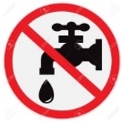
3/ What does the sign say?  - Car parking  - Carpooling  - Car using  - Car traveling | 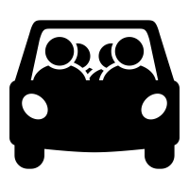
4/ What does the sign refer to ?  - Unplug after use  - Plug in socket  - Plug and socket  - Plug here | 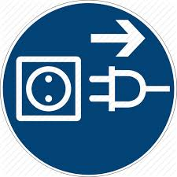
5/ What does the sign say?  - Traveling by bus is better than by bikes  - Use public transport or bikes to save energy  - The ways for buses and bicycles  - Bus station | 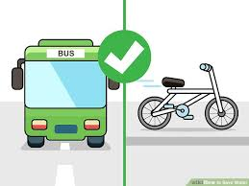
6/ What does the sign want us to do?  - Save water  - Waste water  - Use water economically  - A & C are correct | 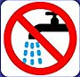
7/ What does the sign say?  - Save electricity  - Don’t use light bulb  - No light here  - No led bulb | 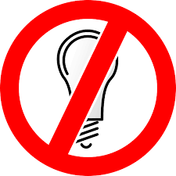
8/ This sign warns us to_______________  - Be careful! lightning can kill.  - Be careful! electricity can kill.  - Be careful! thunderstorm can kill.  - Be careful! pollution can kill . | 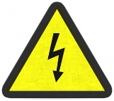
9/ What does the sign say?  - Touch the light.  - No sunlight.  - Please turn off lights when not in use.  - Risk of electric shock. | 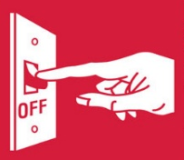
10/ This sign wants us to _______________  - Use onetime shopping bags  - use environmentally friendly bags  - use your own travel shopping bags  - All are correct | 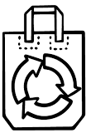
IV. Choose the word (A, B, C or D) that best fits the blank space in the following passage. (1,5m)
1. About twenty percent of the world’s present energy comes from the sun in one form or another. Special devices have already been made available to (1) ___________ on the roofs of houses and flats to catch the sun’s rays and thus heat water. Thousands (2) _______ these devices are now being used to provide energy in homes throughout the United States while more (3) ________ a million solar water- heating units have already been built in homes in Japan. Other purposes for which (4) _____________ energy is, at present, being used include the separation of salt from seawater, irritation and sewage disposal.
For most people in (5) ____________ countries , the need is not for air-conditioners or central heating but for cheap (6)______________ of cooking food, drying crops , and lighting houses.
1. A. put B. locate C. fit D. fix
2. A. in B. with C. on D. of
3. A. than B. of C. through D. over
4. A. sun B. sky C. space D. solar
5. A. develop B. developing C. develops D. to develop
6. A. manners B. ways C. models D. types
- One of the most important discoveries of the nineteenth century was a method (1) ___________ using natural gas for cooking and heating. Large amounts of natural gas are (2) ____________ in The United States, usually several thousand feet below the surface the earth. Natural gas is most often found in places where petroleum, the oil from (3) _____________ gasoline is made, is found. Often the natural gas must be removed before the oil itself is reached.
For many years after natural gas was first discovered, it was thought to have no value. (4) ________________, people began to understand its uses and to find ways of storing it and of moving it from place to place.
Today, natural gas is stored in large tanks and used for lighting, cooking and heating. In many ways natural gas is one of our finest fuels. It can be (5) _____________ for cooking without making the room hot. It is cheap and can be moved (6) __________ from one place to another through long pipelines some of which are hundreds of miles in length.
1. A. in B. of C. to D. from
2. A. find B. finding C. to find D. found
3. A. who B. whom C. which D. whose
4. A. However B.Moreover C.Besides D. Therefore
5. A. use B. using C. to use D. used
6. a. easily B. easy C. easier D. easiest
V. Reading comprehension (1,5m)
1. These days , it seems like everyone is worried about how the world will meet its energy demands when we have no out of oil and natural gas. Scientists and researchers are investigating such power sources as solar energy, wind energy, and even energy from hot rocks beneath the earth’s surface. However, there is no energy source that I believe should not be developed any further- that is nuclear power . In fact, I think we should stop using it as soon as possible. Even though it provides the world with a source of electricity , nuclear power is not a good energy source because it is too expensive., the materials used in power plants are not safe, and there is a great possibility of accidents.
A. Write True or False for the following statements.
1. According to the passage, nowadays people are worried about finding a new source energy.
2. Scientists and researchers think natural gas is the most suitable for future use.
3. Nuclear power provides electricity for people , but it’s not a perfect energy source.
4. According to the author, materials used in the power plants may cause accidents.
B. Choose the most suitable item.
5. What does the word “ it” in line 5 refer to ?
A. nuclear power B. solar energy C. power plants D. energy from hot rocks
6. What is the main idea of this passage?
A. We should not develop . nuclear power
B. This good energy source is very expensive.
C. Solar energy is a good energy source.
D. Energy from hot rocks beneath the earth’s surface is being used.

2. Almost all our energy comes from oil, coal, and natural gas. We call them fossil fuels. The earth’s fossil fuels are running out. What will happen when there are no oil, coal, and gas on earth?
Scientists are trying to find and use other alternative source of energy. We can use energy from the sun, the wind, and the water.
Solar energy is unlimited. The sun supplies all the energy used to grow plants, to evaporate water for rain, and to maintain the temperature of the planet. All are necessary for human life. If we are able to collect solar energy, we will be sure to have this abundant source of power.
Another source of energy from nature is the wind. Wind power is clean and plentiful. Energy from the wind has been used for centuries to move ships, grind grain, pump water and do other forms of work. In more recent times, wind has been used to generate electricity.
Water can also provide power. For a long time, people have used water to power machines. Some early uses of water power were to mill grain, saw wood, and power machinery for the textile industry. Today water power is mostly used to generate electricity.
- Write True or False for the following statements.
1. There aren’t any alternative sources of energy which scientists are trying to find.
2. Energy from the sun is limited but energy from the wind is not. 3. Our planet’s temperature can’t be maintained without solar power. 4. Water power can be used to saw wood. B. Choose the most suitable item.

5. What is the main topic of the passage?
A. Three alternative sources of energy.
B. Solar energy is important.
C. Water is necessary.
D. Almost all our energy comes from oil
6. The word “All” refers to _________________.
A. the energy used to grow plants.
B. evaporating water for rain.
C. maintaining the temperature of the planet.
D. triple A, B, C

VI. WORD FORMS
1. A_______________ is a person who installs and repairs things such as water pipes, toilets, etc. (plumbing)
2. Water is going all over the floor because of the _______________________________________ faucet . (drip)
3. _______________are very demanding. They want products that are both cheap and of good quality. (consume)
4, We suggest ______________________________________________the light bulb. It is broken, (replacement)
5. Recycled ____________________are of the same quality as those made from non-recycled material, (produce)
6. I'm pleased that my secretary solved the problem ___________________________________________. (effect)
7. There have been many _________________________________ in the field of electrical engineering, (innovate)
8. No doubt that there will be a great _____________________________of food for the world's population, (short)
9. Televisions, dishwashers and freezers are electrical _____________________________________ . (apply)
10.Can I just make one ________________________________________ about how we might do this? (suggest)
11.Solar energy can be used on _______________________________________________________ days. (cloud)
12.A leader must be able to communicate ________________________________ in order to be successful.(effect)
13.In order to improve _____________________________________, we need to buy a new machine. (efficient)
14.______________________________________________________________ , the decision is yours. (Ultimate)
15.It was __________________________________________________ that I did badly in the exam. (disappoint)
16.Scientists are looking for an __________________________________ way reduce energy consumption.(effect)
17.I think the careless drivers should be fined _______________________________________________. (heavy)
18.To keep the air unpolluted, people ought to use ________________________energy to create electricity. (sun)
19.If there is sometimes wrong with the light, ask an ______________________________ to look at it. (electric)
20.They spent a ________________________________________________ weekend at a country hotel. (luxury)
VII. WRITE:
A.TRANSFORMATION:
      - You forgot to switch on the washing machine, didn’t you?
You didn’t
      - The First World War began in 1918.
The First World War broke
      - They continued to work until they were exhausted
They went
      - My father doesn’t smoke any more
My father has given
      - I want you to take good care of this tree.
You should look
      - I find it easy to find a better solution to that problem
I have no
      - The children are excited about going to the circus
The children are looking
      - Brian and his mother are very similar
Brian takes
      - I’m afraid that we haven’t got any eggs left
I’m afraid that we ran
      - Thuy is responsible for taking care of her little brother
Looking
      - Hoa has to do the test again because she failed her math test.
………………………………; Therefore,
      - Though she was not beautiful, she took part in the beauty contest.
She wasn’t beautiful.
      - He suggests I have my hair cut.
“Why don’t you
      - They requested us to leave the place at once.
They suggested
      - “ Why don’t you visit the museum after lunch?” I said to them.
I suggested
      - Let’s go by bus instead of taxi.
Why not
      - Why don’t you go to bed early, John?”
John’s father suggested
      - I suggest turning off the lights before going out.
I think we
      - I suggest that you should practice more English every day.
It would be better if
      - He said “ Let’s keep sheets with single printed page for drafting.”
He suggested that………………………………………………………………………..

- Rearrangement:
- about / my recent /I’m / water bill. / worried
I _______________________________________________
- there are / you should/ to make sure /in the pipes. / no cracks / get a plumber
You _______________________________________________
- water as / twice as much / baths use / showers.
Baths _______________________________________________
- can waste / of water / a month. / a dripping faucet / 500 litters/
A _______________________________________________
- of water / you should / reduce the amount / your family use.
You _______________________________________________
- getting a plumber / Mrs. Ha suggested / to check / the pipes / in the house.
Mrs. Ha _______________________________________________
- I think / instead of/ save energy. / take a shower / a bath to/ we should/
I _______________________________________________
- 10 percent to 15 percent / lighting / of the / electricity bill. / accounts for
Lighting _______________________________________________
- the consumers/ has. /the label / tells/ energy efficiency/ each model /how much/
The _______________________________________________
- are installed / to receive/ solar panels /the energy / of the house / from the sun. / on the roof
Solar _______________________________________________
- resources by / save natural / we can / instead of /coal, gas and oil. /using solar energy
We _______________________________________________
- uses two /money if/ she will / she / energy-saving bulbs./ pay less /
She _______________________________________________
13..not only works effectively / which/ Consumers want products / but also saves money
Consumers _______________________________________________
- of fresh water / if we / wasting water, / be a shortage/ /in a few decades. /go on/there will
If we _______________________________________________
- to turn /Mrs. Yen forgot / left / when she/off the faucet/ for work.
Mrs. Yen _______________________________________________
- the beach./ we can’t /It’s / so / go to / raining, /
It’s _______________________________________________
- for the poor. /organize / I suggest / a show / we should/ to raise money
I suggest _______________________________________________
- solar energy /will be / in 2050. / all buildings / heated by/ in Sweden
All ______________A_________________________________
19.percent to 15 percent / lighting / of the / electricity bill. / accounts for
→Lighting _______________________________________________
20.uses two /money if/ she will / she / energy-saving bulbs./ pay less /
She _______________________________________________

EXERCISES ( UNIT 6,7)
1. All of us need a/an ___________ environment. ( pollute )
2. They are very ___________ students ( energy )
3. This mushrooms is_________________, we can’t eat it (poison)
4. The label tells the consumers how much energy__________ each model has. ( efficient)
5. A ___________ faucet can waste 500 liters of water a month (drip)
6. Many household ________________ are expensive to run ( apply)
7. This product will not only work ___________ but also save money. ( effect )
8. We are afraid that there will be a ________________ of fresh water I a few decades ( short)
9. Scientists are looking for an effective way to reduce energy __________________. ( consume )
10. Some __________________ groups checked the sea yesterday. (environment)
11. They buy a ________________ car last month. ( luxury )
12. All fluorescent bulbs really more _____________ than normal light bulbs ? ( efficiency )
13. Everyone must learn to save ______________ resources. ( nature)
14. Polluted water can _________________do harm to our health. (direct)
15. In a few years’ time, our house will be ____________ by solar energy soon. (hot )
16. _____________ are concerned about the air pollution around the world. ( environment)
17. In Western countries electricity, gas and water are _________________. ( need )
18. There are a lot of technological___________________ designed to save energy. (innovate)
19. We will leave a happier and ____________ life if we keep the environment clean. (health )
20. Energy-saving bulbs should be used to save ___________ . ( electric )
21. We were impressed by the speed and_______________ of the new system ( efficient)
22. The high cost of heating and ____________ prevents us from wasting electricity, ( light )
23. New Zealand’s growing reputation as a_______________ of wine ( produce)
24. Without ________________ , natural resources will be used up within a hundred years. ( conserve )
25. All this proves that the system works __________________ (effect)
26. I am ____________ that people have spoiled this area. ( disappoint)
27. ______________ call for the ____________ of the countryside ( conserve)
28. _______ sewage forms sludge, which is sent out into the sea and dumped ( treat)
29. There has been some ____________ in unemployment recently. ( reduce)
30. The drivers have left lots of garbage on the ground after their ________________ ( refresh)

- It was cold for us to go out.
Because ________________________________________________________________________.
- Shall we listen to music instead of story?
I suggest _______________________________________________________________________.
3. Why don’t we take the students to the park at weekend?
I suggested the children students__________________________________________________________
4. I’ll be on holiday next month, so I won’t be able to attend the party.
Since ___________________________________________________________________________
5. “Why don’t you complain to the company, Nam?” said Hoa.
Hoa suggested ____________________________________________________________________.
6. Be careful or you will fall down.
If _________________________________________________________________________________.
7. They cycle very well.
They___________________________________________________________________________.
8. We didn’t go swimming because it rained heavily.
Because of ________ ___________________________________________________________________.
9. The ending of the movie was fantastic.
The movie ____________________________________________________________________________
10. Recycle and we will save natural resources.
If _____________________________________________________________________________ _.
11. The ending of the film is dramatic.
The film _____________________________________________________________________ ____.
12. If you don’t study harder, you won’t pass the speaking test.
Unless ___________________________________________________________________________ __
13. Why don’t we use buses instead of motorbikes?
How about _____________________________________________________________________.
14. The test was too difficult for us to do
Because _______________________________________________________________________.
Because of _______________________________________________________________________.
15. If we go on wasting water, there will be a shortage of fresh water in a few decades.
If we keep _______________________________________________________________________.
If we carry _______________________________________________________________________.

