Unit 15 COMPUTERS
Word | Class | Meaning
adjust | v. | điều chỉnh
bulletin | n. | bản tin
challenging | adj. | mang tính thử thách
concern | n. | mối quan tâm
connect | v. | kết nối
degree | n. | bằng cấp
document | n. | văn bản
icon | n. | biểu tượng
impact | n. | sự ảnh hưởng
insert | v. | chèn
install | v. | cài đặt
freshman | n. | sinh viên năm thứ nhất
fix | v. | sửa chữa
guarantee | n. | sự bảo đảm, sự bảo hành
jack | n. | giắc cắm
jam | n. | sự tắc nghẽn
manual | n. | sách hướng dẫn sử dụng, sổ tay
path | n. | đường mòn, đường dẫn
post | v. | đăng
printer | n. | máy in
requirement | n. | yêu cầu, sự yêu cầu
restrict | v. | giới hạn, hạn chế
skeptical | adj. | hoài nghi
store | v. | lưu trữ

Unit 5 Computers
LESSON 4 WRITE.
Bài 1
1. Match the words with the numbers in the picture.
(Ghép các từ cho sẵn với các con số trong bức tranh.)
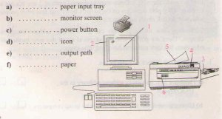
Lời giải chi tiết:
Hướng dẫn giải:
a) 6. paper input tray
b) 1. monitor screen
c) 4. power button
d) 2. icon
e) 3. output path
f) 5. paper
Bài 2
2. Look at the pictures and the words. Write the instructions on how to use the printer.
(Hãy nhìn tranh dùng từ cho sẵn để viết thành lời hướng dẫn về cách sử dụng máy in.)
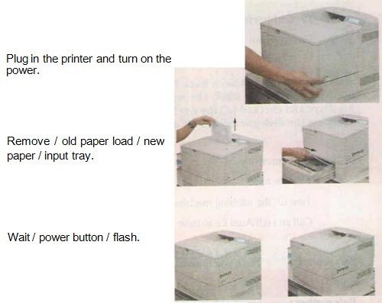
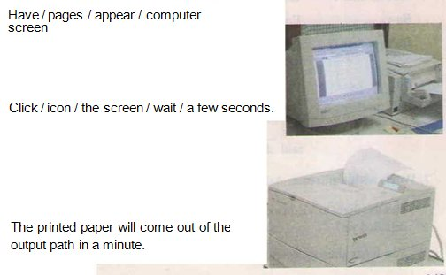
Lời giải chi tiết:
Hướng dẫn giải:
Plug in the printer and turn the power on.
Remove the old paper and load the new paper in the paper input tray.
Wait for the power button to flash.
Have the pages appear on the screen.
Click the printer icon on the screen and wait for a few seconds.
The printed paper will get out from the output path in a minute.
===========================================================
UNIT 15 COMPUTERS
LESSON 5 LANGUAGE FOCUS

Language Focus
● Present perfect with yet and already
● Comparision of present and past simple
Present perfect with yet - already
1.Yet - not yet : vẫn chưa
Dùng ( ? ) ( - )
Ex : Have you turned it on yet ?
No , I haven’t . I haven’t turned it on yet .
2.Already : dùng ( + )
Ex : I have already done it .

Bài 4
4. Complete the dialogues. Use the present perfect or the past simple of the verbs in brackets.
(Hoàn thành những hội thoại sau, dùng thì hiện tại hoàn thành hoặc thì quá khứ đơn của động từ trong ngoặc
Ba: (1) _____ you ______ the film Jurassic Park yet? (see)
Nam: Yes, I have.
Ba: When _____ you ________ it?
Nam: I _____ it three months ago.
*********** *********** ***********
Loan: We (2) _____ a vacation since last year.
Chi: Why not?
Loan: My parents (3) ________ very busy since then. (be)
*********** *********** ***********
Nga: (4) ________ you _________ the news about Nam? (hear)
Mai: No. What (5) ________ ? (happen)
Nga: He (6) _______ an accident. He was jogging. (have)
He suddenly (7) ___ and (8) _____ his leg. (fall, break)
*********** *********** ***********
Sung: (9) _____ the plane a _______ yet? (arrive)
Clerk: Yes, it _______.
Sung: When _____ it _________?
Clerk: It ________ at the airport two hours ago.
Hướng dẫn làm bài :
Ba: (1) Have you seen the film Jurassic Park yet?
Nam: Yes, I have.
Ba: When did you see it?
Nam: I saw it three months ago.
*********** *********** ***********
Loan: We (2) haven't had a vacation since last year.
Chi: Why not?
Loan: My parents (3) have been very busy since then.
*********** *********** ***********
Nga: (4) Have you heard the news about Nam?
Mai: No. What (5) happened?
Nga: He (6) had an accident. He was jogging.
He suddenly (7) fell and (8) broke his leg.
*********** *********** ***********
Sung: (9) Has the plane arrived yet?
Clerk: Yes, it has.
Sung: When did it arrive?
Clerk: It arrived at the airport two hours ago.

Bài 1
1. Ba's mother has just been back from the market. She wanted him to do some housework while she was at the market. Ba made notes in his diary and checked (√) the work he has done. Look at Ba's diary and complete the dialogue using YET and ALREADY.
(Mẹ của Ba mới đi chợ về. Mẹ muốn bạn ấy làm một số việc nội trợ trong khi mẹ đi chợ. Ba ghi lại công việc của mình vào cuốn nhật ký và đánh dấu (√) vào việc bạn ấy đã làm. Hãy nhìn cuốn nhật ký của Ba rồi hoàn thành hội thoại dưới đây, dùng YET và ALREADY.)
Do homework √
Tidy the room X
Turn off the washing machine √
Call and tell Aunt Le to have lunch √
Ba’s mother: Have you finished your homework yet, Ba?
Ba: Yes, ____________, Mom.
Ba’s mother: Good. What about your room? Is it tidied now?
Ba: I’m sorry. Mom. ______________
Ba’s mother: Bad boy, Ba. And the washing machine! Have you turned it off yet?
Ba: Don't worry. Mom. ____________.
Ba’s mother: Have you called and told Aunt Le to have lunch with us today?
Ba: Yes ______________ and she said she would come.
Hướng dẫn làm bài :
Ba’s mother: Have you finished your homework yet?
Ba: Yes, I have already done my homework, Mom.
Ba’s mother: Good. What about your room? Is it tidied now?
Ba: I'm sorry. Mom. I haven't tidied the room yet.
Ba’s mother: Bad boy, Ba. And the washing machine! Have you turned it off yet?
Ba: Don't worry. Mom. I have already turned off the washing machine.
Ba’s mother: Have you called and told aunt Le to have lunch with us today?
Ba: Yes. I have already called and told aunt Le to have lunch, and she said she would come.
Bài 2
2. Work with a partner. Ask and answer questions about the flights.
(Hãy làm việc với bạn bên cạnh. Đặt câu hỏi và trả lời về các chuyến bay.)
- Has the flight to Vientiane departed yet?
- Yes. It has already departed.
- Has the flight from Los Angeles arrived yet?
- No. It hasn’t arrived yet.
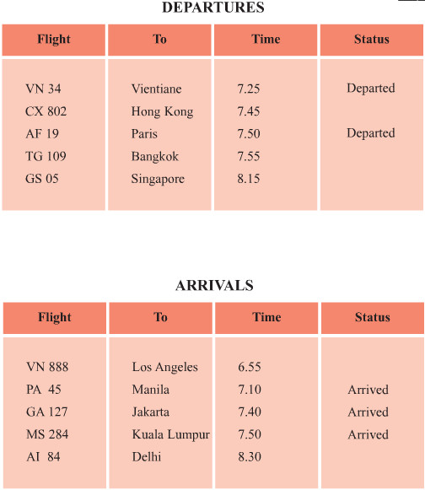
Hướng dẫn làm bài :
- Has the flight to Vientiane departed yet?
Yes. It has already departed.
- Has the flight to Paris departed yet?
Yes. It has already departed.
- Has the flight to Hongkong departed yet?
No. It hasn't departed yet.
- Has the flight to Bangkok departed yet?
No. It hasn't departed yet.
- Has the flight to Singapore departed yet?
No. It hasn't departed yet.
- Has the flight from Los Angeles arrived yet?
No. It hasn't arrived yet.
- Has the flight from Jakarta arrived yet?
Yes. It has already arrived.
- Has the flight from Manilas arrived yet?
Yes. It has already arrived.
- Has the flight from Kuala Lumpur arrived yet?
Yes. It has already arrived.
- Has the flight from Delhi arrived yet?
No. It hasn't arrived yet.
Bài 3
3. Read the sentences. Check (√) the correct column.
(Hãy đọc những câu sau đây rồi đánh dấu (√) vào đúng cột.)
 | finished  action | incomplete  action
a) I’ve been to Sa Pa highlands. | √
b) They have lived in Ca Mau for 10 years. |  | √
c) She has finished her homework.
d) He has worked with the computer since early morning.
e) We have found the problems with the printer.
f) Someone has unplugged the printer.
g) People have received information through the internet recently.
Hướng dẫn làm bài :

 | finished  action | incomplete  action
a. I' ve been to Sapa highlands. | √
b. They have lived in Ca Mau for 10 years. |  | √
c. She has finished her homework. | √
d. He has worked with the computer since early morning. |  | √
e. We have found the troubles of the printer. | √
f. Someone has unplugged the printer. | √
g. People have received information through the internet recently. |  | √

LESSON 3 ÔN TẬP HỌC KÌ II
Phần A
I. Listen to the record player three times, then choose the best answer (A, B, C or D). (1.0 pt)
1. Mrs Quyen is calling from __________________.
A. San Francisco B. Ha Noi C. New York D. Nha Trang
2. Mrs Quyen and her husband are coming to San Francisco on ______________.
A. Sunday B. Monday C. Tuesday D. Wednesday
3. Their ________________ is included in the ticket price.
A. meals B. travel C. accommodation D. hotels
4. Mrs Smith will pick her up at her ______________ at 7 o’clock.
A. hotel B. tour C. house D. place
II. Find the word whose underlined part differs from the other three in pronunciation or the position of primary stress (0.5pt)
5. A. changed B. learned C. laughed D. arrived
6. A. rescue B. recent C. city D. century
III. Choose the word or phrase (A, B, C or D ) that best fits the space in each sentence . (2.5pts)
7. A: Shall I do the washing-up? – B: ___________________________
A. I’m afraid not B. I don’t think so C. I’m sorry I can’t D. No, thanks. I can do it myself
8. Chicago is ______________ right on the shore of Lake Michigan.
A. placed B. situated C. laid D. said
9. Empty cans are brought back to the factory for ______________.
A. recycling B. recycled C. recycle D. be recycled
10. After hiring the ____________, they paddled out.
A. can B. canyon C. canoe D. ship
11. It’s difficult to find accommodation at ____________ times.
A. busy B. full C. daily D. crowded
12. How long was that building _____________?
A. built B. build C. building D. to build
13. The boy fell ____________ his bike and hit his head on the road.
A. on B. off C. out D. down
14. They won the prize in the rice-cooking contest because their rice was the most ______________.
A. nice B. traditional C. delicious D. expensive
15. Do you know how _____________ fire without using matches?
A. make B. to make C. making D. to making
16. Viet Nam is the second biggest ______________ country.
A. rice-exporting B. rice-export C. export-rice D. exporting-rice
IV. Read the signs and choose the best answer (0.5pt)
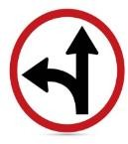  17. What will you do when seeing this sign? | A. Go straight or turn left.  B. Do not turn left.  C. Follow this way.  D. Go straight.
18. What does this sign mean?   | A. trash for reusing  B. trash for reducing  C. trash for returning  D. trash for recycling
V. Choose the word (A, B, C or D) that best fits the blank space in the following passage.(1.5pts)
On June 6th , 1912, a (19) erupted in Novarupta, Alaska. People did not know that the volcano was going to erupt. When it did erupt, someone knew what (20) ________. They rang the church bell. The people from the town followed the sound of the church bell. They went to the sea (21) ___________they escaped on boats. The town was covered by ash for almost three days. Many buildings were destroyed (22) _________of the weight of ash on (23) __________roofs. People who lived 1,200 kilometers (24) _________ from the volcano could hear the eruption.
19. A. volcano B. fire C. mountain D. water fall
20. A. did B. to do C. are doing D. done
21. A. what B. place C. where D. when
22. A. although B. and C. but D. because
23. A. its B. our C. their D. your
24. A. in B. of C. away D. out
VI. Read the following passage. Decide if the statements from 25 to 28 are True or False and choose the correct answer (A, B, C or D) for the questions 29 and 30. (1.5pts)
Tet or Lunar New Year holiday is the most important celebration for Vietnamese people. Tet is a festival which happens in late January or early February. Before Tet, people usually clean and decorate their homes. They go to market to buy candy, jams or dried water melon seeds. They also get new clothes which are worn at Tet. They often buy beach blossoms and marigolds which are traditional flowers on Tet holiday. Tet is a time for family members gather and have some special meals with special food such as sticky rice cakes. People often visit relatives and close friends on the second day of the holiday.
A. True or False (1.0 pt)
25. Tet is the most important celebration in Vietnam. _________
26. Tet happens in early January _________
27. People don’t clean and decorate their homes _________
28. People often visit relatives and close friends on the first day of New Year _________
B. Multiple choice (0,5pt)
29. What is the other name of Tet?
A. Festival B. Lunar New Year C. Christmas D. Mid Fall Festival
30. What do people do before Tet?
A. Visit relatives B. Gather together C. Eat sticky rice cakes D. Clean and decorate their home
VII. Use the correct form of the word given in each sentence. (1pt)
31. Sapa is a area. (mountain)
32. , he recovered quickly after the accident. (fortune)
33. in the flower-arranging should prepare their own vase. (participate)
34. Mrs. Quyen had a very trip to the U.S. (enjoy)
VIII. Rearrange the groups of words in a correct order to make complete sentences. (0.5pt)
35. was presented/ The Statue / to the USA/ of Liberty / in 1876/ by France/.

36. should give/ when he / You / the fainting victim/ a cup of tea/ or she/ revives.

IX. Rewrite each of the following sentences in another way so that it means almost the same as the sentence printed before it. (1.0 pt)
37. The girl is my daughter. She is wearing a pink dress.
The girl _____________________________________________________________________________
38. My father planted some roses in the garden yesterday.
Some roses __________________________________________________________________________
39. May I turn on the air conditioner?
Do you mind _________________________________________________________________________
40. “We like this place ,” the tourists said .
The tourists said ________________________________________________________________________

ĐÁP ÁN
I. Listen to the record player three times, then choose the best answer (A, B, C or D). (1.0 pt)
1. B 2. B 3. C 4. A
II. Find the word whose underlined part differs from the other three in pronunciation and the position of primary stress. (0.5pt)
5. C 6. A
III. Choose the word (A, B, C or D) that best fits the space in the following passage. (2.5 pts)
7. D 8. B 9. A 10. C 11. A
12. A 13. B 14. C 15. B 16. A
IV. Read the signs and choose the best answer (0.5pt)
17. A 18. D
V. Choose the word (A, B, C or D) that best fits the blank space in the following passage.(1.5pts)
19. A 20. B 21. C 22. D 23. C 24. C
VI. Read the following passage. Decide if the statements from 21 to 24 are True or False and choose the correct answer (A, B, C or D) for the questions 25 and 26. (1.5pts)
25. TRUE 26. FALSE 27. FALSE 28. FALSE
29. B 30. D
VII. Use the correct form of the word given in each sentence. 1 pt)
31. mountainous 32. Fortunately 33. Participants 34. enjoyable
VIII. Rearrange the groups of words in a correct order to make complete sentences. (0.5pt)
35. The Statue of Liberty was presented to the USA by France in 1876.
36. You should give the fainting victim a cup of tea when he or she revives.
IX. Rewrite each of the following sentences in another way so that it means almost the same as the sentence printed before it. (1pt)
37. The girl wearing a pink dress is my daughter.
38 Some roses were planted in the garden by my father yesterday.
39 Do you mind turning the air conditioner?
40. The tourists said they liked that place .

