UNIT 5 – AROUND TOWN
LESSON 1-1 (New words)
I. New words
1. large (adj) /lɑːdʒ/ : to, lớn
2. extra large (adj) /ˈekstrə lɑːdʒ / : cực lớn
3. jeans (n) /dʒiːnz/ : quần jean
4. changing room (n) /’tʃeɪndʒɪŋ ruːm/ : phòng thay đồ
5. medium (adj) /ˈmiːdiəm/ : trung bình
6. sweater (n) /ˈswetə(r)/ : áo len
7. customer (n) /ˈkʌstəmər/ : khách hàng
8. Sales assistant (n) /seɪlz əˈsɪstənt/ / : trợ lí bán hàng
9. sizes (n) /saɪziz/ : kích cỡ, kích thước
10. clothes (n) /kləʊz/ : quần áo

II. Fill in the table with the words above:

Clothes | Sizes | Others
III. Choose the word or phrase (A, B, C or D) that best fits the space in each sentence.
1. This T-shirt is very big. It’s an ______________size.
A. medium B. extra large C. small D. large
2. Do you have this dress in a ____________size. This medium one is too small.
A. small B. extra large C. delicious D. medium
3. Do you have these ____________ in dark blue? Can I try them on.
A. sweater B. T-shirt C. dress D. jeans
4. A ________________works in a store.
A. teacher B customer C. sales assistant D. students
5. A ________________wants a medium pink dress.
A. customer B. dress C. sweater D. jacket
6. This pink __________ is so nice.
A. sweater B. clothes C. T-shirts D. shirts
7. That green dress is too big. This one is too small. Do you have it in a __________ size?
A. big B. medium C. small D. extra large
8. Can I try this sweater on? – Yes, the ______________________is over there.
A. yard B. gym C. changing room D. balcony
9. How much is this _________ ?
A. T-shirts B. sweater C. shoes D. shirts
10. Jeans, sweater, dress and shirt are _____________.
A. sales assistant B. changing room C. customer D. clothes

UNIT 5 – AROUND TOWN
LESSON 1-2 (Grammar)
- Grammar :
- Demonstratives: this/ that / these / those
( đại từ chỉ định this / that / these / those )
We use “this / that / these / those” to show which things we are talking about
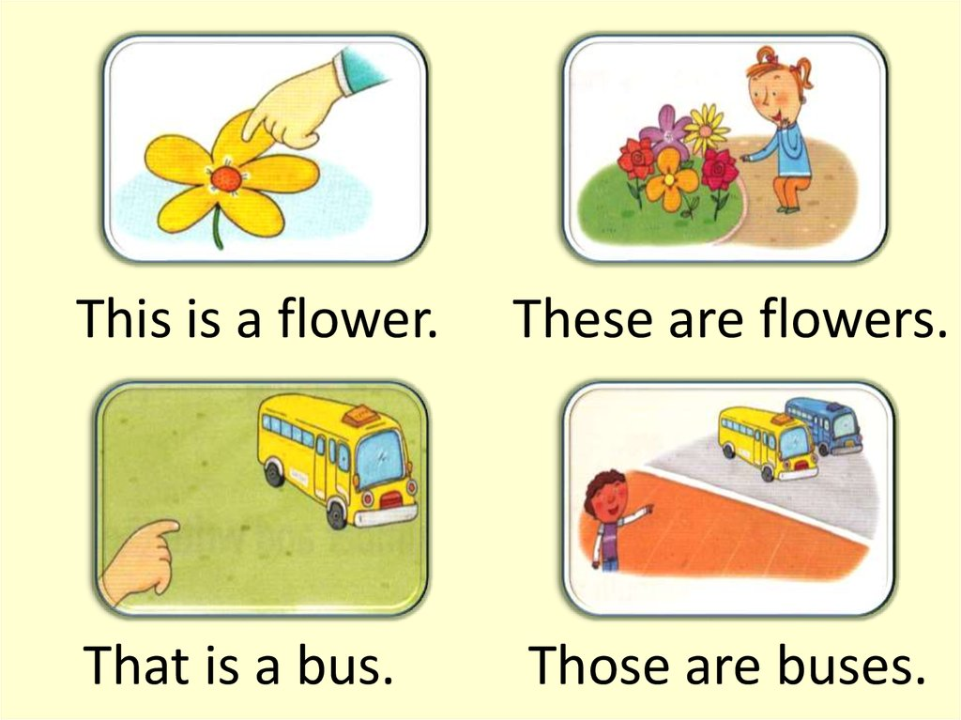
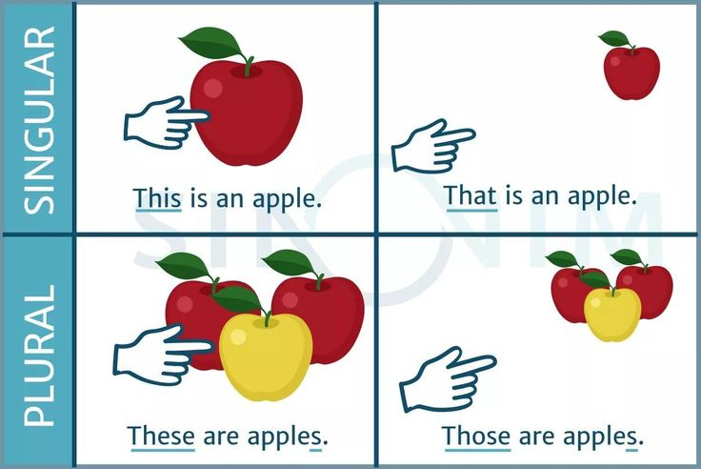
( Chúng ta dùng “this / that / these / those” để chỉ ra những thứ mà chúng ta đang nói đến)

This / that ( Đây / Kia ) : for singular nouns - dùng cho danh từ số ít
These / those ( Những cái này / Những cái kia ) : for plural nouns dùng cho danh từ số nhiều
This / these ( cái này/ những cái này) : for thing/ things close to the speaker - dùng chỉ vật/những vật ở gần người nói
That / those (Kia/ những cái kia ) : for thing/ things further away- dùng chỉ những vật ở xa người nói
B. How much is …? / How much are …?: Bao nhiêu …?
How much is this / that + singular noun?

Ex: How much is this T-shirt ?
How much is that dress?
How much are these / those + plural nouns ?

Ex: How much are these shoes ?
How much are those socks ?
- Object pronoun ( đại từ ở vị trí tân ngữ ): it / them
We use “it / them” after a verb or a preposition. ( Chúng ta dùng “it / them” sau 1 động từ hoặc 1 giới từ)
We use “it” for singular noun and “them” for plural noun.( Chúng ta dùng “it” cho danh từ số ít và “them” cho danh từ số nhiều.)
Ex: I like this dress. Do you like it, too ?
I like these shoes. Can I try them on?
Do you see my T-shirt? I am looking for it.
Do you see my shoes? I am looking for them.
II. Fill in the blanks with the correct form of the words.
1. ________ is a dress. (These)
2. _______ sweaters are pink. (This)
3. How much is ________ blue shirt ? (those)
4. How much are _________ red shoes ? (this)
5. ________ pants are cheap. (That)
6. I like _____ brown dress. (These)
7. My brother likes ________ green books. (this)
8. He doesn’t like _________red sweater. (those)
9. ________ store wants a sales assistant. (These)
10. He likes going to ________ mall (Those)
III. Choose the word or phrase (A, B, C or D) that best fits the space in each sentence.
1. I like this dress. Do you like __________, too ?
A. It B. they C. them D. its
2. I like these shoes. Can I try ___________ on?
A. It B. they C. them D. its
3. He likes those jeans. Can he try ___________ on?
A. them B. they C. It D. its
4. I like this T- shirt.Do you have _________ in white ?
A. they B. It C. them D. its
5. I like this sweater . Can I try __________on?
A. them B. they C. its D. It
UNIT 5 – AROUND TOWN
LESSON 1-3 (Pronunciation)
I. Find the word whose underlined part differs from the other three in pronunciation.
1. A. sweaters B. pants C. rooms D. jeans
2. A. clothes B. shoes C. dresses D. families
3. A. buys B. wears C. sales D. likes
4. A. sweater B. sneakers C. teacher D. beach
5. A. pants B. dollars C. assistants D. salad
II. Find the word that differs from the other three in the position of primary stress.
6. A. customer B. dessert C. restaurant D. sweater
7. A. around B. about C. between D. under
8. A. expensive B. different C. exciting D. delicious
9. A. window B. medium C. excuse D. sweater
10. A. shopping B. jacket C. really D. assistant
III. Choose the word (A, B, C or D) that best fits the space in the following passage.
Alice likes shopping. She often goes (11) ___________ with her mom on the weekend. She (12) _______ at the clothing store now. She wants some new clothes for the coming winter. There are many colors and sizes. She needs a sweater, a hat and pants (13) ________ blue because she likes blue (14) _________. She is choosing a shirt for her mom. The shirt is 20 dollars. She feels (15) ___________ when she goes out.
11. A. sports center B. restaurant C. to the mall D. apartment
12. A. am B. is C.are D. be
13. A. to B. on C. at D. in
14. A. color B. size C. style D. changing room
15. A. ugly B. unhappy C. happy D. sad
IV. Rewrite each of the following sentences in another way so that it means almost the same as the sentence printed before it.
16.Does she have the shoes in black?
Does she
17. There is a changing room over there.
The changing room
18. Does your store have a pink dress?
Is there ?
19. The sweater’s price is 45$.
The sweater
20. These shirts are small.
These are
KEY – UNIT 5 -LESSON 1
UNIT 5 – AROUND TOWN
LESSON 1-1 (New words)
I. New words
1. large (adj) /lɑːdʒ/ : to, lớn
2. extra large (adj) /ˈekstrə lɑːdʒ / : cực lớn
3. jeans (n) /dʒiːnz/ : quần jean
4. changing room (n) /’tʃeɪndʒɪŋ ruːm/ : phòng thay đồ
5. medium (adj) /ˈmiːdiəm/ : trung bình
6. sweater (n) /ˈswetə(r)/ : áo len
7. customer (n) /ˈkʌstəmər/ : khách hàng
8. Sales assistant (n) /seɪlz əˈsɪstənt/ / : trợ lí bán hàng
9. sizes (n) /saɪziz/ : kích cỡ, kích thước
10. clothes (n) /kləʊz/ : quần áo

II. Fill in the table with the words above:

Clothes | Sizes | Others
jeans  sweater | medium  large  extra large | changing room  customer  Sales assistant
III. Choose the word or phrase (A, B, C or D) that best fits the space in each sentence.
1. This T-shirt is very big. It’s an ______________size.
A. medium B. extra large C. small D. large
2. Do you have this dress in a ____________size. This medium one is too small.
A. small B. extra large C. delicious D. medium
3. Do you have these ____________ in dark blue? Can I try them on.
A. sweater B. T-shirt C. dress D. jeans
4. A ________________works in a store.
A. teacher B customer C. sales assistant D. students
5. A ________________wants a medium pink dress.
A. customer B. dress C. sweater D. jacket
6. This pink __________ is so nice.
A. sweater B. clothes C. T-shirts D. shirts
7. That green dress is too big. This one is too small. Do you have it in a __________ size?
A. big B. medium C. small D. extra large
8. Can I try this sweater on? – Yes, the ______________________is over there.
A. yard B. gym C. changing room D. balcony
9. How much is this _________ ?
A. T-shirts B. sweater C. shoes D. shirts
10. Jeans, sweater, dress and shirt are _____________.
A. sales assistant B. changing room C. customer D. clothes

UNIT 5 – AROUND TOWN
LESSON 1-2 (Grammar)
- Grammar :
- Demonstratives: this/ that / these / those
( đại từ chỉ định this / that / these / those )
We use “this / that / these / those” to show which things we are talking about
( Chúng ta dùng “this / that / these / those” để chỉ ra những thứ mà chúng ta đang nói đến)

This / that ( Đây / Kia ) : for singular nouns - dùng cho danh từ số ít
These / those ( Những cái này / Những cái kia ) : for plural nouns dùng cho danh từ số nhiều
This / these ( cái này/ những cái này) : for thing/ things close to the speaker - dùng chỉ vật/những vật ở gần người nói
That / those (Kia/ những cái kia ) : for thing/ things further away- dùng chỉ những vật ở xa người nói
B. How much is …? / How much are …?: Bao nhiêu …?
How much is this / that + singular noun?

Ex: How much is this T-shirt ?
How much is that dress?
How much are these / those + plural nouns ?

Ex: How much are these shoes ?
How much are those socks ?
- Object pronoun ( đại từ ở vị trí tân ngữ ): it / them
We use “it / them” after a verb or a preposition. ( Chúng ta dùng “it / them” sau 1 động từ hoặc 1 giới từ)
We use “it” for singular noun and “them” for plural noun.( Chúng ta dùng “it” cho danh từ số ít và “them” cho danh từ số nhiều.)
Ex: I like this dress. Do you like it, too ?
I like these shoes. Can I try them on?
Do you see my T-shirt? I am looking for it.
Do you see my shoes? I am looking for them.
II. Fill in the blanks with the correct form of the words.
1. _this______ is a dress. (These)
2. _these______ sweaters are pink. (This)
3. How much is ___that_____ blue shirt ? (those)
4. How much are ____these_____ red shoes ? (this)
5. ___those_____ pants are cheap. (That)
6. I like __this___ brown dress. (These)
7. My brother likes ____these____ green books. (this)
8. He doesn’t like _____that____red sweater. (those)
9. ____this____ store wants a sales assistant. (These)
10. He likes going to __that______ mall (Those)
III. Choose the word or phrase (A, B, C or D) that best fits the space in each sentence.
1. I like this dress. Do you like __________, too ?
A. It B. they C. them D. its
2. I like these shoes. Can I try ___________ on?
A. It B. they C. them D. its
3. He likes those jeans. Can he try ___________ on?
A. them B. they C. It D. its
4. I like this T- shirt.Do you have _________ in white ?
A. they B. It C. them D. its
5. I like this sweater . Can I try __________on?
A. them B. they C. its D. It
UNIT 5 – AROUND TOWN
LESSON 1-3 (Pronunciation)
I. Find the word whose underlined part differs from the other three in pronunciation.
1. A. sweaters B. pants C. rooms D. jeans
2. A. clothes B. shoes C. dresses D. families
3. A. buys B. wears C. sales D. likes
4. A. sweater B. sneakers C. teacher D. beach
5. A. pants B. dollars C. assistants D. salad
II. Find the word that differs from the other three in the position of primary stress.
6. A. customer B. dessert C. restaurant D. sweater
7. A. around B. about C. between D. under
8. A. expensive B. different C. exciting D. delicious
9. A. window B. medium C. excuse D. sweater
10. A. shopping B. jacket C. really D. assistant
III. Choose the word (A, B, C or D) that best fits the space in the following passage.
Alice likes shopping. She often goes (11) ___________ with her mom on the weekend. She (12) _______ at the clothing store now. She wants some new clothes for the coming winter. There are many colors and sizes. She needs a sweater, a hat and pants (13) ________ blue because she likes blue (14) _________. She is choosing a shirt for her mom. The shirt is 20 dollars. She feels (15) ___________ when she goes out.
11. A. sports center B. restaurant C. to the mall D. apartment
12. A. am B. is C.are D. be
13. A. to B. on C. at D. in
14. A. color B. size C. style D. changing room
15. A. ugly B. unhappy C. happy D. sad
IV. Rewrite each of the following sentences in another way so that it means almost the same as the sentence printed before it.
16.Does she have the shoes in black?
Does she have black shoes?
17. There is a changing room over there.
The changing room is over there
18. Does your store have a pink dress?
Is there a pink dress in your store? ?
19. The sweater’s price is 45$.
The sweater is 45$
20. These shirts are small.
These are small shirts.

