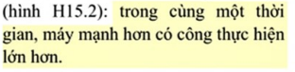
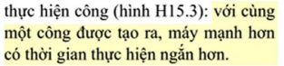

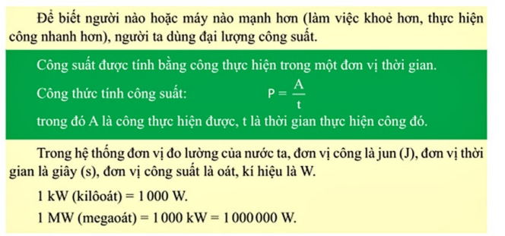
P = $\frac{A}{t}$

