ỦY BAN NHÂN DÂN QUẬN PHÚ NHUẬN
TRƯỜNG THCS ĐỘC LẬP

HƯỚNG DẪN TỰ HỌC
MÔN : ANH 8
NĂM HỌC : 2021-2022
NỘI DUNG : UNIT 1 : MY FRIENDS
Lesson 2: SPEAK AND LISTEN
I-SPEAK
1-Practice the dialogue
Hoa : This person is short and thin . She has long blond hair.
Lan : Is this Mary?
Hoa: Yes.
2- Now take turn to make similar dialogue. Use the adjectives in the table.
VOCABULARY
- Slim (adj) : mảnh khảnh
- Curly (adj) : xoăn
- Blond (adj) = fair (adj) : vàng
- Bold (adj) : hói
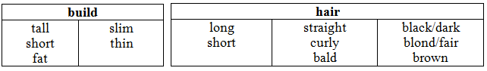
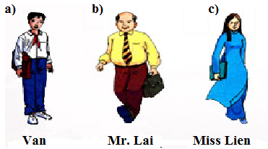
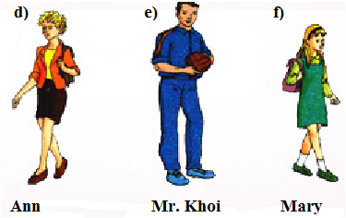
EX : A: This person is tall and thin. He has short black hair.
B: Is this Van?
A: Yes.
II- Listen
Listen and complete the conversations. Use the expressions in the box.
How do you do
Nice to meet you
It’s a pleasure to meet you
I’d like you to meet
Come and meet
a)
Hoa: Hello, Nam.
Nam: Morning, Hoa.
Hoa: Nam, (1) _________________________________ my cousin, Thu.
Nam: (2) ___________________________________, Thu.
Thu : Nice to meet you too, Nam.
b)
Khai: Miss Lien, (3) ___________________________ my mother.
Miss Lien: (4) _______________________________, Mrs. Vi.
Mrs. Vi: The pleasure is all mine, Miss Lien.
Miss Lien: Oh, there is the principal. Please excuse me, Mrs. Vi, but I must talk to him.
Mrs. Vi: Certainly.
c)
Ba: Bao, (5) ________________________my grandmother.
Bao: Hello, ma'am.
Grandmother: Hello, young man.
Ba: Bao is my classmate, grandmother.
Grandmother: What was that?
Ba: Classmate! Bao is my classmate.
Grandmother: I see.
d)
Mr. Lam: Isn't that Lan's father, my dear?
Mrs. Linh: I'm not sure. Go and ask him.
Mr. Lam: Excuse me. Are you Mr. Thanh?
Mr. Thanh: Yes, I am.
Mr. Lam: I'm Lam, Nga's father.
Mr. Thanh: (6) ____________________________?
Students practice the dialogue
III- Homework
Practice the dialogue again .
Learn by heart the new words.
Prepare Read

