THEME 5: Around Town - Grade 6

Week 14 - P: 38, 39, 40

Date: 06/12 – 11/12

LESSON 1

- Vocabulary:
1. large (adj) lớn, rộng
2. extra-large (adj) rất lớn
3. jeans (n) quần jean
4. changing room (n) phòng thay đồ
5. medium (adj) cỡ trung bình
6. sweater (n) áo len dài tay
7. customer (n) khách hàng
8. sales assistant (n) nhân viên bán hàng

- Grammar:
Demonstratives & Object Pronouns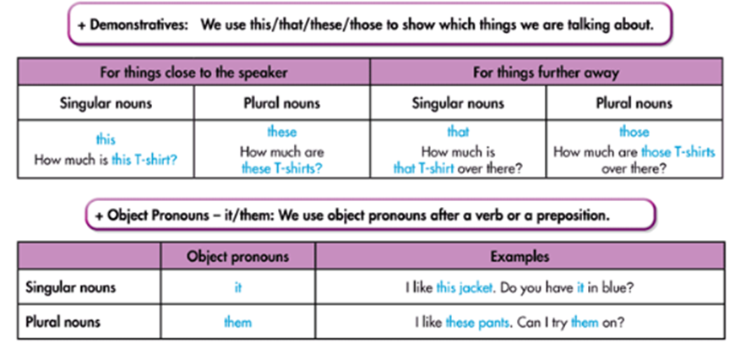

Exercises
I. New Words:
a. Fill in the table.
clothes | sizes | others
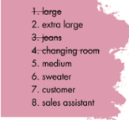

II. Listening. 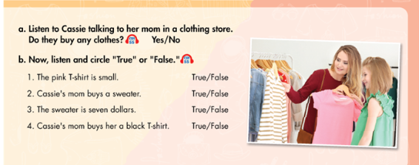
True / False
True / False
True / False
True / False
Yes / No

Listen and fill in the blanks

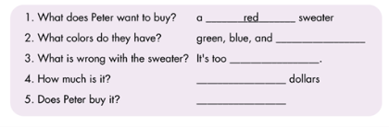

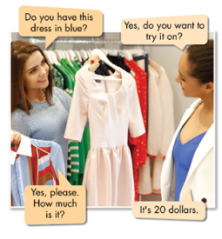
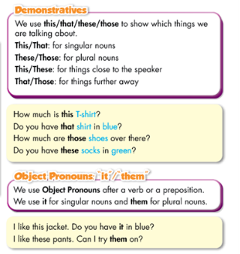
III. Grammar
a. Listen and repeat

b. Read the sentences . Circle the correct words.
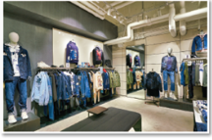
1. How much are that / those shoes?
2. Excuse me, how much is this / these shirt?
3. I like that skirt. Do you have it / them in black?
4. Do you have this / these shoes in black?
5. I like these shorts. Can I try it / them on?
6. What size are those / these pants over there?
7. How much is that / this shirt by the window?

c. Complete the dialogue with this, those, it, or them.
