THEME 5: Around Town - Grade 6

Week 14 - P: 38, 39, 40

Date: 06/12 – 11/12

LESSON 1

Exercises
New words
a. Use the words in the box to label the pictures.
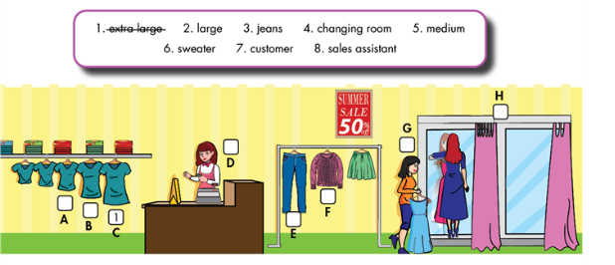

b. Fill in the blanks using the words in Task a.
1. This T-shirt is very big. It’s an extra large size.
2. Do you have this dress in a …………..………..size? This medium one is too small.
3. A: Do you have these ………………….in dark blue? Can I try them on?
4. B: Sure. The ……………………….is over there.
5. A ………………………….works in a store.
6. The ………………….wants a medium blue dress.
7.A: This pink …………………….is so nice. How much is it?
B. It’s ten dollars.
8. That blue jacket was too big. This one is too small.
Do you have it in a ………………………..size?

Grammar
a. Circle the correct answers.
1. A: Do you have this / these shoes in black?
B: Yes, do you want to try it / them on?
A: Yes, please. How much is / are they?
B: It’s / They’re thirty-five dollars.
2. A: Do you have this / these dress in red?
B: Yes, do you want to try it / them on?
A: Yes, please. How much is / are it?
B: It’s / They’re forty-three dollars.

b. Circle the mistakes. Use this/these, is/are to correct the sentences.
1. These T-shirt is very big. Do you have a smaller one? This
2. A: Do you have this jeans in dark blue? Can I try …….
Them on?
B: Of course. The changing rooms is over there. ……..
3. A: This pink skirt are so nice. How much is it? ……..
B: It are ten dollars.
4. These blue jacket is too big. Do you have it in a medium size? ……..
5. A: How much are this jacket? ……….
B: It are twenty-five dollars. ……….

Writing
Complete the conversation with the given phrases or your own ideas.
