THEME 5: Around Town - Grade 6
PHIẾU HỌC TẬP

Week 16 - P: 31,32
Date: 20/12 – 25/12
LESSON 3
- NEW WORDS.
- Read the clues and do the crossword puzzle

- Cook food over fire.  - Food from the sea like fish and sauce.  - Plants used to make food taste nicer.  - Meat from a pig.  - Cook food in oil.  - Meat from a sheep.  - People eat this brown or orange liquid with rice or noodles.  - Meat from a cow.  - A type of long and thin shaped food. | 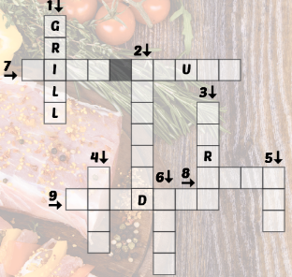

- Fill in the blanks using the words in task A.
- Steak-fries is a kind of meat dish. It’s _______________ and french fries.
- We________ the sausages on the barbecue.
- You can get food __________ in this restaurant. They serve really good crab and shrimp.
- I don’t like to eat grilled beef or pork, so I had grilled __________.
- _____________ the steak in a little butter. It’s so good.
- Pad see ew is a popular dish from Thailand with fried ___________.
- I really like fried ___________. Bacon is my favorite type.
- I like to put chili in my _______ and pour it on my noodles.
- My mom uses_______ from the garden to make our food taste amazing.
- READING.
- Read the article and write the names of the dishes next to the pictures:
FOOD IN VIET NAM

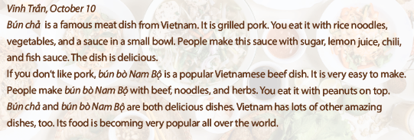
- 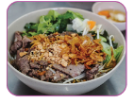_____________________________.

- 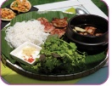 ______________________________.

- Read the article again and write the answers.
- What meat is in bún chả?
- The meat is grilled pork.
- What do you eat bún chả with?
- ___________________________________________________________________________________.
- What do they make the sauce in bún chả with?
- ___________________________________________________________________________________.
- What do people make bún bò Nam Bộ with?
- ______________________________________________________________________________________.
- What do you put on top of bún bò Nam Bộ ?
- _________________________________________________________________________________________.

C. WORD FORMATION
Write the correct forms of the words in the brackets.
1. My favorite dish is _______________ rice with eggs. It’s very delicious. (FRY)
2. Paul works as a sales _______________ in a department store. (ASSISTANCE)
3. Excuse me, where is the _______________ room? (CHANGE)
4. Vietnam has a lot of _______________ dishes, such as Phở or Bún chả. (AMAZE)
5. Cơm tấm is a rice dish with _______________ pork. (GRILL)
6. These snacks are full of sugar and salt. They are not _______________. (HEALTH)

