Unit 11: Traveling around Viet Nam
Section : Read
- Vocabulary:
- seaside (adj): thuộc về bờ biển
- oceanic institute : Viện hải dương học
- giant Buddha : tượng Phật khổng lồ
- offshore island : hòn đảo xa bờ
- except (v): ngoại trừ
- eternal ( adj): vĩnh cửu
- waterfall (n) : thác nước
- railway (n): đường sắt
- tribal village : bản làng
- slope (n): sườn núi
- jungle stream: dòng suối trong rừng rậm
- guest (n): nhà trọ
- recognize (v): công nhận
- heritage (n) : di sản
- magnificient (adj): lộng lẫy
- limstone (n): đá vôi
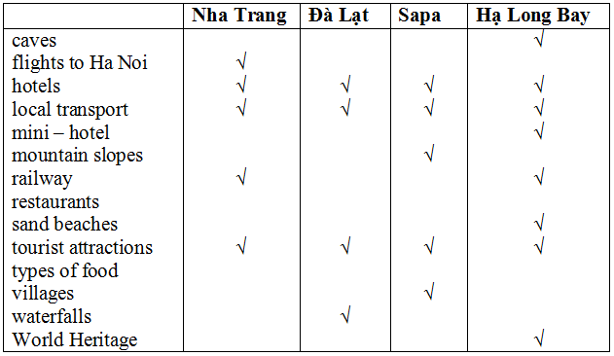
1. Check (√) the topics mentioned in the brochures about the resorts.

2.Answer. Where should these people go?
These people want to spend their coming summer vacation in Viet Nam. Help them find a suitable place. Check (√) the boxes.
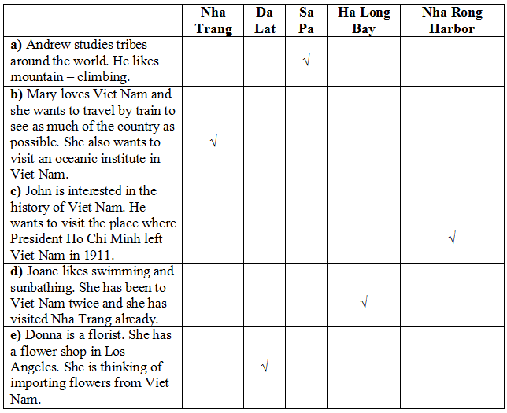

Gợi ý:
a) Andrew should go to Sa Pa because there are tribal villages there.
b) Mary should go to Nha Trang because there is an Oceanic Institute there.
c) John should go to Nha Rong Harbour because it's the place where President Ho Chi Minh left Viet Nam in 1911.
d) Joanne should go to Ha Long Bay because there are beautiful sand beaches there.
e) Donna should go to Da Lat because there are beautiful kinds of flowers there.

