Unit 10: Recycling
Section :Language focus

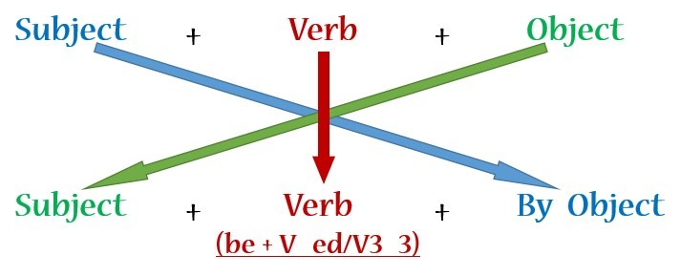
- Read the guide on how to recycle glass. Look at the instructions, rewrite them in the passive form and put the pictures in the correct order:

a) Break the glass into small pieces.
=> The glass is broken into small pieces.
b) Then wash the glass with a detergent liquid.
=> Then the glass is washed with a detergent liquid.
c) Dry the glass pieces completely.
=> The glass pieces are completely dried.
d) Mix them with certain specific chemicals.
=> The glass pieces are mixed with certain specific chemicals.
e) Melt the mixture until it becomes a liquid.
=> The mixture is melted until it becomes a liquid.
f) Use a long pipe, dip it into the liquid, then blow the liquid into intended shapes.
=> A long pipe is used to dip the mixture into the liquid and then the liquid is blown into intended shapes.
=> A long pipe is used. The mixture is dipped into the liquid. Then the liquid is blown into intended shapes.
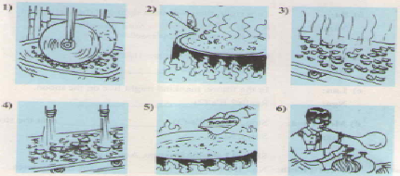
Trật tự tranh:
1 –> 4 –> 3 –> 5 –> 2 –> 6
2. A famous inventor, Dr. Kim is going to build a time machine. One of this assistants, Hai, is asking him questions about the invention. Complete the dialogue. Use the correct form of the verbs in brakets.
Hai: When (0) will the project be started, Doctor?
Dr. Kim: Very soon.
Hai: Many people want to see the time machine.
Dr. Kim: Yes. It (1) will be shown to the public when it is finished.
Hai: (2) Will it be built by the end of the year, Doctor?
Dr. Kim: I'm afraid not, but it (3) will be finished before Tet.
Hai: (4) Will it be made by you?
Dr. Kim: No, I need you to build it. When can you start?
Hai: Let's begin tomorrow.
3. Complete the dialogues. Use the words in the box.
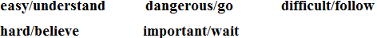
a) Ba: Turn right, then left, and the left again.
Nam: It's (0) difficult to follow your directions. Can you start again, please?
b) Mr. Dao: Can you do the exercise, Hoa?
Hoa: Yes, Mr. Dao. It's (1) easy to understand.
c) Lan: In the future, mankind might live on the moon.
Nga: Really? It's (2) hard to believe.
d) Mrs. Thoa: Stop, Tuan! It's (3) dangerous to go near the stove.
Tuan: Sorry, Mom.
e) Hoa: Should I stir the mixture, aunt Thanh?
Aunt Thanh: No. It's (4) important to wait for five minutes.
4. Complete the letter. Use the correct forms of the verb be and the adjectives in the box.
happy delighted certain relieved sure afraid
Dear Nam,
Your grandfather and I (0) are delighted that you passed your English exam.
Congratulations!
Aunt Mai (1) was happy that you remembered her birthday last week. She told me you gave her a beautiful scarf.
I (2) am relieved that your mother is feeling better. Please give her my love.
We're looking forward to seeing you in June. However, grandfather (3) is afraid that the day is wrong. (4) Are you sure that you're arriving on Saturday 20th? I (5) am certain that there are no trains from Ha Noi on Saturday.
Write soon and confirm your arrival date and time.
Love,

