VOCABULARY ENGLISH 6 UNIT 13: ACTIVITIES AND SEASONS
Các hoạt động và mùa trong năm

 | Word | Transcript | Class | Meaning | Example
1 | activity | /ækˈtɪvəti/ | n. | hoạt động, sinh hoạt | Do you like sporting activities?
2 | autumn/fall | /'ɔ:təm/ | n. | mùa thu | It's very cool in the autumn.
3 | basketball | /'bɑ:skitbɔ:l/ | n. | bóng rổ | He likes playing basketball.
4 | cold | /kəʊld/ | adj. | lạnh, rét | Would you like a glass of cold water?
5 | cool | /ku:l/ | adj. | mát, mát mẻ | I like cool weather.
6 | dry | /drai/ | adj. | khô | It's cold and dry.
7 | dry season | /drai 'si:zn/ | n. | mùa khô | It seldom rains in the dry season.
8 | fall | /fɔ:l/ | n. | mùa thu | Do you like fall?
9 | go for a walk | /ɡəʊ fə(r) ə wɔ:k/ | v. | đi dạo | I want to go for a walk.
10 | go sailing | /ɡəʊ seiliɳ/ | v. | đi chơi thuyền buồm | Do you want to go sailing?
11 | hot | /hɔt/ | adj. | nóng | I feel very hot.
12 | humid | /'hju:mid/ | adj. | ẩm, ẩm ướt | I hate humid weather.
13 | rain | /rein/ | v. n. | mưa | There are heavy rains in Hanoi now.
14 | rainy | /ˈreɪni/ | adj. | mưa, có mưa, mưa nhiều | Today is a rainy day.
15 | rainy season | /'reini 'si:zn/ | n. | mùa mưa | It rains every day in the rainy season.
16 | season | /'si:zn/ | n. | mùa | There are four seasons in my country.
17 | snow | /snəʊ/ | v. n. | tuyết (n), tuyết rơi (v) | Children are playing in the snow.
18 | snowy | /ˈsnəʊi/ | adj. | có tuyết rơi, nhiều tuyết | It was snowy yesterday.
19 | spring | /spriɳ/ | n. | mùa xuân | It's warm in the spring.
20 | summer | /ˈsʌmər/ | n. | mùa hè | It's very hot in the summer.
21 | sunny | / 'sʌni/ | adj. | nắng, có nắng | It's very hot in the sunny season.
22 | weather | /ˈweðər/ | n. | thời tiết | What is the weather like today?
23 | winter | /wintər/ | n. | mùa đông | I hate the winter.
STRUCTURE ENGLISH 6 UNIT 13

1. Talking about the weather (Nói về thời tiết):
The weather / It + is + ADJ (tính từ).

Ex: The weather is warm in the winter.

2. Asking and answering about the weather (Hỏi và trả lời về thời tiết):

Cách 1:
What’s the weather like (in + mùa / nơi chốn)?

Cách 2:
How’s the weather (in + mùa / nơi chốn)?

Ex 1: What is the weather like in the spring? / in HCM city?
- It is cool in the spring. / It is very hot in HCM city.
Ex 2: How is the weather in the summer?
- It’s hot in the summer.
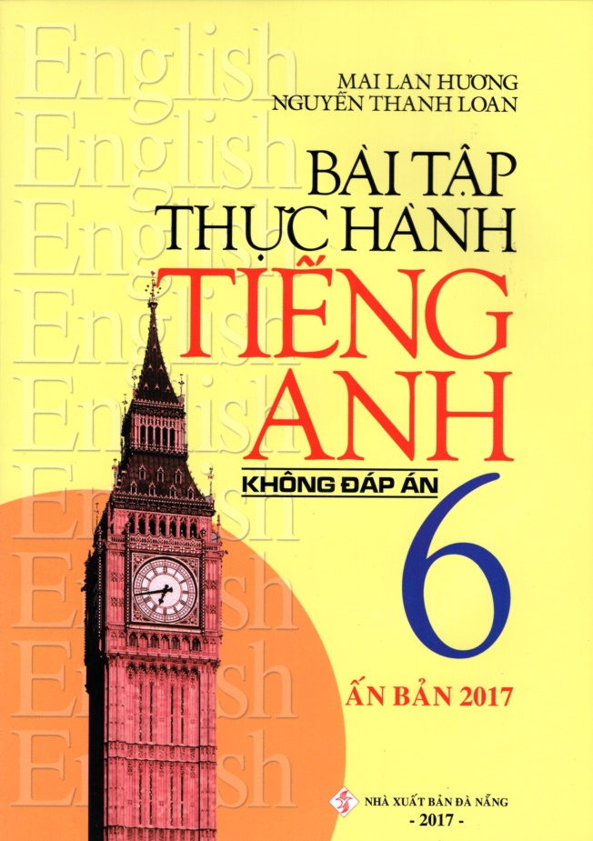
- Chúc các em giữ gìn tốt sức khỏe trong mùa dịch.
- Các em học thuộc từ, đọc kĩ cấu trúc …sau đó mở sách unit 13 và 14 để áp dụng vào bài nhé. Coi kĩ từng phần trong sách giáo khoa nha. LÀM BÀI TẬP THÊM TRONG QUYỂN BÀI TẬP THỰC HÀNH CỦA TÁC GIẢ MAI LAN HƯƠNG NỮA NHÉ.
- Đề cương thầy cô có gửi trên web này luôn. Các em ôn tập nhé.
- Đừng phụ lòng ba mẹ thầy cô nha.
Best wishes for you.
Love you all!

EXERCISE 1- UNIT 13: ACTIVITIES AND THE SEASONS

I/ Chọn từ đúng trong ngoặc để hoàn thành các câu:

1/ It’s hot in the (summer/ fall/ winter)

2/ What (warm/ weather/ spring) do you like?

- I like cold weather.

3/ When it’s cool, he (goes/ play/ does) jogging.

4/ What (does/ do/ is) Nam do when it’s hot?

5/ I like hot weather (or/ but/ so) she likes cold weather.

6/ What is the weather (want/ love/ like)in the summer?

7/ It’s (hot/ cold/ warm) in the spring.

8/ There are four (weather/ seasons/ sports) in a year.

II/ Hãy viết câu theo mẫu dưới đây:

Ex: Nam/hot// go swimming

What does Nam do when it’s hot?

He goes swimming.

1/ she/cold// watch TV

…………………………………………………………………………………………

…………………………………………………………………………………………

2/ Lan/warm// go for a walk

…………………………………………………………………………………………

…………………………………………………………………………………………

3/ your father/cool/ride his bike

…………………………………………………………………………………………

…………………………………………………………………………………………

4/ he/hot/go sailing

…………………………………………………………………………………………

…………………………………………………………………………………………

5/ your brother/rainy// play chess

…………………………………………………………………………………………

…………………………………………………………………………………………

III/ Hoàn thành các câu sau với các từ cho sẵn trong khung:

jogging games summer camping fall tennis aerobics zoo

1/ She usually plays ………. in the fall.

2/ My mother always goes.…. in the summer.

3/ Nam and Ba sometimes go to the ……….

4/ They never go ………. because they don’t have a tent.

5/ My brother likes playing video ……….

6/ Hoa does ………. and plays tennis.

7/ What do you do in the ……….?

8/ It’s cool in the ……….

IV/ Điền vào chỗ trống với MỘT giới từ thích hợp:

1/ It’s warm ………. the spring.

2/ What’s the weather like ………. Ha Noi?

3/ My sister is learning English ………. the moment.

4/ Hung often plays soccer ………. his friends ………. Saturday.

5/ What do you do ………. your free time?

6/ I’d like two kilos ………. rice, please.

7/ Do you like listening ………. music ………. night?

8/ How many days are there ……. a week?

V/ Hãy chọn đáp án A, B hoặc C để hoàn thành các chỗ trống:

There are …(1)……. seasons in a year. They are spring, summer, fall and

…(2)…….. In the summer, the days are …(3)……. and the nights are …(4)……. The

sun shines in the sky. It is …(5)……. and the sky is …(6)…….

In the spring, there are …(7)……. In the spring and the fall, it is …(8)……. very

cold, but it sometimes rains. When it rains, we take …(9)……. In the fall, there are

many clouds in the …(10)….
1/ | A. two | B. three | C. four
2/ | A. autumn | B. winter | C. cold
3/ | A. short | B. long | C. warm
4/ | A. short | B. long | C. cold
5/ | A. hot | B. warm | C. cool
6/ | A. black | B. white | C. blue
7/ | A. flowers | B. sports | C. drinks
8/ | A. no | B. not | C. none
9/ | A. coat | B. hat | C. umbrellas
10/ | A. cool | B. day | C. sky

EXERCISE 2- UNIT 13: ACTIVITIES AND THE SEASONS
I/ Điền động từ chia ở dạng thích hợp vào chỗ trống:

1/ My sister usually…... badminton in the fall.

2/ Do you ……. sailing in your free time?

3/ When it’s cool, Nam ……. fishing.

4/ Mai likes ……. swimming every morning.

5/ We usually ……. sports in the afternoon.

6/ My mother sometimes ……. to classical music.

7/ Can he ……. basketball?

8/ Ba is ……. soccer with his friends.

II/ Đặt câu hỏi cho các từ gạch chân:

1/ …………………………………………..

I play basketball in the spring.

2/ ………………………………………….

It’s cool in the fall.

3/ ………………………………………….

He goes swimming when it’s hot.

4/ ………………………………………….

He never goes camping in the winter.

5/ ………………………………………….

There are four seasons in a year.

6/ ………………………………………….

My sister plays badminton when it’s hot.

7/ ………………………………………….

She likes warm weather.

III/ Mỗi câu có một lỗi sai. Tìm và sửa lại:

1/ When it warm, we go fishing.

2/ He often goes volleyball in the summer.

3/ What do you in the fall?

4/ It’s very cold so they can’t go swim.

5/ What does the weather like in the winter?

6/ She like cool weather.

7/ When it’s warm, we play jogging.

8/ We play often tennis in the summer.

IV/ Hoàn thành đoạn văn với các từ cho sẵn trong khung:

rain | spring | seasondays | winter
 | swimming | summer | flowers

We have different weather according to different seasons. In the (1)…….., it is

cold and dark. In the (2)…….. it isn’t so cold. The (3)…….. get longer and longer. The

sun shines, it gets warmer and warmer. Plants and (4)…….. open, but we still have

much (5)…….. Then (6)…….. comes. Summer is the best (7)…….. of all. We go

(8)…….. and go to the beach or the mountains.

V/ Hãy điền một từ thích hợp để hoàn chỗ trống:

My sister is (1)…….. grade 6. When it (2)…….. hot, she often (3)……..

swimming. When it (4) cold, she (5)…….. volleyball (6)…….. her friends. She

sometimes (7)…….. jogging (8)…….. the fall and the spring.

EXERCISE 3 - UNIT 13: ACTIVITIES AND THE SEASONS

I. Chọn từ khác với những từ còn lại:
1.house, school, classroom, weather. |  |  |  |  | ………………..
2. hot,cold, cool, chair. |  |  |  |  | ………………….
3. badminton, volleyball, teacher, soccer. |  |  |  |  | ………………….
4. flower, from,at,in |  |  |  |  | ……………………..
5. today, tall,big,heavy |  |  |  |  | ……………………
6. summer, fall, winter, fly |  |  |  |  | ……………………
7. farmer,driver, activity, nurse |  |  |  |  | ………………….
8. season, yellow, brown, white |  |  |  |  | …………………..
9. often, Sunday, Tuesday, Saturday |  |  |  |  | ……………………..
10. fat, eye,leg, hand |  |  |  |  | …………………….
II. Chọn từ đúng trong ngoặc:

1.Nam (like/likes)…………….coffee but he (don’t/doesn’t) ………………like milk.

- The book is …………(in/of/under) the chair.Please put it on the table.

- I don’t …………..(am/can/need) blue hats.

- How many ……………(pens /pen) do you need?

- Peter is doing (some/a/an) …………….exercise.

- He is ……………(teach/teacher /teaching) English.

- The children are playing ……………(in/on/under) the garden.

- This is …………..(my/I/mine) new friend. Look at ……….(he/his) new hair.

- How ………….(much/many) is this eraser?

- How ……………(often/many/much) does she go to the cinema? – Twice a week.

III. Sửa lỗi trong các câu sau:

1.He doesn’t want some eggs. .........................................................................................

- It usually is hot in the summer. ...................................................................................

- What do often you do when it is cold? ........................................................................

- What the weather like in the fall? ................................................................................

- My sister never go swimming. ...................................................................................

IV. Hãy sắp xếp các từ sau thành câu hoàn chỉnh:

1.a/ house/ white/ doesn’t/ brother/ my/ want

..........................................................................................................................................

- need/ short/ I/ pencil/ a.

..........................................................................................................................................

- a/ sister/ does/ want/ your/ blue/ ruler?

..........................................................................................................................................

- do/ Nam/ and/ Mai/ what/ want/?

..........................................................................................................................................

- half past seven/ he/ has/ usually/ breakfast/at

..........................................................................................................................................

- after/ does/ ice-cream/ eat/ he/ cakes/ or/ dinner/?

..........................................................................................................................................

- do/ it/ cold/ is/ what/ you/ do/ often/ when/?

..........................................................................................................................................

- sometimes/ mountains/ walk/ I/ in/ the.

..........................................................................................................................................

- the/ it/ in/ fall/ is/ cool/ often.

..........................................................................................................................................

- often/ exercises/ morning/ how/ does/ she/ do/ winter/ in/ the/?

..........................................................................................................................................

V. Đổi các câu sau sang thể phủ định và nghi vấn:

1.It is often cold in the summer.

.....................................................................................................................................

.................................................................................................................................... ?

- They sometimes walk in the mountains.

.....................................................................................................................................

.................................................................................................................................... ?

- Mai usually goes to the movies on Sundays.

.....................................................................................................................................

.................................................................................................................................... ?

- Mrs Lan likes some apples.

.....................................................................................................................................

.................................................................................................................................... ?

- You can camp here.

.....................................................................................................................................

.................................................................................................................................... ?

- He always has some eggs for breakfast.

.....................................................................................................................................

.................................................................................................................................... ?

VI. Điền một từ thích hợp vào mỗi chỗ trống,và trả lời các câu hỏi bên dưới:

There are four …………..in the year. They ……………spring, summer, fall and …………….In the spring, the weather is usually warm. Sometimes it is cold ………….not very cold. There …………..many flowers in the spring.In the summer, the day is long and the night is short. People often ………………swimming in this season. The fall is the season of fruits. In the winter, it’s usually very …………….. The day is short and the …………….is long.

*Answer the questions:

1.How many seasons are there in a year? ...................................................................

- What are they? ........................................................................................................

- Is it usually warm in the spring? .............................................................................

- What are there in the spring? ..................................................................................

- Is the day long or short in the summer? .................................................................

- Is the day long or short in the winter? ....................................................................

- What’s the weather like in the winter? ...................................................................

- What do people often do in the summer? ...............................................................
- Is the fall the season of fruits? ...............................................................................

- Is the night short in the winter? ............................................................................

---THE END---

