VOCABULARY ENGLISH 6 UNIT 14: MAKING PLANS
Lập kế hoạch
 | Word | Transcript | Class | Meaning | Example
1 | plan | /plæn/ | n | kế hoạch, dự án | Do you have any plans for this summer?
2 | plan | /plæn/ | v | lập kế hoạch, dự tính | I have to plan for a new project.
3 | vacation | /və'keiʃn/ | n | kỳ nghỉ | What are you going to do for vacation?
4 | holiday | /'hɔlədi/ | n | kỳ nghỉ, ngày lễ | I often visit my grandparents on summer holiday.
5 | go on holiday | /gou ɔn 'hɔlədi/ | v | đi nghỉ | Where will you go on holiday?
6 | summer vacation | / 'sʌmə və'keiʃn/ | n | kỳ nghỉ hè | We often enjoy our summer vacation in the countryside.
7 | destination | /,desti'neiʃn/ | n | điểm đến, nơi đến | The next destination is Ha Long Bay.
8 | citadel | /'sitədl/ | n | thành quách, thành trì | This is a very ancient citadel.
9 | Bay | /bei/ | n | vịnh | Ha Long Bay is very beautiful.
10 | beach | /bi:tʃ/ | n | bãi biển | We are going to Sam Son beach.
11 | pagoda | /pə'goudə/ | n | chùa | My grandmother usually goes to the pagoda.
12 | match | /mætʃ/ | n | trận đấu | This is a very important football match.  soccer
13 | camera | /'kæmərə/ | n | máy ảnh, máy quay phim | I bought a new camera yesterday.
14 | group | /gru:p/ | n | nhóm | The class is divided into two groups.
15 | suggestion | /sə'ʤestʃn/ | n | lời đề nghị, sự gợi ý | Thank you so much for your suggestion.
16 | idea | /ai'diə/ | n | ý,ý tưởng | That's a good idea.
17 | note | /nout/ | n | lời ghi chép, lời ghi chú | You need to take note.
18 | visit | /'vizit/ | v | thăm, viếng | We are going to visit Uncle Ho's Mausoleum.
19 | prepare | /pri'peə/ | v | chuẩn bị | My mother always prepares very carefully for vacation.
20 | bring | /briɳ/ | v | mang | You should bring the umbrella in case it rains.
21 | take a photo | /teikə 'foutou / | v | chụp ảnh | Do you want to take a photo?
22 | stay | /stei/ | v | ở lại | We will stay at the hotel.
23 | then | /ðen/ | adv | sau đó, kế đó | She has dinner, then she does her homework.
24 | finally | /'fainəli/ | adv | cuối cùng, sau cùng | Finally we arrived at home.
25 | Why | / wai / | ( adv) | Tại sao | Why are you late?
26 | Minibus | / minib^s/ | (n) | Xe buýt nhỏ | My father travels to work by minibus
27 | tonight | /təˈnaɪt/ | (adv) | tối nay | Tonight, I’m going to do my homework
28 | tomorrow | /təˈmɔːr.oʊ/ | (adv) | Ngày mai | Tomorrow, I’m going to watch a soccer match.

STRUCTURE ENGLISH 6 UNIT 14: MAKING PLANS

1. The near future tense (Thì tương lai gần): be going to
+ S + am/is/are + going to + Vo.
- S + am/is/are + not + going to + Vo.
? Is/Are + S + going to + Vo?

- “Be going to”: (Dự định sẽ): Được dùng để diễn tả một hành động sắp xảy ra trong tương lai gần hay là 1 kế hoạch đã được sắp xếp trước, 1 dự định chắc chắn.

- Từ nhận biết: today (hôm nay), tonight (tối nay), on Saturday (vào thứ bảy), tomorrow (ngày mai), on the weekend = at weekend (vào cuối tuần),
next week/month/year.., (tuần / tháng / năm tới), this summer/month/year..,
(mùa hè / tháng / năm này)..,

Ex 1: My mother is going to visit Uncle Hai tomorrow.
(Mẹ tôi dự định sẽ đi thăm bác Hải ngày mai.)

Ex 2: We are going to see a movie at Sao Mai theater tonight.
(Chúng tôi sẽ xem phim tại rạp Sao Mai tối nay.)

* Note (chú ý): Chúng ta thường dùng thì hiện tại tiếp diễn với động từ go và come để diễn đạt dự định trong tương lai.

Ex 1: I am going to the movies tonight.
(Không dùng: I am going to go to the movies tonight.
(Tối nay tôi sẽ đi xem phim.)

Ex 2: My aunt is coming to stay with me this weekend.
(Cuối tuần này dì tôi sẽ đến ở với tôi.)
2. Making suggestions (Đề nghị, gợi ý ai làm gì):
Let’s + Vo….
What about + Ving / N…?
Why don’t we + Vo…?

Ex: Let’s go swimming. Chúng ta hãy đi bơi.
What about going to Dalat? Đi Đà Lạt nhé?
Why don’t we go swimming? Sao chúng ta không đi bơi?

3. How to use “too”(Cách sử dụng “too”):

- “Too” (quá): là một trạng từ chỉ mức độ cao hơn, nhiều hơn mức độ cho phép.

Ex 1: It is too cold. Trời thì quá lạnh.
Ex 2: You are too late. Bạn tới quá trễ.
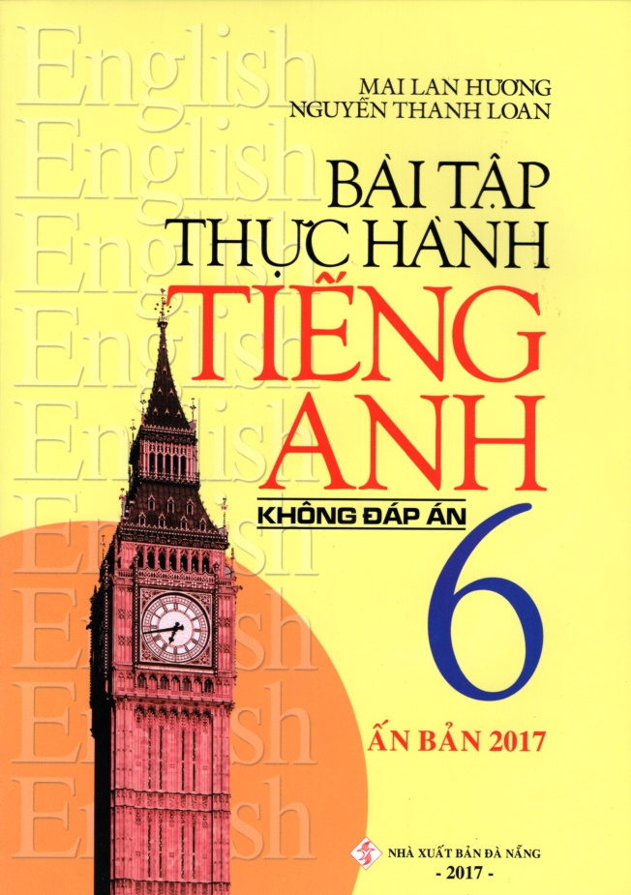
- Chúc các em giữ gìn tốt sức khỏe trong mùa dịch.
- Các em học thuộc từ, đọc kĩ cấu trúc …sau đó mở sách unit 13 và 14 để áp dụng vào bài nhé. Coi kĩ từng phần trong sách giáo khoa nha. LÀM BÀI TẬP THÊM TRONG QUYỂN BÀI TẬP THỰC HÀNH CỦA TÁC GIẢ MAI LAN HƯƠNG NỮA NHÉ.
- Đề cương thầy cô có gửi trên web này luôn. Các em ôn tập nhé.
- Đừng phụ lòng ba mẹ thầy cô nha.
Best wishes for you.
Love you all!

 |  |  |  |  |  |  | EXERCISES - UNIT 14
I. Multiple choice:
1. | What are you going to do___________?
A. this vacation of summer |  |  |  |  |  |  |  |  |  | B. in vacation
C. in the vacation |  |  |  |  |  |  |  |  |  | D. last summer
2. I am going to |  |  |  |  |  |  |  |  | my aunt this weekend.
A. bring |  |  |  |  |  | B. take |  |  |  | C. look |  |  | D. visit
3. | “I’m very tired.” – “ |  |  |  |  |  |  |  |  |  |  | ”
A. Oh, yes |  |  |  |  |  | B. No, thanks |  |  |  | C. It’s OK |  |  | D. Why don’t you sit down?
4. | What are you going to do? -
A. Let we go camping! |  |  |  |  |  |  |  |  |  | B. Why do we go camping?
C. What going camping? |  |  |  |  |  |  |  |  |  | D. Why don’t we go camping?
5. | Ba and his friends |  |  |  |  |  |  |  |  |  | going to have a picnic near a lake.
A. am |  |  |  |  |  | B. is |  |  |  | C. do |  |  | D. are
6. | What about |  |  |  |  |  |  |  |  | to the movies?
A. go |  |  |  |  |  | B. to go |  |  |  | C. going |  |  | D. we go

- can’t Nga walk to school?

A. What B. When C. How D. Why

- Saturday afternoon, we’re going to visit my grandfather in the countryside.

A. On |  |  | B. In | C. For |  | D. At
9. Thinh is going |  |  |  | a new bicycle next week.
A. to buying |  |  | B. buy | C. to buy |  | D. buying
10. There’s a soccer |  |  |  |  | on television tonight.
A. match |  |  | B. citadel | C. idea |  | D. restaurant

- We can walk. It’s not very

A. cold |  |  |  |  | B. far |  | C. quiet |  |  | D. tired
12. Lan’s |  |  |  |  |  |  | is very old. She can’t go with them.
A. sister |  |  |  |  | B. uncle |  | C. grandmother |  |  | D. aunt
13. | The is next to Huong river.
A. fruit |  |  |  |  | B. soda |  | C. food |  |  | D. citadel
14. | Mai’s mother goes to the |  |  |  |  |  |  |  | twice a month.
A. market |  |  |  |  | B. school |  | C. tent |  |  | D. pagoda
15. | We don’t know what to do. Can you make a |  |  |  |  |  |  |  |  |  | ?
A. temple |  |  |  |  | B. place |  | C. vacation |  |  | D. suggestion

- are you going to stay in the country? – For fifteen days.

A. How often |  |  |  | B. How long |  |  |  |  |  |  | C. How |  | D . When
17. What are you going to do this weekend?
A. I’m going to do. |  |  |  |  |  |  |  |  |  |  | B. I am going to go camping.
C. I’m going to swimming. |  |  |  |  |  |  |  |  |  |  | D. I’m going to visit some of my friends.
18. |  |  |  |  |  |  |  |  |  |  |  | go to Da Lat.
A. Let’s |  |  |  | B. Why don’t we |  |  |  |  |  |  | C. What about |  | D. Would you like
II. Complete the passage:
 |  |  | pagodas week days do |  |  |  |  |  |  |  | summer where |  | going to
A : What are you going to do this ( 1 ) |  |  |  |  |  |  |  |  |  |  |  |  |  |  | vacation?
B : I’m going to a trip |  |  |  | ( 2 ) |  |  |  |  |  |  |  |  | Hue.
A : How long are you going to stay there ?
B : I’m going to stay for seven ( 3 ) |  |  |  |  |  |  |  |  |  |  |  |  | .
A : ( 4 ) |  |  |  |  |  |  | are you going to stay ?
B : I’m ( 5 ) |  |  |  |  |  |  |  |  | to stay in a hotel.

A : What are you going to |  |  | there ?
B : I’m going to visit some ( 7 ) |  |  |  | and a citadel.

III. Put the words in the correct order:

- going / Mr Tan / Hanoi / week / is / to / next

…………………………………………………………………………………………………

- is / Where / going / have / Lan / dinner / to / tonight ?

…………………………………………………………………………………………………..

- are / What / going / do / the / weekend / you / to / on ?

………………………………………………………………………………………………….

- children / for / her / oranges / and / some / apples / going / buy / to / is / Mrs Lan

………………………………………………………………………………………………….

- Where / tonight / go / going / to / you / are?

……………………………………………………………………………………………….

- do/ you/ class/ What/ going/ are/ to/ today/ after?

……………………………………………………………………………………………….

- going/ visit/ our/ to/ next/ grandparents/ Sunday/ are/ We

……………………………………………………………………………………………….

- we/ this/ a change/ weekend/ camping/ don’t/ for/ Why/ go?

……………………………………………………………………………………………….

- Are/ anything/ do/ tonight/ you/ going/ to?

……………………………………………………………………………………………….

- play/ the beach/ there/ Let’s/ and/ time/ go/ have/ to /a

……………………………………………………………………………………………….

IV. Reading comprehension and answer the questions:

Dung likes camping. She often goes to the beach on the weekend with her parents and her brother. They sometimes go sailing and swim there. Dung’s brother usually brings a camera and he takes some photos. Dung and her parents take food, drinks and fruits. They are going to camp in the countryside this weekend. They are going to stay there for two days. They aren’t going to go sailing but they are going to go to the pagodas tomorrow.

Answer the questions:

- What does Dung like?

……………………………………………………………………..

- When does she go?

……………………………………………………………………..

- Who does she go with?

………………………………………………………………………

- What do they always do on the beach?

……………………………………………………………………….

- Does Dung bring a camera?

……………………………………………………………………….

- How long are they going to stay in the countryside?

……………………………………………………………………….

- Are they going to go sailing this weekend?

……………………………………………………………………….

V. Give the correct tense of the verbs:
1. | They want (walk) |  |  |  | _ to school.
2. | Nam often (go) |  |  | to the movies on Sundays.

3. | She (do) |  |  |  |  |  |  |  |  |  | aerobics every day.
4. | What |  |  |  |  |  |  | he (do) |  |  |  |  |  |  | this weekend?
5.
5. | We (go) _ |  |  |  |  |  |  |  |  |  |  | to the cinema tonight.
6. | Let’s (listen) |  |  |  |  |  |  |  |  |  |  |  |  | to music.
7. | He (read) |  |  |  |  |  |  |  |  |  |  |  | in the living room at present.
8. | My friend would like (play) |  |  |  |  |  |  |  |  |  |  |  |  |  |  |  | the guitar
9. | His father likes (go) |  |  |  |  |  |  |  |  |  |  |  |  |  | jogging.

10. What about (have) |  |  |  |  |  |  |  |  |  |  |  |  |  | a picnic ?
11. I (stay) |  |  |  |  |  |  |  |  |  | there for two days when I come there.
12. My mother (cook) |  |  |  |  |  |  |  |  |  |  |  |  |  |  | in the kitchen now.
13. I (go) |  |  |  |  |  |  |  |  |  | to Hanoi next week.
14. He (not go) |  |  |  |  |  |  |  |  |  |  |  | often to the movie on Sunday nights.
15. My mother (give) |  |  |  |  |  |  |  |  |  |  |  |  | me a new bike next week.
16. Lan always (go) _ |  |  |  |  |  |  |  |  |  |  |  |  |  |  |  | to school on weekdays.
17. Where |  |  |  |  |  |  |  |  | (be) Mai? – She (play) |  |  |  |  |  |  |  |  | in the garden.
18. Tomorrow (be) |  |  |  |  |  |  |  |  |  |  | Sunday. I (do) |  |  |  |  |  |  |  | the housework.

- The teacher (read) _________________ the dialogue at the moment and we (listen)

_________________ to him.

20. Look! She (come) .

VI. Rewrite the sentences

- Let’s go to the movies.
What about ____________________________?
- Why don’t we play football this afternoon?
Let’s _________________________________?
- Why don’t we visit Hương Pagoda?
What about ____________________________?
- What about going to the beach?
Let’s ________________________________?
- What about travelling by motorbike?
Why don’t we _________________________?
- Let’s listen to music.
What about ___________________________?
- Do you want a cup of coffee?
Would you ___________________________?
- My father is going to drive to Nha Trang.
Where _______________________________?
- He likes spring most.
His favorite __________________________ ?
- How many apples does she have in her bag?

How many apples are____________________________?

