Đề số 6 Garde 6
I/Choose the best answer. (3.0 pts)
1.She has an………face and …………. eyes .
A. full / tall B. round / slim C. oval / brown D. thin / purple
2…………….. is his hair ? It’s black
A. How old B. What color C.Where D. Which
3. Are her eyes big ……. small? They are very big .
A. and B. the C.or D. of
4. There is……bread and rice on the table.
A. an B. any C. some D. many
5. …………?_She is cold.
A. How is she ? B. How she feels? C. How does she feel? D. A and C are correct
6. What’s your ……………….. food? We like beef and noodles
A.like B.matter C. favorite D. ‘d like
7. I am tired. I would like…….down and to drink some water .
A. to sit B. sits C. sit D. sits
8. Would you like some milk?……….
A. No,I am. B. No, it wouldn’t. C.Yes,I’d like. D. Yes, it is.
9. Can I ……you? I ‘d like some some orange juice .
A. to help B. helps C. to helps D. help
10.Hoa wants a …….of chocolates.
A.tube B. pack C. box D. bottle
11 A .Don’t pick flowers B. Keep tidy here.
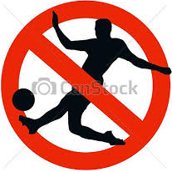
C . Don’t walk the grass D. Water flowers every day 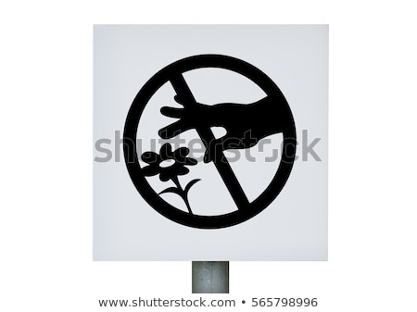
12 . A . Don’t walk here B . Don’t play soccer here
- Play soccer here. D. Walk here

Answers: 1……… 2……… 3……… 4…….. 5…………6………….
7……… 8……… 9……… 10……… 11 ………12………….
II/ Choose the suitable word to fill in each blank. (2.0pts)(Điền từ thích hợp)
Hello, I am Hoa. My favorite (13 )…….is chicken. I like milk,………….( 14 ). I always drink milk (15 )…….breakfast. I have vegetables but I (16 )……. drink tea because it (17 )…….good for ………….( 18 ) . When I (19 )……… hot, I drink (20 )…….orange juice.
13 A. drink B. food C. like D. ᴓ
- A . and B. too C . or D . so
15. A. for B. or C. of D. the
16. A. am not B. is not C. do not D. does not
17. A. ᴓ B. is C. are D. isn’t
18. A. children B. child C . boys D. girls
19. A. feeling B. feels C. to feel D. feel
20. A. some B. any C. an D. a
Answers: 13……..14……..15……. 16…….17……18…….19……..20……….
III/ Read the text then choose True or False. (1.0pt)(Đọc, chọn đúng (True) hoặc sai (False)):
I have a best friend. Her name is Anna. She is eleven years old. She has an oval face. Her hair is short and black. She has brown eyes, a small nose and full lips. Every day, she walks to school. Her favorite drink is apple juice.
21. Vy’s face is oval. …….
22. She has short black hair. …….
23. Her nose is thin. …….
24. She goes to school on foot. …….
Answers: 21…….. 22……. 23……. 24…….
IV/ Rearrange these following words into complete the sentences. (2.0pts).
(Sắp xếp các từ thành câu đúng):
25. I / bar / would / soap / of / like / a
26. the / me / Can / to / go / store / for / you / ?
27. for / is / lunch / chicken / There / some
28. thin / Marry / light / is / and / not /is / but / she / weak
Answers:
25………………………………………………………………………….
26………………………………………………………………………….
27………………………………………………………………………….
28………………………………………………………………………….
V/ Rewrite the following sentences without changing the meaning. (2pts)(Viet cau dong nghia):
29. He likes fish very much.
30. Miss Ha’s face is oval.
31. Do you want bananas?
32. What’s the matter?
Answers:
29.His favorite…………………………………………………………..
30.Miss Ha has…………………………………………………………..
31.Would you…………………………………………………………….?
32.What’s………………………………………………………………..?

