KHANH HOI SCHOOL
EIGHTH GRADE- WEEK 22
UNIT 11- Traveling around Viet Nam
TOPIC: TRAVELING
UNIT 11- Traveling around Viet Nam
Section: - Getting started (Page 98)
- Listen and Read (Page 99, 100)
- Speak (Page 100, 101)
Getting started
Vocabulary:
1. temple (n)
2. literature (n)
Vietnamese literature ( nền văn học Việt Nam)
The temple of literature (văn miếu)
3. bay (n)
Ha Long Bay (vịnh Hạ Long)
4. harbor (n)
Nha Rong harbor (cảng Nhà Rồng)
Match the places of interest in Viet Nam with their names
The Temple of Literature | 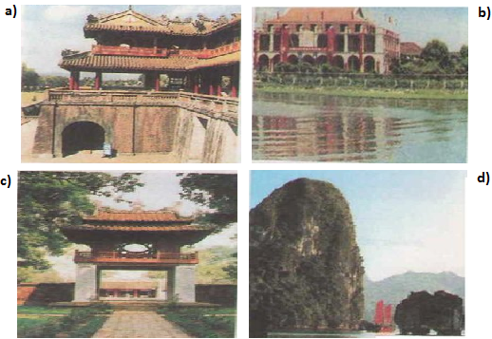
Ngo Mon (Gate)
Ha Long Bay
Nha Rong Harbor
Listen and Read
Vocabulary
1. crop (n)
Ex: The farmers in this country are suffering severe drought and crop failure.
( Nông dân ở đất nước này đang phải chịu đựng hạn hán và mất mùa)
2. corn (n) | 
3. (a) sugar cane (n)  → sugar canes (n, plural) | 
Read the dialogue carefully and answer the questions:
1. Where does Hoa meet The Jones?
→ Hoa/ She meets The Jones at the airport.
2. Is it the first time The Jones have visited Viet Nam?
→ Yes, it is.
3. How do they travel to Ha Noi?
→ By taxi.
4. What do they see along the road to Ha Noi?
→ They see a boy riding a water buffalo, rice paddies, corn and sugar cane fields.
5. What would Tim like to do?
→ He’d like to take a photo.
True or False? Then correct the false sentences and write them in your exercise book.
a/ This is the first time Hoa has met Tim’s family. True
b/ Hoa helps Mrs. Jones with her luggage. True
c/ The Jones family is traveling from the airport in a bus. False
→ The Jones family is traveling from the airport in a taxi.
d/ Shannon has never seen rice paddies before. True
e/ The car is traveling past farmland. True
f/ Only rice and corn are grown around Ha Noi. False
→ Not only rice, corn, but also sugar canes are grown around Ha Noi.
→ Rice, corn, sugar canes and others are grown around Ha Noi.
Speak
Model Sentences:
1. Hoa: Would you mind sitting in the front seat of the taxi, Mr. Jones?
Mr. Jones: No, problem.
2. Tim: Would you mind if I took a photo?
Hoa : Not at all.
Use : To make and respond to formal requests
Form:
1. Do you mind/ Would you mind + V-ing…?
2. Do you mind if I + Verb (in Present simple)…?
Would you mind if I + Verb (in Past simple)…?
Responses:
Agreement: Disagreement
● No, I don’t mind. ● I’m sorry, I can’t.
● No, of course not. ● I’m sorry, it’s impossible.
● Not at all. ● I’d prefer you didn’t .
● Please do. ● I’d rather you didn’t.
● Please go ahead.
* No, I’d be happy to do. / Not at all. I’d be glad to.
(Không có gì. Tôi lấy làm sung sướng/ vui khi được giúp bạn.)
Ex: I want to visit the Imperial Citadel. Would you mind showing me the way to get there?
No, I’d be happy to do.
PRACTICE 1:
Use “ Would/Do you mind + V-ing+…? “ to make these requests more polite.
1. Could you wait a moment, please?
Would/ Do you mind waiting a moment?
2. Will you turn down the TV, please?
Would/ Do you mind turning down the TV?
3. Please make some tea.
Would/ Do you mind making some tea?
4. Could you lend me some money?
Would/ Do you mind lending me some money?
5. Will you post the letters for me?
Would/ Do you mind posting the letters for me?
PRACTICE 2:
Use “ Would/Do you mind if …? “ to make the following more polite.
1. Shall I sit here?
Do you mind if I sit here?
Would you mind if I sat here?
2. Could I smoke?
Do you mind if I smoke?
3. May I ask you a question?
Would you mind if I asked you a question?
4. Shall I carry your luggage?
Would you mind if I carried your luggage?
5. Can I use your handphone?
Do you mind if I use your handphone?
HOMEWORK:
1. Listen : https://vietjack.com/tieng-anh-8/unit-11-listen-and-read.jsp
2. Learn by heart vocabulary.
3. Practice the dialogue.
4. Choose the information on page 101 and write down 2 complete dialogues, using your own words.

