Tuần 6 từ 11/10 đến 16/10/21

Write - Unit 3 trang 32 SGK Tiếng Anh 8
Task 1. Read the description of Hoa’s room.
This is Hoa’s bedroom. There is a desk on the left of the room. On the desk, there are many folders, and above the desk, there is a bookshelf. There is a bed near the desk. On the right side of the room, there is a window. There is a wardrobe beside the window. The wardrobe is opposite the desk.
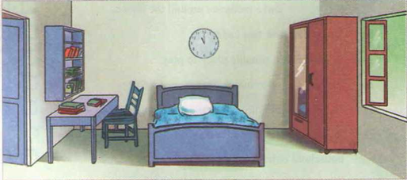

. WRITE UNIT 3
* New word :
- folder (n) : bìa, tài liệu
- wardrobe (n) : tủ quần áo
- in the right corner : góc phải
- oven (n) : lò nướng, vi sóng
- beneath ≠ above: thấp dưới, phía trên
- lighting fixture (n): đèn chùm
- vase of/with flowers: lọ, bình bông.

Task 2. Now write a description of this kitchen.
This is Hoa’s kitchen.
There / refrigerator / right corner / room.
Next to / refrigerator / stove and oven.
On the other side / oven / sink / next to / sink / towel rack.
Dish rack / counter / to the right / window / beneath / shelves.
On / counter / beneath / window / jars / sugar / flour / tea.
In the middle / kitchen / table / four chairs.
Lighting fixture / above / table / beneath / lighting fixture / vase with flowers.
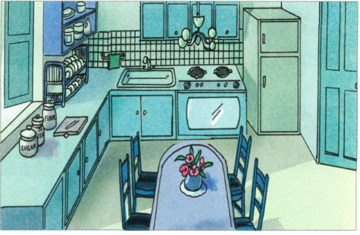
Task 3. Write a description of a room in your house. Refer to the above paragraphs.
MY ROOM
My room is on the second floor. It’s quite a big room and very light because there are two windows overlooking the garden. My desk is between the windows and my bed is against the wall opposite the desk. There’s an armchair near the desk and behind the armchair, there’s a wardrobe. Opposite them, there’s a chest of drawers with bookshelves next to it. I’m very pleased with my room.

Language focus - Unit 3 trang 34 SGK Tiếng Anh 8

New words :
- fish tank (n): hồ cá kiểng
- feed – fed – fed : cho ăn
- draw-drew-drawn : vẽ
- garbage (n) : thùng rác
- repairman (n) : thợ sữa
- fail (v): ≠ pass (v): rớt ≠ đậu
- washing machine: máy giặt

Look at the pictures. Complete the dialogue. Use must or have to and the verbs in the box. (Hãy nhìn tranh và
● Refexive pronouns
● Modals: must, have to, ought to V
● Why - Because

Task 1. Look at the pictures. Complete the dialogue. Use must V or have to V and the verbs in the box.
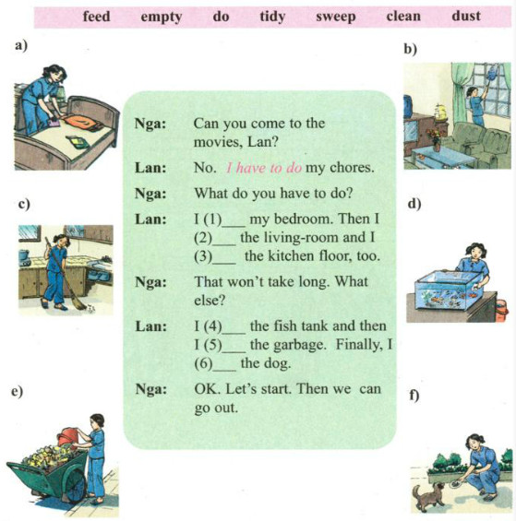
Lời giải chi tiết:
Nga: Can you come to the movies, Lan?
Lan: No. I __________________ my chores.
Nga: What do you have to do?
Lan: I (1) __________________ my bedroom. Then I (2) __________________the living-room and I (3) __________________the kitchen floor, too.
Nga: That won't take long. What else?
Lan: I (4) __________________the fish tank and then I (5) __________________the garbage. Finally, I (6) __________________the dog.
Nga: OK. Let’s start. Then we can go out.

Task 2. Look at the pictures. Use ought to to give advice to these people.
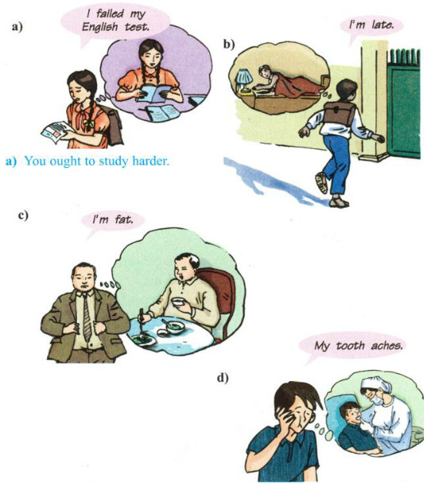
Task 3. Complete the diologues. Use the reflexive pronouns in the box. You will have to use some of the reflexive pronouns more than once.

myself yourself himself yourselves
herself ourselves themselves
a.
Miss Lien: Did someone help Ba draw that picture?
Bao: No. He did it (0) ________ himself __________
b.
Nga: The repairman can’t fix the washing machine until tomorrow.
Mrs. Linh: Come on. We’ll have to try and do it (1) _______.
c.
Aunt Thanh: What’s the matter, Hoa?
Hoa: I cut (2)_______.
Aunt Thanh: Let me see. Oh, it's all right. You didn't cut (3) _______ badly.
d.
Lan: Why are you crying, Nga?
Nga: I just watched the movie Romeo and Juliet. The boy killed (4)_______ and then the girl killed (5)_______ as well.
Lan: Why did they kill (6)_______?
Nga: It’s a long story.
e.
Mr. Nhat: Boys and girls, you'll do this experiment this afternoon.
Students: Will you come to help us?
Mr. Nhat: Yes, I will. But you'll have to do it (7)_______ first.
Task 4. Work with a partner. Ask and answer questions about Hoa, Nam, Ha, Nga, and Mrs. Vui using Why -Because.
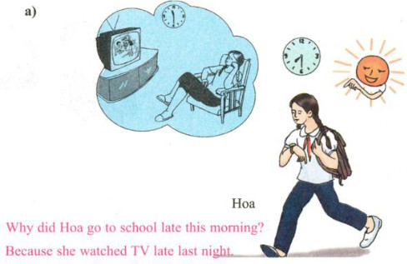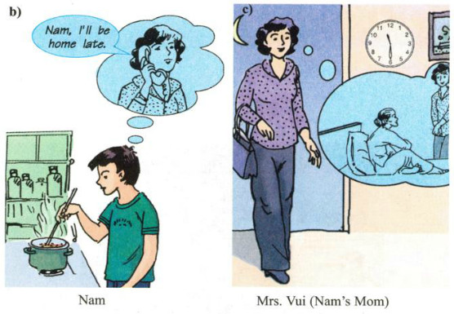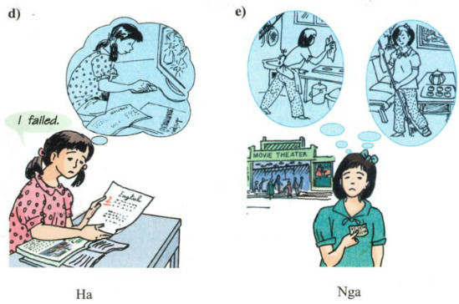
a. Why did Hoa go to school late this morning?
=> Because she watched TV late last night.
b. Why does Nam have to cook dinner?
=> Because his mother will be home late.
c. Why does Mrs. Vui/ Nam’s Mom come home late?
=> Because she has to come to see her mother. Maybe she’s ill.
d. Why did Hoa fail her English exam?
=> Because she didn't learn her lesson carefully.
e. Why can’t Nga go to the movies?
=> Because she has to clean the house.

UNIT 4 : OUR PAST (THÔØI XA XÖA CUÛA CHUÙNG TA)

 | Verb (v) | Noun (n) | Adjective (adj) | Adverb (adv)
1 | Appear : xuaát hieän | Appearance
2 | Amaze | Amazement: ngaïc nhieân | Amazed/amazing
3 | Die : cheát | death | dead
4 | Discover | Discovery : khaùm phaù
5 |  |  | Cruel : ñoäc aùc | Cruelly
6 | Equip : trang bò | Equipment :thieát bò
7 | Excite : haøo höùnng | Excitement | Exciting/ Excited | Excitedly
8 | Sound : nghe | Sound : aâm thanh
9 |  | Tradition : truyeàn thoáng | Traditional : | Traditionally
10 |  | Fool : ngöôøi khôø daïi  Foolishness : cxöû ngngoác | Foolish : ngu ngoác, k. daïi | Foolishly
11 |  | (un)fortune : vaän may | (un)fortunate: may maén | (un)fortunately
12 |  | Rag : raùch röôùi | Ragged | raggedly
13 | immediacy | : ngay lập tức | Immediate | Immediately
14 |  | greed | Greedy : tham lam

UNIT 4: OUR PAST (THÔØI XA XÖA CUÛA CHUÙNG TA)
GETTING STARTED-LISTEN AND READ :
* New word :
- Belong (v) to :thuộc về  - Use – used : sử dụng, đã từng  Use (v) – useful (a) : hữu ích  - Great-grandma (n)≠ Great-grandpa : bà cố.  - Equip (v) – equipment (n) : thiết bị  - Light – lit – lit : …thắp sáng, thắp đèn.  - Folktale (n) : traditional story…truyện cổ tích  - Tradition(a)-traditional(a)-traditionally(adv)…truyền thống  - Without +Ving or (n) : No,…không  Notes : used to V :  (+) S + used to V  (-) S + didn’t + use to + V  (?) did + S + use to + V ? | 1.I used _______ on a farm when I was young. (live)  - There wasn’t any _______________. (electricity)  - Mom had to do everything without the help of modern ____________. (equip).

GETTING STARED.
Describe these groups of friends and their favorite activities.
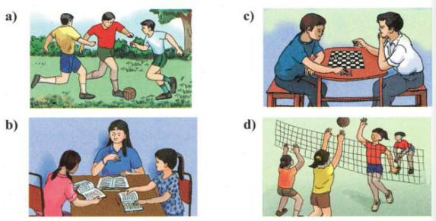
a. The boys are playing football/ soccer.
b. The girls are studying.
c. The boys are playing chess.
d. The girls are playing volleyball.
LISTEN AND READ.
Grandma: This is me, Nga. I used to live on a farm when I was a young girl.
Nga: What was life like then?
Grandma: I didn't go to school because I had to stay home and help my mom. I used to look after my younger brothers and sisters.
Nga: What did Great-grandma do?
Grandma: She used to cook the meals, clean the house and wash the clothes.
Nga: That sounds like hard work!
Grandma: It was. And there wasn't any electricity. Mom had to do everything without the help of modern equipment.
Nga: What did you do in the evenings?
Grandma: After dinner, Mom lit the lamp and Dad used to tell us stories.
Nga: Do you remember any of them?
Grandma: Oh. yes. The best one was The Lost Shoe. It’s an old folktale.
Nga: Please tell me the tale, Grandma. Traditional stories are great.
Grandma: All right. Once a poor farmer ...
Task 1. Practice the dialogue with a partner.
Task 2. Work with a partner. Ask and answer the questions.
a) Where did Nga’s grandmother use to live?
b) Why didn’t she go to school?
c) What did Nga’s great-grandmother use to do?
d) What did Nga’s great-grandmother and great-grandfather do after dinner?
e) What did Nga ask her grandmother to do at the end of the conversation?
Task 3. Fact or opinion? Check (✓) the boxes.

 | F | O
a. I used to live on a farm.
b. There wasn't any electricity.
c. Mom had to do everything, without the help of modern equipment.
d. My father used to tell us stories.
e. The best one was The lost shoe.
f. Traditional stories are great.

Homework
1. Các em chép bài vào tập bài học.
2 . Dịch Listen and read Unit 4
3. Copy từ vựng lần vào tập 2 lần
4.Hạn chót nộp chụp bài lên group là lúc 17h00 thứ 6 nhé.
5..Chúc các em làm bài thành công và ôn tập, củng cố kiến thức mới thật tốt.

Bài tập vận dụng : (Unit 3)
Chia động từ trong ngoặc
1. My father (jog) ............................................ every morning.
2. We (visit) ................................... Hương Pagoda next week.
3. She (be) ........................................ 14 on her next birthday.
4. They (live) ................................... with their grandparents.
5. He (have) .......................................... a lot of friends soon.
6. Mai (brush) ...........................................her teeth after meals.
7. I (come) ...................................................... back tomorrow.
8. She (have) ............................................... a meeting tonight.
9. Lan (invite) some of her friends to her birthday party on Sunday.
10. Hoa (go) ........................................... swimming every day.
11. We often ............................. (play) tennis in the afternoon.
Viết lại câu.
1, You shouldn’t stay up late to watch TV.
You………………………………………………………………..
2, We finds it interesting to work together.
It’s……………………………………………………………………………….

3, No one helps me to do the housework every day.
I……………………………………………………………………
4, Do you have to go out right now?
Must………………………………………………………………
5, The microwave is behind the refrigerator.
The refrigerator is……………………………………………….
6, Doing morning exercise is very good for your health.
It’s……………………………………………………………….
7, It’s dangerous to swim in this river without adults.
Swimming………………………………………………………….
8, It’s not easy to do the English exercises alone.
Doing………………………………………………………………
9, Walking to school every day is good for our health and environment.
It’s ……………………………………………………………………….
10, It isn’t necessary for you to go shopping in the cold weather like this.
Going……………………………………………………………………….
11, Learning foreign languages is very helpful for us in the future.
It’s………………………………………………………………………….

Chuyển đổi câu
1. The question is very easy. All of us can answer it.
The question ..........................................................................
2. Tuan is good at swimming.
Tuan swims ............................................................................
3. My brother usually fixes the household appliances very well.
My brother .............................................................................
4. I intend to visit my friends next Sunday.
I am ........................................................................................
5. She doesn’t go to the party because she has no time.
5. She doesn’t go to the party because she has no time
She doesn’t have……………………………………………..
6. Peter is too young to see the horrow film.
Peter is not .............................................................................
7. Remember to turn off the light before going out.
Don’t ......................................................................................
8. That girl is very intelligent.
What.................................................................................... !
9. I intend to come over to pick you up.
I am ........................................................................................
10. Hoa is older than Nien.
Nien is ....................................................................................
11. Her hair is long and black.
She has. ...................................................................................
7. The theater is near Hoa’s house.
The theater isn’t ......................................................................
12. Alexander Graham Bell invented the telephone.
Alexander Graham Bell was . .................................................
9. I’ll telephone you tomorrow evening.
I’ll make ..................................................................................
13. How about going the movie tonight?
Let’s ........................................................................................
Chia cho đúng từ loại trong ngoặc.
1. I’ll make ........................... for the meeting tonight. (arrange)
2. There was still no ............................... on what to do next. (agree)
3. HCM city is an important .................................... center. (commerce)
4. Michael Faraday made a lot of ………………… in the field of electricity. (invent)
5. We’re thinking of ........................... to Australia. (emigrate)
6. There was an ............................... of paintings at the Art Gallery. (exhibit)
7. Your order is ready for ............................................ . (deliver)
8. This old man is ..................................... in one ear. (deafen)
9. Thomas Watson was Bell’s ..................................... , wasn’t he? (assist)
1. People in my country are very warm and ......................... (friend)
2. An .........................is a child whose parents are dead. (orphanage)
3. L.A. Hill is a .........................writer. (humor)
4. I’m .........................sorry for the delay. (extreme)
5. She looks more .........................than her sister. (beautifully)
6. They were very .........................to survive a shipwreck. (luck)
7. I love the ........................of summer evenings in the countryside. (peaceful)
8. Those cats look ......................... (love)
10. He was ........................... in the demonstrating his invention. (success)

