Tuần 7 từ 18/10 đến 23/10/21

Speak - Unit 4 trang 40 SGK Tiếng Anh 8

SPEAK.
Task 1. Work with a partner. Look at the pictures. Talk about the way things used to be and the way they are now.
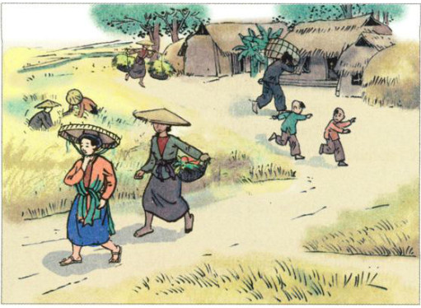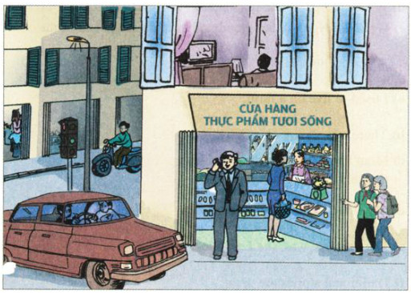

Example :
- People used to live in cottages or small houses, but now they live in modern flats, bigger houses or high buildings.
- People used to work hard, but now they have more free time for entertainment.
- People used to do tiring and low-paid jobs on farms or in the fields, but now they can do lighter and higher-paid jobs in offices or firms.
- People used to travel on foot, but now they can go by bicycle, by motorbike, by car or even by plane.
- People used not to go to school, but now they can go to school and pursue interests outside the homes.
- There used not to be electricity in the home, but now there is electricity in almost everywhere.
- There used not to be facilities such as schools, hospitals, hotels and markets. Now there are enough facilities for people to live on.
- There used not to be telephones, telegraph lines, internet services. Now there are telephones, telegraph lines and internet services available for people to use.
Task 2. Now tell your partner about the things you used to do last year.

Listen - Unit 4 trang 41 SGK Tiếng Anh 8
New words :
- Suit (n)(v) – suitable (a) –suitably (adv) : ……………………………………
- Comfort (n) – comfortable (a)- comfortably(adv):
……………………………………
- Discover – discovered(v) Discovery (n) :
……………………………………
- (Un)fortunate (a) – (un)fortunately (adv) = (un)lucky (a) – (un)luckily (adv): ………………
- Collect – collected (v) – collection (n) – collector (n) : ……………………………………
- Decide – decided (v) Decision (n) : …………………………………………
- Excit (n) – excited (a) – excitedly (adv)
Exciting (a) – excitingly (adv) …………………
- Die (v) – death (n) – deaf (a) : ………………
- Fool (n) –foolishness (n)-foolish (a)-foolishly(adv): ………………………………
- Greed(n) – greedy (a):` ……………………
- Sell – sold – sold ≠ buy – bought- bought :……..
- Lay – laid –laid (v): ……………………
- Sell – sold –sold (v): ……………………
- Shout – shouted : ……………………
- Cut – cut – cut : ……………………
- Rich (a) ≠ poor (a) : ……………………
- Husband ≠ wife (n) : ……………………

Listen to the story. Write the letter of the most suitable moral lesson.
Write the letter of the most suitable moral lesson.
a) Don’t kill chickens.
b) Don’t be foolish and greedy.
c) Be happy with what you have.
d) It’s difficult to find gold.
Audio script:
Once a farmer lived a comfortable life with his family. His chickens laid many eggs which the farmer used to buy food and clothing for his family.
One day, he went to collect the eggs and discovered one of the chickens laid a gold egg. He shouted excitedly to his wife, "We're rich! We're rich!"
His wife ran to him and they both looked at the egg in amazement. The wife wanted more, so her husband decided to cut open all the chickens and find more gold eggs. Unfortunately he couldn't find any eggs. When he finished all the chickens were dead.
There were no more eggs of any kind for the foolish farmer and his greedy wife.
Read - Unit 4 trang 41 SGK Tiếng Anh 8
New words :
- Poor (a) ≠ rich (a) : ……………………
- Die (v) – death (n) – dead (a) : ……………………
- Daughter (n) – son (n) : ……………………
- Marry –married (v) ……………………
- (un)fortune (n) – (un)fortunate (a) – (un)fortunately (adv) = (un)luck (n): ……………………
- Upset (a) = sad, worried : ……………………
- Broken heart (n) : ……………………
- Cruety (n) – cruel (a) to sb- cruely(adv) : …………
- Do chore (v) = do housework : ……………………
- Hold – held – held : ……………………
- Excite (v) – excitement (n) – excited (a)-exciting(a)……
- Prince (n) : …………………………………………
- Have none : nothing……………………
- Appear (v) – appearance (n) : ……………………
- Fairy (n) : ……………………
- Magic(n)-magical (a) – magically (adv) : ………
- Change –changed sth into sth : ……………………
- Rag (n) : poor clothes ……………………
- Run – ran – run : ……………………
- Drop – dropped : ……………………
- Fit – fitted : ……………………
- Immediacy(v)–immediate(a) –immediately (adv)…
…………………………………………
- Own – owned : ……………………
- Fall-fell-fellen : ……………………
Fall in love with sb : ……………………

READ.
The Lost Shoe
Once a poor farmer had a daughter named Little Pea. After his wife died, the farmer married again. His new wife had a daughter, Stout Nut. Unfortunately, the new wife was very cruel to Little Pea. Little Pea had to do chores all day. This made Little Pea’s father very upset. He soon died of a broken heart.
Summer came and went. In the fall, the village held its harvest festival. That year, everyone was excited as the prince wanted to choose his wife from the village. Stout Nut’s mother made new clothes for her, but poor Little Pea had none.
However, before the festival started, a fairy appeared and magically changed Little Pea’s rags into beautiful clothes.
As Little Pea ran to the festival, she dropped one of her shoes and lost it. When the prince found the shoe, he decided to marry the girl who owned it. Of course the shoe fitted Little Pea. and the prince immediately fell in love with her.
Task 1. Complete the sentences with words from the story.
a) Little Pea’s father was a ________.
b) Little Pea’s mother________ when she was young.
c) Little Pea________ to do the housework all day after her father got married________ .
d) The prince wanted to________ a girl from Little Pea’s village.
e) Stout Nut’s mother did not make ________ ________ for Little Pea.
f) The prince found Little Pea’s________ shoe.

Task 2. Answer the questions. Write the answers in your exercise book.
a) Who was Little Pea?
b) What did Stout Nut’s mother make Little Pea do all day?
c) How did Little Pea get her new clothes?
d) Who did the prince decide to marry?
e) Is this a true story? How do you know?

Homework
1. Các em chép bài vào tập bài học.
2 . Dịch Listen, read
3. Copy từ vựng lần vào tập
4.Hạn chót nộp chụp bài lên group là lúc 17h00 thứ 6 nhé.
5..Chúc các em làm bài thành công và ôn tập, củng cố kiến thức mới thật tốt.

Bài tập vận dụng :
Viết lại câu.
1, You shouldn’t stay up late to watch TV.
You………………………………………………………………..
2, We finds it interesting to work together.
It’s……………………………………………………………………………….

3, No one helps me to do the housework every day.
I……………………………………………………………………
4, Do you have to go out right now?
Must………………………………………………………………
5, The microwave is behind the refrigerator.
The refrigerator is……………………………………………….
6, Doing morning exercise is very good for your health.
It’s……………………………………………………………….
7, It’s dangerous to swim in this river without adults.
Swimming………………………………………………………….
8, It’s not easy to do the English exercises alone.
Doing………………………………………………………………
9, Walking to school every day is good for our health and environment.
It’s ……………………………………………………………………….
10, It isn’t necessary for you to go shopping in the cold weather like this.
Going……………………………………………………………………….
11, Learning foreign languages is very helpful for us in the future.
It’s………………………………………………………………………….

