
Animals
VOCABULARY • Unit 3

Write the names of the animals. Use eight of the words in the box.
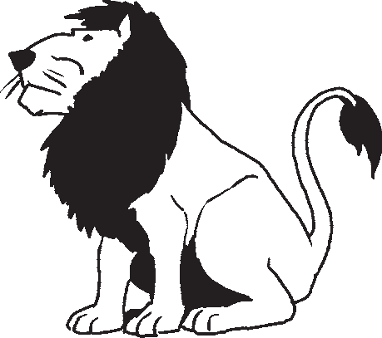
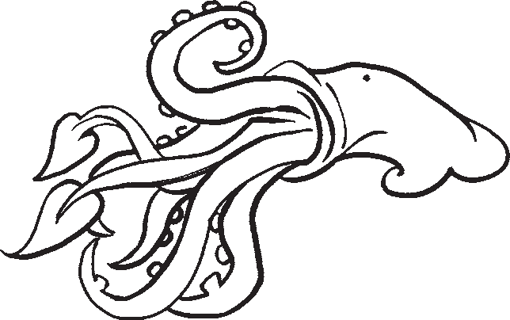
bee crab duck earthworm lion monkey squid wolf fly snake dog

1 2
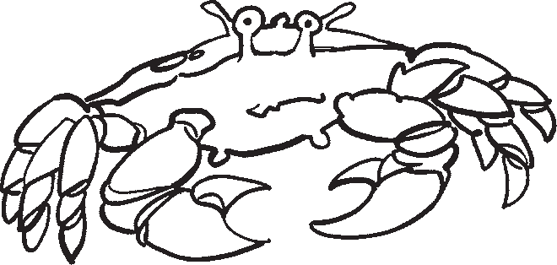
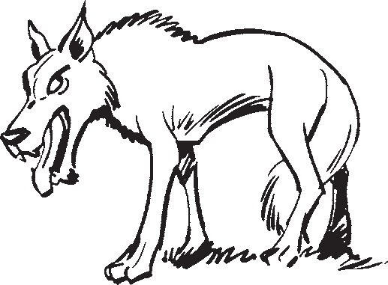

3 4

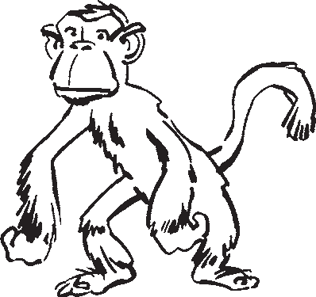

5 6
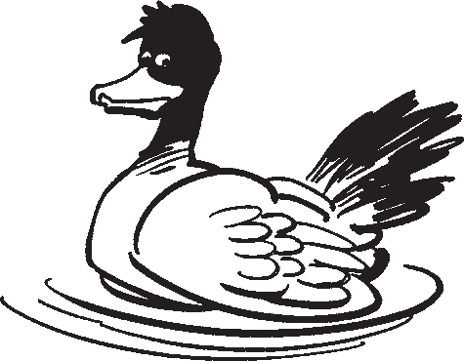
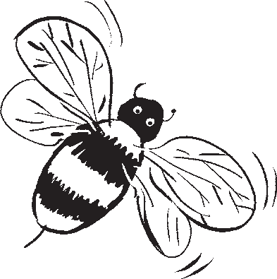
7 8

Write one sentence about each animal in exercise 1.
1
2
3
4
5
6
7
8

Animal skills

Complete the sentences with an animal.
  - A is bigger than any other animal in the world. It isn’t a fish, but it lives in
the sea.
  - A is an insect. It flies from flower to flower. It makes a food which some people eat for breakfast.
  - A is a bird. Some of these birds are red, yellow, orange or blue. Some people teach these birds to speak.
  - A is green. It jumps and it likes water. It eats insects.
  - Some people think a looks like a human! These animals like bananas.
  - A lives in the sea. An octopus has got eight ‘arms’, but this has got ten. People eat it in restaurants.

Complete the texts with the correct form of the verbs in the box.
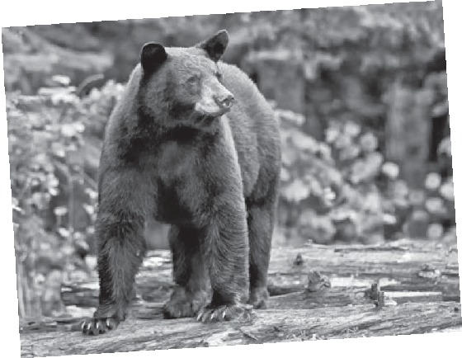
catch move kill hunt play sleep run climb find fly protect
older, the birds 7 away. Then they look for their own food.
Lions are also dangerous animals, but not all of the time. Young lions 8 with each other, and older lions 9 a lot! Lions eat meat, and they 10 other animals. They are good at hunting, because they can 11 very fast.
food for them. When they are
6
young birds. When they are young, the mother
them from bigger birds. Some
trees and eat the
4
animals also 5
the animals and eat them.
Young birds are very small, so their mother
them, because they can very fast. Then they 3
1
2
Bears are very dangerous animals. Sometimes, they chase smaller animals, and they usually

Present continuous: affirmative and negative

LANGUAGE FOCUS • Unit 4
1 What are the people doing in these places? Write affirmative and negative sentences using the words in brackets.
the train station (I)
I’m buying a ticket.
I’m not waiting for a train.
- a party (We)

- the school library (Oscar)

- a café in town (Kate)

- at home (My mum)

- the school computer room (The students)

- the park (The dog)

Present continuous: questions

Write questions about what is happening now using the present continuous. Then write true short answers.
your teacher / ask
Is your teacher asking you difficult questions?
Yes, he is.
  - your friends / revise

  - you / listen

  - your classmates / read

  - you / concentrate

  - your mum / watch

  - you / learn

2 Write affirmative and negative sentences about the picture using the present continuous.
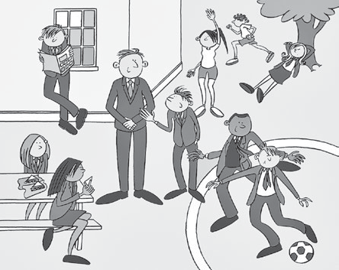
    - One boy
    - One girl
    - Two boys
    - Two girls
    - One boy
    - One girl
    - The teacher

Present continuous and present simple

Complete the sentences with the present continuous or the present simple.
- Right now, I

- In the summer, we always

- I usually

- At the moment, my friends

- My grandparents never

- My English teacher always

- At the moment, my parents

School subjects
VOCABULARY • Unit 4

Look at the pictures. Then write the school subjects.
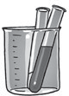

1 2
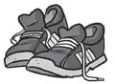


3 4
5 6


7 8

Write sentences about the school subjects in exercise 1 using the words in the box or your own ideas.
    - I usually repeat
    - I listen to
    - I always check
    - I’m good at
    - I sometimes read
    - I make notes
    - I ask

4 Look at the pictures and write sentences using the correct form of the verbs in the box.
calculate check make notes revise spell type

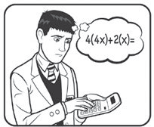

1 Andrew 2 Sofia
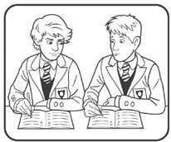
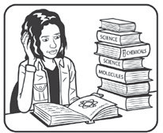

3 Fergus and Paul 4 Anya

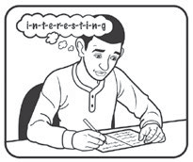
(not) good at (not) interested in like (not) enjoy love prefer

I love art because I enjoy painting and drawing.
1
2
3
4
5
6
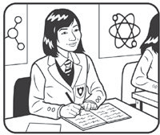
5 Katy 6 Pavel

7
8

Verbs: studying a language

3 Complete true sentences about how you study your subjects at school.
I practise speaking English with my friends.

