Week: 9 (1/11-6/11)
Periods: 17-18
Grade 8
Unit 5: STUDY HABITS
- Getting stared (HS tự thực hiện)
- How often do we have Math? We have Math five times a week.
- How often do you have Math? I have Math five times a week.
- How do you have English? I have English 3 times a week.
- How do you have physics? I have physics twice a week.
- How do you have chemistry? I have chemistry twice a week.
- Listen and read (p. 46-47)
- habit (n): thói quen habitual (adj) – habitually (adv)
- report card: (n): sổ liên lạc
- pride (n) niềm tự hào take pride in be proud of (adj) proudly (adv): tự hào, kiêu hãnh
- semester = term (n): học kỳ
- improve (v): cải thiện improvement (n): sự cải thiện
- Spanish (n): tiếng Tây Ban Nha – Spain (n)
- pronounce (v): phát âm pronunciation (n): sự phát âm
- believe (v): tin tưởng belief (n): lòng tin
- dictionary (n): tự điển
- promise (v): hứa hẹn, lời hứa
promise + to-inf – promise + S + will + V
- need/ want + to-inf
- ask + O + (for O) +to-inf
- say said said : nói
- Practice the dialogue with a partner. (p. 46-47)
- True or false? Check (√) the boxes. (p.47)
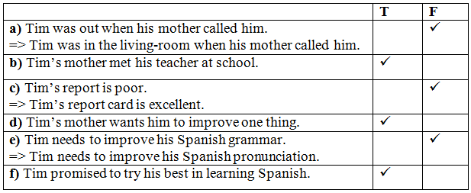
- Answer the questions. (p.47)
- She is Tim’s teacher.
- She gave Tim’s mother his report card.
- He studied very hard.
- She said that Tim should work harder on his Spanish pronunciation
- She gave him a dictionary.
- Speak (p.47-48) (HS tự thực hiện)
- I often do my work after dinner/ after school/ late at night/ early in the morning.
- My brother/ My sister/ My mother/ My friend helps me with my homework.
- I spend half an hour/ two hours/ more than an hour/ less than an hour on it (Math/ Vietnamese/ ... )?
- I need to improve biology/ physics/ chemistry/ ...
- I do grammar exercises/ read English stories/ listen to the news in English/ ...
- Listen (p. 48- HS tự học)
- days present (n): ngày hiện diện # days absent (n): ngày vắng mặt
- behave (v): cư xử behavior (n): cách cư xử
- participate in sth (v): tham gia vào cái gì participation (n): người tham gia
- fail(v, n): thất bại, sự thất bại
- fair : trung bình
- satisfy (v) : làm thoả mãn satisfaction(n): sự thoả mãn
satisfactory # unsatisfactory (a): thoả đáng # không thoả đáng
satisfied + with(a): được thoả đáng, được hài lòng satisfying (a): làm hài l2ng
- comment (v, n): phê bình, lời phê bình
- sign /saɪn/ (v): ký tên signature /ˈsɪɡ.nə.tʃɚ/ (n): chữ ký
Listen to the dialogue and complete the report card (p.48)
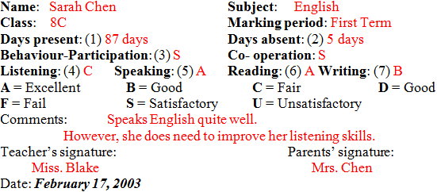

Miss Lien: Good evening, Mr. Lam and Mrs. Linh.
Mr. Lam: Thank you.
Miss Lien: I'm pleased to tell you that Nga has worked very hard this year and her grades are very good.
Mrs. Linh: I'm so pleased to hear that.
Miss Lien: She missed 5 days of school due to sickness but an attendance of 87 days for the whole tern is acceptable. Both her participation and cooperation are satisfactory. So, there're no problems there.
Mrs. Linh: How is she doing in English?
Miss Lien: Her speaking and reading are excellent and her writing is good. If she works a bit harder on her writing skills, she should get an A for writing next term.
Mrs. Linh: How about comprehension?
Miss Lien: I'm afraid she's not very good at that. I gave her a C.
Mrs. Linh: How can we help her improve?
Miss Lien: Get her to watch English TV if possible, and encourage her to listen to English radio programs. Also, I have some cassettes here which you can borrow.
Mr. Lam: Thank you very much, Miss Lien. We really appreciate your help.
- Write (p.50-51)
- identify (v): nhận ra, nhận biết identification (n): việc nhận dạng
- enjoy (v): thích, thưởng thức enjoyment (n): niềm vui enjoyable (a): thú vị
- celebrate(v): mừng lễ celebration (n): sự mừng lễ
- postcard (n): bưu thiếp
- S + be + adj + to-inf
Ex. I’m pleased to hear you had an enjoyable Chrismas vacation.
- regards : thân mến (lời kết thư)
- Look at Hoa's letter to Tim. She wrote it at the end of term. Identify the sections. Label them with correct letter. (p. 50-51)
- Body of the letter: Nội dung lá thư
- Heading - writer's address and the date: Tiêu đề - địa chỉ của người viết và ngày tháng
- Closing - Your friend/ Regards/ Love: Cuối thư - Bạn của bạn/ Lời chúc tốt đẹp/ Thân thương
- Opening - Dear ..., : Đầu thư - Thân mến ...,
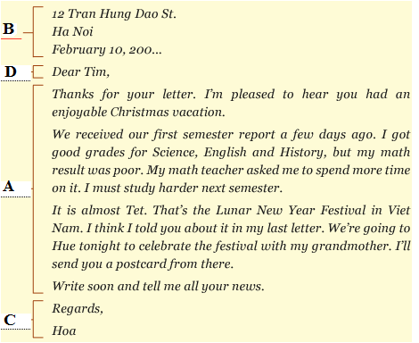
- Now help Lan write a letter to her pen pal Donna in San Francisco. Use the information in the box. (p.51)
