Full name: ______________
Class: 6
Week 6 / 2021

PHIẾU HỌC TẬP SỐ 6

UNIT 2: SCHOOL - Lesson 3 (pages 20,21)

A. Vocabulary:

1. adventure (n) /ədˈventʃə(r)/ cuộc phiêu lưu
2. author (n) /ˈɔːθə(r)/ nhà văn, tác giả
3. fantasy (n) /ˈfæntəsi/ kì ảo
4. mystery (n) /ˈmɪstəri/ bí ẩn
5. novel (n) /ˈnɒvl/ tiểu thuyết

B. Grammar:
Wh – questions (từ hỏi)
What’s your favorite book? | I like Harry Potter and the Sorcerer’s Stone.
What kind of book is it? | It’s fantasy novel.
Who’s the author? | It’s by J.K.Rowling.
Why do you like it? | I think it’s very exciting.

C. Practice: Do exercise pages 12&13 (in workbook)

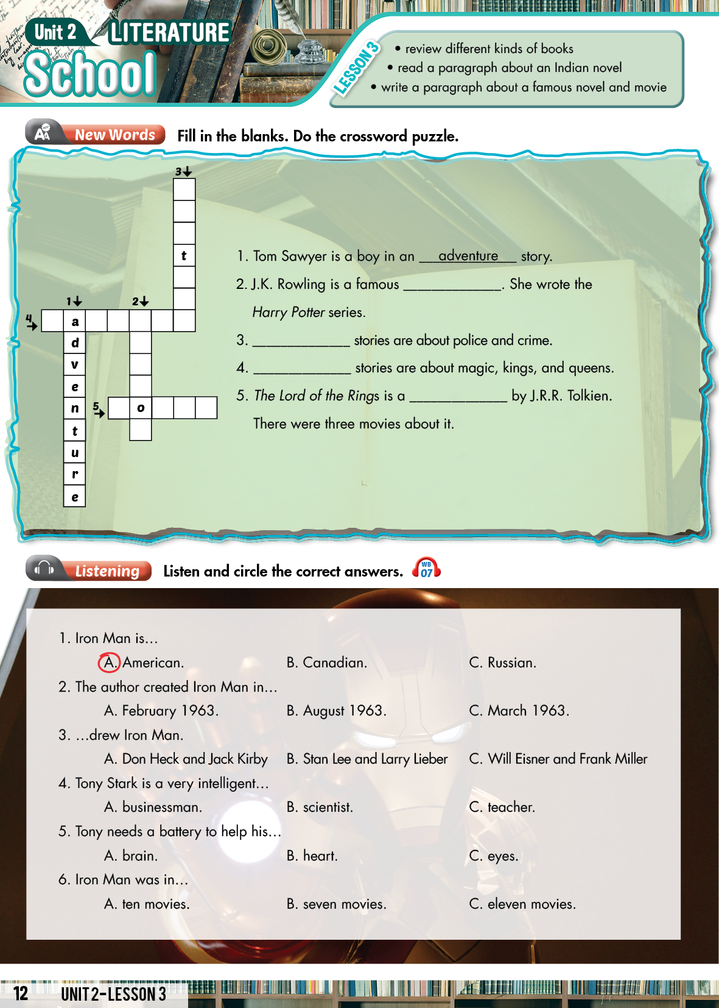
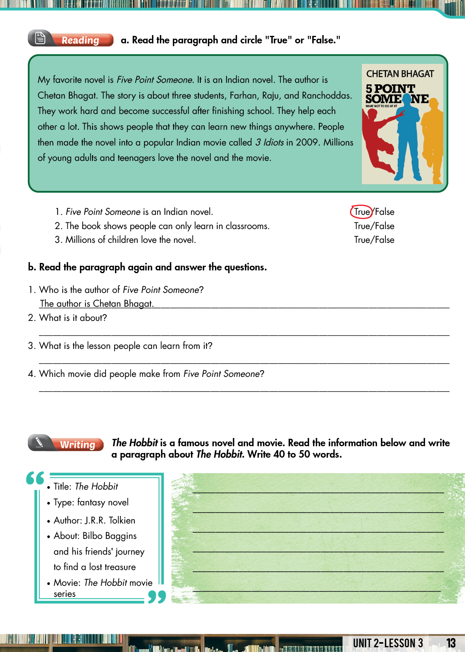
STUDENT’S BOOK (SỬ DỤNG KHI HỌC SINH KHÔNG CÓ SÁCH ) 