Full name : ……………………………………………………..
Class : 9………………. Week 7 -2021
PHIẾU HỌC TẬP SỐ 7

Unit 3 : A trip to the countryside

Period 13: Language focus

I-WISHES (Review)
1. PRESENT WISH (ñieàu öôùc ôû hieän taïi)

S + wish + S + (be) : were
wishes
(V): ed/ coät 2
(not + V) + didn’t + V

2.FUTURE WISH (ñieàu öôùc ôû töông lai)

S + Wish + S + would + V …
Wishes could
might

II-Preposition of time.
(giới từ chỉ thời gian)
*At + giờ / ngày lễ

Ex ; At 7 o’clock, At 6 o’clock
At noon, At midnight, At lunch time
At Christmas, At Easter

*On + ngày / tuần/ ngày + tháng

Ex : On Monday / On weekends / On the weekend
On Saturday night
On July 4th

*In + tháng/ mùa / năm/ buổi

Ex :In June, In summer, In 2008, In the 21st century
In the morning / In the night,
In the middle of the night

III.Adverb clauses of result
(Mệnh đè trạng ngữ chỉ kết quả)
- SO (vì thế)
Ex: He ran to the station because he was late
He was late, so he ran to the station.

EXERCISES
I.Rewrite these sentences using WISH or IF ONLY

1. I don’t have a tape recorder.
=> I wish ____________________________________________________.
2. She won’t tell me about the meeting.
=> I wish ____________________________________________________.
3. I can’t speak French.
=> I wish ____________________________________________________.
4. My parents don’t understand me.
=> I wish _____________________________________________________.
5. I have to study for a test.
=> I wish _____________________________________________________.
6. We live in a small flat.
=> We wish __________________________________________________.
7. I’m sorry. I’m late.
=> I wish _____________________________________________________.
8. The weather isn’t nice today.
=> We wish __________________________________________________.
9. I have to stay home because of illness
=> I wish _____________________________________________________.
10. I can’t visit my grand-parents often.
-> I wish ______________________________________________________.
II- FILL A CORRECT PREPOSITION

1. My interview is _________2 o’clock _________Monday.
2. We’ve been waiting here __________10 minutes.
3. Are you leaving HCMC for Hanoi __Saturday morning?
4. My sister was born _________4th ________1978.
5. I was learning English _________2 pm yesterday when she came.
6. ________this morning I thought that they were a couple.
7. That accident happened _________a cold evening.
8. They will fly to Singapore __________February.
9. We will visit our parent ___________Christmas
10. It sometimes rains ____________winter.
V-Rewrite the sentences(using “so” – “because” )

1. We drove very slowly because the roads were icy.
.....................................................................................................
2. We decided to leave early because the party was boring.
......................................................................................................
3. The match was postponed until next Saturday because the weather was bad.
...............................................................................................…
4. We couldn’t cross the road because of the traffic was heavy.
..........................................................................................................
5. They didn’t buy the house because its price was high.
..........................................................................................................

TEXTBOOK

LANGUAGE FOCUS
Task 1. What do these people wish? Write the sentences.
(Những người này mơ ước điểu gì? Viết câu.)
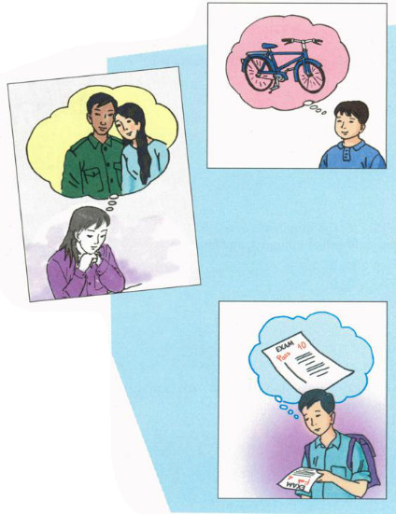
a) Ba/ can have/ new bicycle
b) Hoa/ can visit/ parents
c) I/ pass/ exam

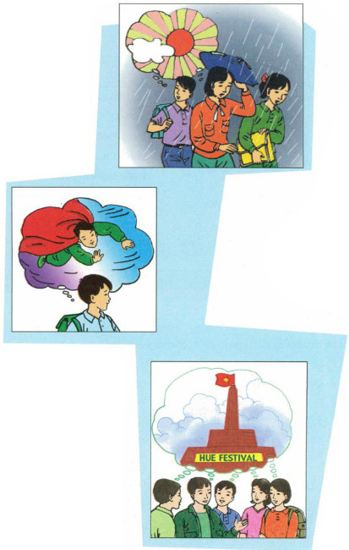
d) We/ it/ not rain
e) He/ can fly
f) They/ stay/ Hue
Task 2. Work with a partner.
Look at Mr Thanh’s itinerary for his business trip to Singapore. Complete the sentences. Use the prepositions in the box.
(Thực hành với một bạn cùng học.
(Nhìn vào lộ trình của ông Thanh trong chuyến công tác đến Singapore. Hoàn chỉnh các câu. Dùng giới từ trong khung.)
Itinerary for Le Huy Thanh
Monday, September 20  Depart: Ha Noi / 2 pm  Arrive: Singapore / 6.30 pm  Tuesday, September 21  MEETING  Rallies Center / 11 am -1 pm  LUNCH  Lion City Restaurant / 1.30 - 2 pm | Wednesday, September 22  MEETING  Raya Palace / 2.15 - 7 pm  DINNER  Little India Restaurant / 7.30 - 10 pm  Thursday, September 23  Depart: Singapore / 9 am  Arrive: Ha Noi / 11.30 am

at till on after up to between
a) Mr Thanh leaves Ha Noi ___ 2 p.m.
b) He arrives in Singapore ___ Monday evening.
c) On Tuesday morning, there is a meeting ___ 11 a.m. and 1 p.m.
d) On Wednesday, Mr Thanh has appointments ___ 10p.m.
e) He returns to the hotel ___ 10 p.m.
f) He will be in Singapore from Monday ___ Thursday.
Task 3. Complete the sentences with ON, AT, IN, FOR
(Hoàn chỉnh các câu sau với ON, AT, IN, FOR).
a) Goodbye. See you ___ Monday.
b) The bus collected us ___ 5 o’clock early ___ the morning.
c) We usually go to our home village at least once ___ the summer.
d) We walked ___ half an hour to roach the waterfall.
e) They planned to have the trip ___ June.
f) She loves to watch the stars ___ night.
Task 4. Match the half-sentences. Then write the fill sentences in your exercise book.
(Ghép các nửa câu. Sau đó viết câu đầy đủ vào vở bài tập của em.)
1. Hoa worked hard,... | a) so I turned on the air conditioner.
2. It was hot,... | b) so she didnỵt have time for breakfast
3. Nga is sick today,... | c) so Mrs. Robinson took it back to the shop.
4. Na woke up late,... | d) so she won't go to school.
5. The new camera didn't work,... | e) so she passed her exam.
Period 14: FORTY- FIVE -MINUTE TEST

