Full name: ______________
Class: 6
Week : 11th / 2021

PHIẾU HỌC TẬP SỐ 11

UNIT 4 : FESTIVALS and FREE TIME - Lesson 2

A. Vocabulary:
performance | (n) | /pərˈfɔːrməns/ | màn trình diễn
food stand | (n) | /fuːd stænd/ | quầy thức ăn
fashion show | (n) | /ˈfæʃn ʃəʊ/ | chương trình biểu diễn thời trang
puppet show | (n) | /ˈpʌpət ʃəʊ / | chương trình múa rối nước
tug of war | (n) | /ˌtʌɡ əv ˈwɔːr/ | kéo co
talent show | (n) | /ˈtælənt ʃəʊ/ | chương trình biểu diễn tài năng
B. Grammar: 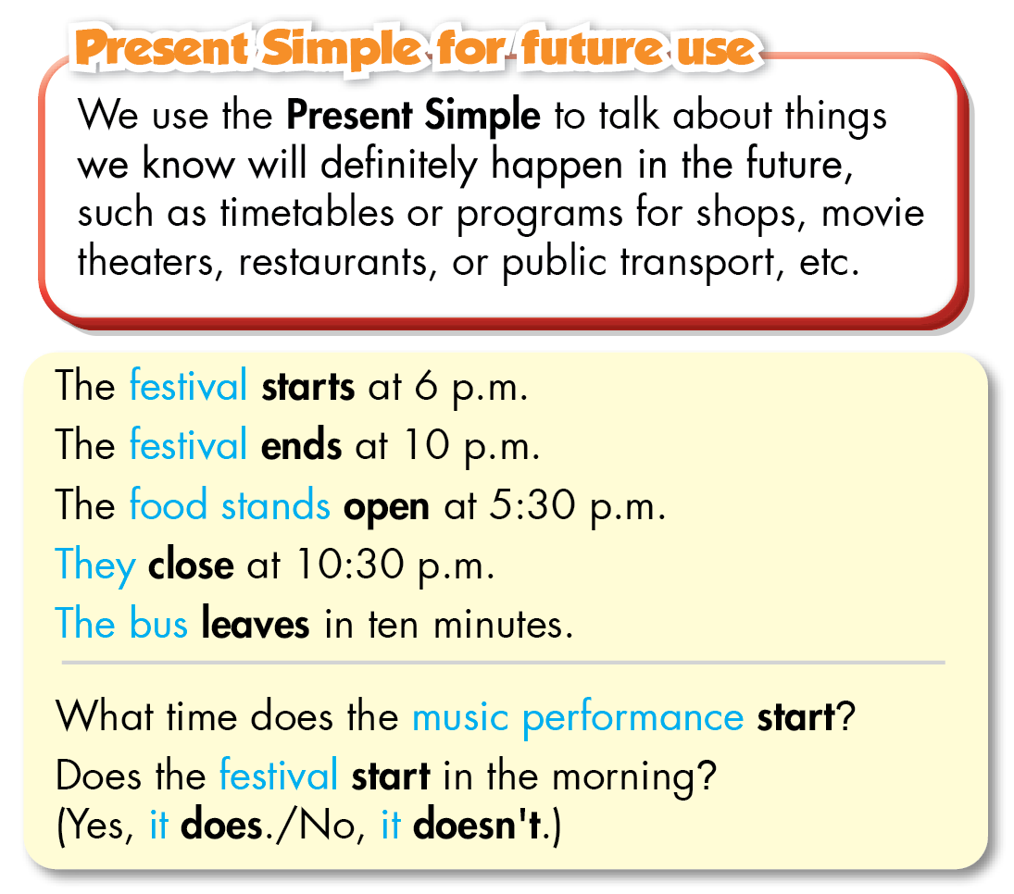
C. Practice:
I.Fill in the blanks with the words from the box.
fireworks get lucky money eat traditional foods talent show
always rarely food stands never
1. I rarely eat fast food. I don't like the taste and it often makes me sick.
2. My favorite part about Tết is to __________. I usually use it to buy new books.
3. I think you should participate in the __________. You can dance really well.
4. Mary __________ waters her flowers before going to school. She waters them every morning.
5. I want to check out the __________. All the dishes look very tasty.
6. Let's watch __________together. My mom lets us stay up late and you can sleep at my apartment.
7. We __________ go out after eight. My dad doesn't think it's safe.
8. We __________such as stollen, a special cake, on Christmas Day.
II. Fill in the blanks using the Present Simple.
1. What time does the music performance start? (start)
2. Does the café___________in the morning? (open)
3. The train___________at 4:45 p.m. (leave)
4. What time does the restaurant___________? (close)
5. The puppet show___________in ten minutes. (end)
6. What time does the bus ___________? (leave)
III.Write sentences using the words below.
1. We/decorate/houses/Halloween.
2. John/sometimes/play video games/his friends/after school.
3. fashion show/start/8 p.m.
4. How/people/prepare/Christmas
5. How/often/you/go shopping
6. bus/leave/10a.m.
IV.Read the text messages between Amy and Jim and answer the questions.
Amy: Hi, Jim. Are you free on Saturday?
Jim: Sure, Amy. Why?
Amy: There's a festival in the park. Do you want to go?
Jim: Yeah! What time does it start?
Amy: It starts at 10 a.m. and ends at 10 p.m.
Jim: Cool! What can we do?
Amy: There's a tug of war and a fashion show. Oh, and the food stands open at 10:30 a.m.
Jim: Great. You know I'm always hungry! Can we go there by bus?
Amy: Yes. There's a bus near my house. It leaves at 9:30 a.m.
Jim: I can't wait! See you on Saturday!
1. Where is the festival?
2. What time does the festival start?
3. What activities can they do there?
4. What opens at 10:30 am ?
5. What time does the bus leave?

