UNIT 1: HOME (cont)

* Objectives: By the end of this lesson, Students will be able to use present simple to exchange information about their homes, talk about family members , housework and use the present simple with Wh-questions

New words | 1. laundry | 2. dinner | 3. bed | 4. shopping | 5. dishes | 6. kitchen
Meaning or definition | ...................  ................... | ...................  ................... | ...................  ................... | ...................  ................... | ...................  ................... | ...................  ...................
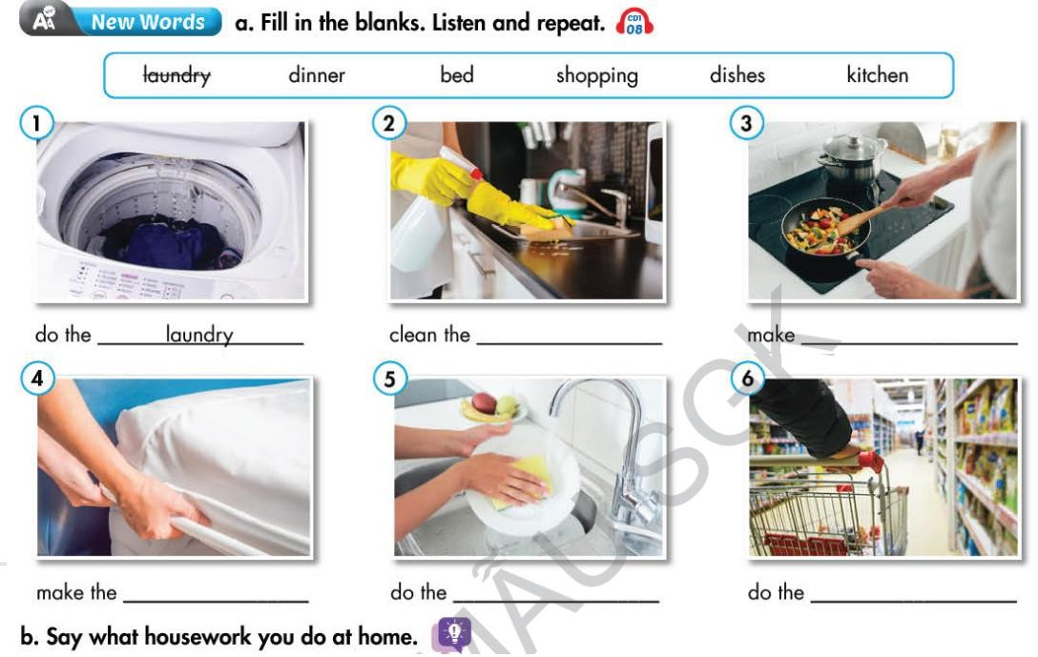

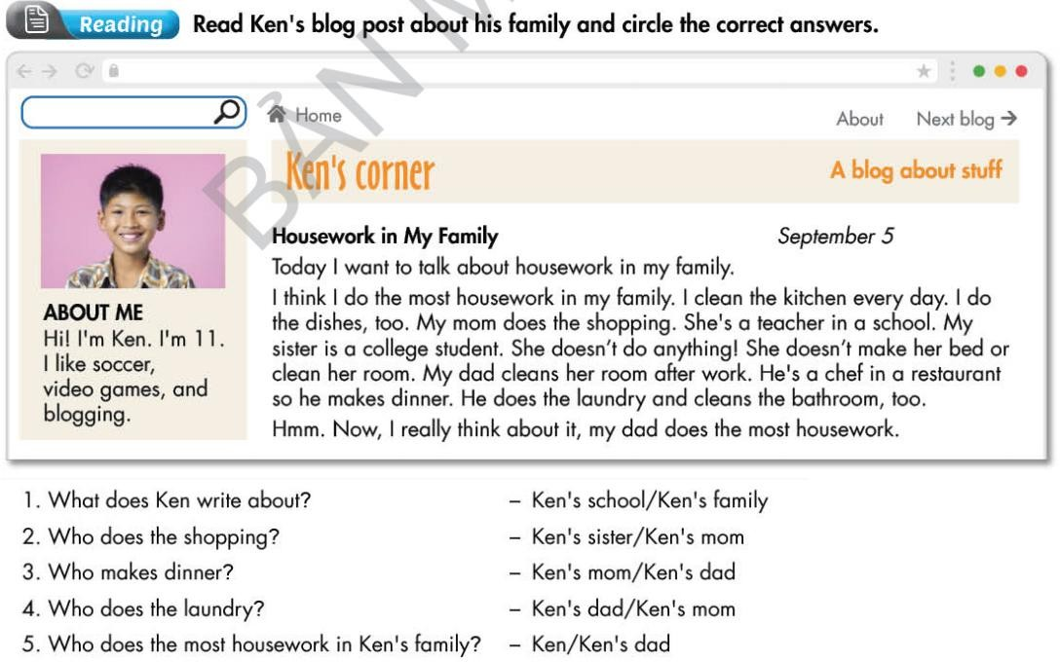

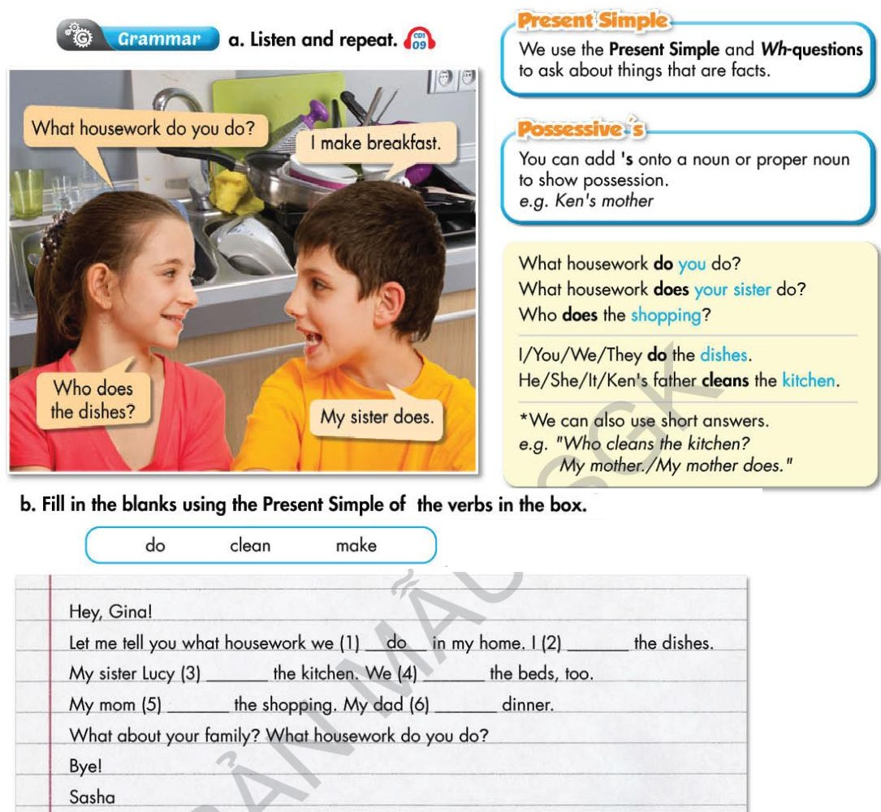

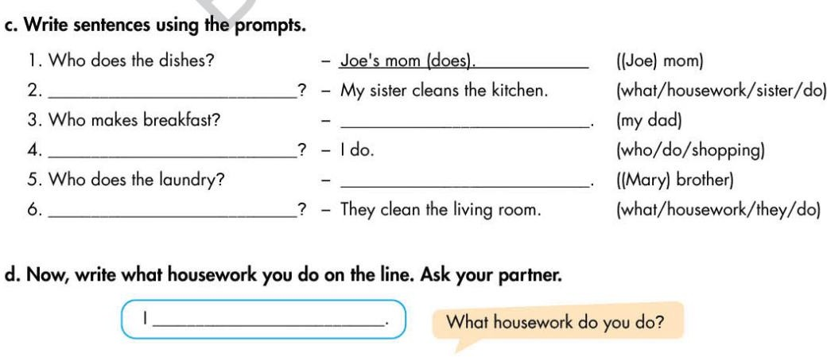

Column A | Column B | Answers
1. What housework do | A. dinner ? | 1. +
2. What housework | B. you do ? | 2. +
3. Who makes | C. housework in your family ? | 3. +
4. Who cleans | D. your best friend do ? | 4. +
5. Who does the most | E. the kitchen ? | 5. +
6. What housework does | F. does your sister or brother do ? | 6. +

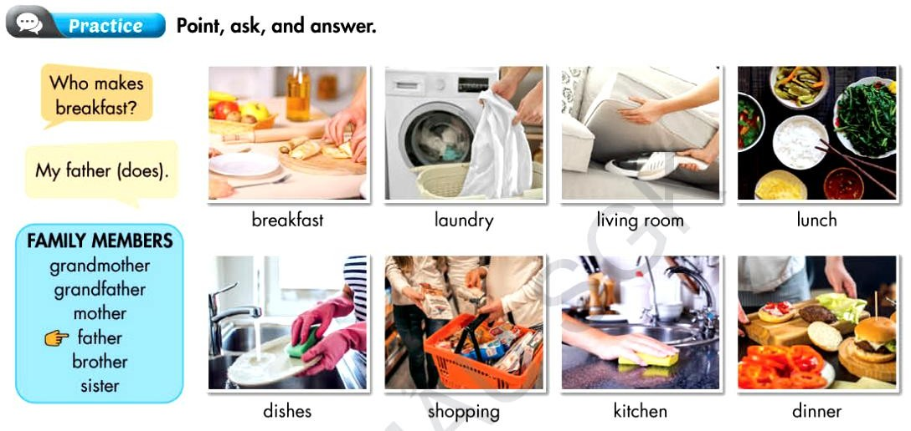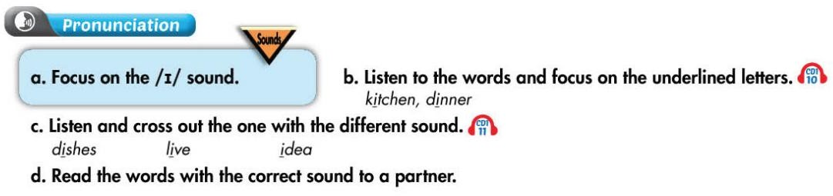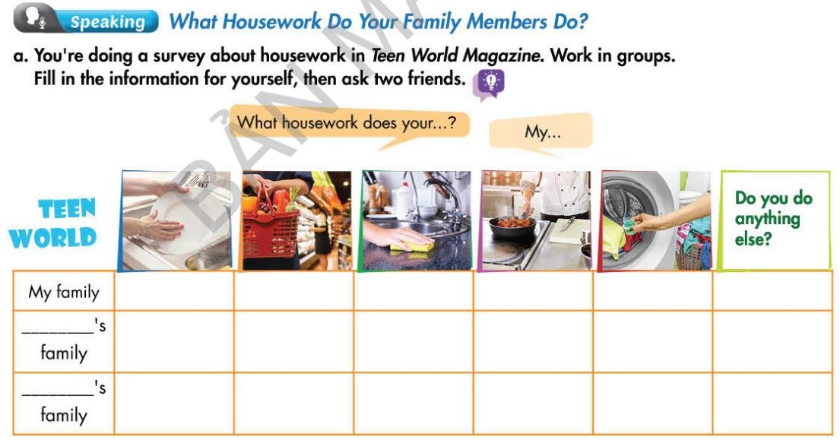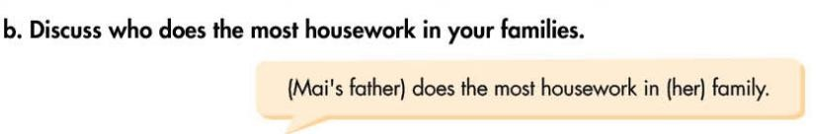

 GRAMMAR CORNER:

Exercise 1: Choose the word or phrase that is best completes each unfinished sentences below:

- I have Math lessons Monday and Friday.
  - on B. in C. at D. from
- His new house on Tran Phu Street.
  - is B. are C. am D. A&C
- Mai brushes teeth every morning.
  - his B. my C. her D. your
- We are traveling to the countryside bus.
  - on B. in C. from D. by
- He goes to school five o’clock the morning.
  - on/in B. for/at C. in/on D. at/in
- Mai dressed at six thirty every morning.
  - does B. brushes C. gets D. lives
- Minh goes to school 12.45 every afternoon.
  - in B. at C. on D. to
- My father is an . He works in a big factory.
  - teacher B. doctor C. farmer D. engineer
- is your brother? - He is thirteen.
  - What time B. How far C. How old D. How long
- My teacher lives a big city.
  - in B. on C. at D. to

Exercise 2: Match the questions and answers. Write the answer in each blank :

Column A | Column B | Answers
1. What are you watching ? | A. I like programmes about  History. | 1+ ................
2. What kind of programmes do  you watch ? | B. To my friend's house. | 2+ ................
3. Where are you going ? | C. Every day. | 3+ ................
4. Where does she live ? | D. A programme about animals. | 4+ ................
5. Who are you talking with? | E. A friend from school. | 5+ ................
6. How often do you ride your  bicycle to school ? | F. 24, High Street. | 6+ ................

Exercise 3: Supply the correct form of the verbs in brackets :

- This (be) Liz’s mother.
- Her name (be) Hang.
- She (be) 39 years old.
- She (be) a doctor.
- She (work) in a factory.
- Every day, she (get) up early. She (get) up at 5 o’clock.
- She (brush) her teeth and (wash) her face.
- Then, she (do) the housework.
- She (have) breakfast at half past six.
- Then, she (go) to work at fifteen to seven.
- She (go) home at half past four.
- They (work) very hard.

Exercise 4: Supply the correct form of the verbs in brackets :

- I (be not) a student. I (be) a nurse.
- They (be not) her father and mother.
- The doctors (be not) in the room.
- Their classroom (be not) on the fourth floor.
- Mary’s house (be not) on Tran Phu street.
- These (be not) her father’s books
- Ann (be not) in class 7A. Her teacher (be not) Mr. Brown.
- We (not get) up at 6. 00.
- They (not brush) their teeth very often.
- Henry’s father (not have) lunch at home.
- She (not listen) to the radio after school.
- My mom (not watch) TV in the morning.

Exercise 5: Answer the following questions, using the given clues:

- What do you do? (student)
→
- Where is your class? (the third floor)
→
- What time does Lucy do her homework? (at 7 o’clock)
→
- How many rooms does your house have? (three)
→
- What does your brother do after school? (do his homework)
→
- How many classes are there in your school? ( 36 classrooms )
→

Exercise 6: Complete the sentences with the correct form of the verbs :

- Scott and Daniel (brush) their teeth after meals.
- The little boy (eat) lunch at 11 o’clock.
- The children (go) to bed at nine o’clock.
- Mrs Smith (go) to the market every day.
- Amy (swim) on Sundays.
- My classmates (clean) the board after school.
- Classes (start) at seven every day.
- The girl (study) Literature on Friday.
- I (leave) the house at half past six.
- My son (drink) milk for breakfast.

