Môn: Tiếng Anh 8
Giáo trình: I-Learn Smart World
Tuần 11: (15/11 – 20/11/2021)

Tiết 1:
THEME 4: THE PAST
Lesson 1: Retell past events (p.34-35)
( kể lại các sự việc ở quá khứ)
I. New words: ( HS viết vào tập)
1. eat – ate – eaten (v): ăn
eat a cake / a sandwich : ăn bánh ngọt / ăn bánh mì san-wich
2. make – made – made (v): làm
make a cake / a sandwich : làm bánh
3. read – read – read (v): đọc
read a book/ a story : đọc sách / truyện
4. do – did – done (v): làm
do yoga : tập yoga
do homework: làm bài tập
5. drink – drank – drunk (v): uống
drink milk / soda : uống sữa / soda
6. go – went – gone (v): đi
go home : về nhà
go to school : đi học

II. Useful Language: ( HS viết vào tập)
1. I’d done my homework before I went to bed.
( Tôi đã làm bài tập trước khi tôi đi ngủ.)
2. She’d gone home before it rained.
( Cô ấy đã về nhà trước khi trời mưa.)
Grammar: The past perfect tense (Thì quá khứ hoàn thành) :
S + had V3/ed..............
( had = ‘d )
Diễn tả một sự việc đã xảy ra và hoàn thành trước một sự việc khác trong quá khứ .
S + had V3/ed ...before S + V2/ed ....
Ex: I ‘d done yoga before I went to sleep.
( Tôi đã tập yoga trước khi tôi đi ngủ.)
*PRACTICE ( page 35)
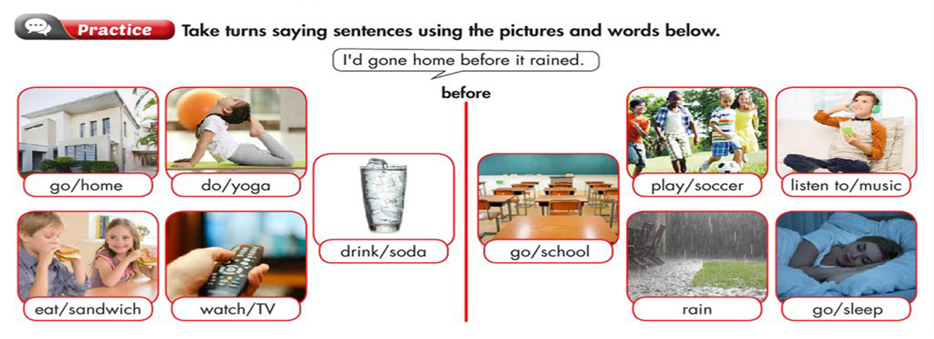

Tiết 2:
THEME 4: THE PAST
Lesson 2: describe repeated actions in the past (p. 36-37)
( Mô tả các hành động lặp lại trong quá khứ)
I. New words: (HS viết vào tập)
1. pretend (v) /prɪˈtend/ : giả vờ, giả bộ
pretend to be (a doctor): giả bộ làm (bác sĩ )
2. argue (v) /ˈɑːrɡ.juː/: cãi nhau, giành
argue about (something) with someone : giành nhau ( cái gì)với ( ai)
3. practice (v) /ˈpræk.tɪs/: thực hành, luyện tập
practice + V-ing
4. forget (v) /fɚˈɡet/ : quên
forget + to V : quên làm gì...
5. complain (v) /kəmˈpleɪn/: phàn nàn, than phiền
complain to (someone) about (something) : than phiền với (ai) về ( việc gì)

II. Useful Language: ( Hs viết vào tập)
When I was younger, I’d always dream of being a superhero. Me, too
( Khi tôi còn nhỏ, tôi thường ước trở thành một siêu anh hùng) ( Tôi cũng vậy.)
When I was at school, my brother would often practice singing with me. Oh, really?
( Khi tôi còn đi học ở trường, anh trai tôi thường luyện tập hát với tôi.) (Ồ, thật hả?)
Structure:
would ( often/ always) V: thường.... chỉ hành động lặp đi lặp lại trong quá khứ
S + would ( often/ always) V...................
(would = ‘d )
- PRACTICE ( page 37)

Tiết 3:
THEME 4: THE PAST
MULTIPLE CHOICE
1. Billy’d..................milk before he went to school.
A. gone B. drunk C. eaten D. made
2. Would you like to ..............a story?
A. do B. make C. read D. drink
3. What is your mom doing? She is making...................
A. a book B. yoga C. housework D. a cake
4. Hellen’d gone home...................it rained.
A. before B. after C. when D. until
5. They ....................homework before they went to bed.
A do B. did C. had done D. have done
6. She likes singing, so she often pretends …………….a singer.
A. to be B. to make C. to do D. to build
7. When he was young he’d often argue …………..games with his friends.
A. with B. to C. about D. without
8. Do you think I should practice ……………………………..English every day?
A. spelling B. telling C. talking D. speaking
9. My teacher would complain to me ……………………my coming late.
A. about B. along C. to D. with
10. My teacher would always complain…………..my parents when I was late for school.
A. to B. with C. on D. about
11. My brother and I would sometimes argue ………………… toys.
A. to B. with C. on D. about
12. I’d sometimes forget……………… my homework.
A. to do B. doing C. did D. does
13. When I was five, I’d often pretend …………………….. a doctor.
A. to be B. being C. was D. is
14. We’d always ....................................... to be superheroes.
A. argue B. practice C. pretend D. complain
15. Ba had done homework before we ................. go bed.
- go B. going C. goes D. went

REARRANGEMENT
1. / I would sometimes / we were young./ argue about/ My brother and/ toys when /
....................................................................................................................
2. / to school./drunk milk / I went/ / I had / before/
...........................................................................................................................
3. done/ before/ she/ her homework/ watched TV./ She’d/
............................................................................................................................
4. always/ playing guitar/ My father/ on weekends./ practice/ would/
.............................................................................................................................
5. a small child/ a wonderful time/ in the kindergarten./ I had/ when I was/
……………………………………………………………………………………...

