Week: 15
Period: 29
Unit 5: THE MEDIA
Lesson 1: Getting started and speak
(HS tự học)
- Getting started: (p.40)
A: Which of these is your favorite activity in your free time?
B: Watching TV.
- How many hours a week do you spend watching TV?
- About 4 or 5 hours, I guess.
- Speak: (p.42)
Grammar: tag-question: câu hỏi đuôi
You like watching sports, don’t you, Trung?
Yes, I do / No, I don’t
EXERCISES

I.Choose the correct word or phrase (A, B, C, D) that best fit the space in each sentence:
1. “The Ao dai is the _______________ dress of Vietnamese women.
A. casual B. regional C. baggy D. traditional
- The English can’t drive on the left, _______________?
A. does he B. can he C. do they D. can they
- Can you tell me how many chapters this book consists _______________?
A. of B. to C. with D. in
- Although we are far away from each other, we still _____________very often.
A. keep in touch B. say hello C. keep together D. keep on
- He told me that he _______________ leave the city the following day.
A. will have to B. would have to C. has to D. have to
- He wants to improve his English pronunciation, _______________ he practises speaking every day.
A. but B. when C. so D. or
- “ I’m taking my final exam next week.” - “ _________________.”
A. Cheers ! B. Congratulations ! C. Good luck ! D. Come on !
- “ Do you mind waiting a few minutes?” - “ _________________.”
A. Don’t worry B. Never care C. I hope not D. Not at all
II. Look at the sign/ picture. Choose the best answer (A, B, C or D) for each sign/ picture:

1.What does the sign say?  A. Road for children only .  B. No children on this road .  C. Road near school with many children .  D. Zebra-crossing for children . | 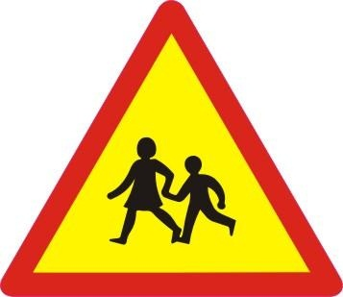
2. Say something when you look at this picture.  A. There is not a deep hole in front of him.  B. I think he’s going to fall into the deep hole.  C. I don’t think the deep hole is dangerous for him.  D. The man is not so busy using his mobile phone. | 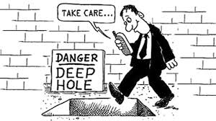

III. Choose the word (A, B, C or D) that best fits the blank space in the following passage.
Every year people in many countries learn English. Some of them are young children. ____________(1) are teenagers. Many are adults. Some learn at school. Others study by themselves. A few learn English just by _____________(2) the language in films, on television, in the office or among their friends. But not many are _____________(3) enough to do that. Most people must work hard to learn English.
Why do all people learn English? It’s not difficult _____________(4) this question. Students learn English at school because it is one of their compulsory _______________(5). Others learn English _______________(6) they want to read books in English or for their jobs.
1. A. They B. Others C. People D. All
2. A. hearing B. writing C. looking D. speaking
3. A. happy B. well C. lucky D. interested
4. A. understand B. to understand C. answer D. to answer
5. A. subject B. subjects C. homework D. exercises
6. A. so B. but C. because D. and
IV. Use the correct form of the word given in each sentence:
1. Most modern buildings have underground _____________lots. (park)
2. Don’t _____________the room without knocking. (entrance)
3. The show brought _____________ to millions of viewers. (enjoy)
4. They are studying hard for their coming ______________. (examine)
5. Let me introduce you a ____________ university. I think it is really reliable (repute)
6. Paola answered the questions ________________ (exact)
V. Rearrange the words or group of words in the correct order to make complete sentences:
1. have been added / fashionable / Modern patterns / to make it more / to the Ao dai /./
Modern patterns ____________________________________________.
2. and convenient way / The Internet is / to get information / a very fast /./
The Internet ________________________________________________.
VI. Rewrite each of the following sentences in another way so that it means almost the same as the sentence printed before it,
1. Because the weather is fine, we will go out for eating dinner.
The ___________________________________________________________. ( so)
2. Practice speaking English everyday or you can’t improve your English.
If you _______________________________________________________.
3. Poets, writers and musicians have mentioned the Ao dai in poems, novels and songs.
The Ao dai has _________________________________________________.
4. “ Why do you want to take the course?” He said to me
He asked _____________________________________________________.
- Homework:
- Prepare unit 5 (cont) – lesson 2- Listen and read

