ĐÁP ÁN ĐỀ ÔN 13
Choose the word that does not have the same pronunciation of the underlined part as that in the rest
- A. fashion B. label C.casual D.baggy
- A. course B. deposit C. advance D. mass
- A. humor B. hug C. dump D. junkyard
choose the word that does not have the same stressed syllable as that of the rest.
4. A.exist B.despite C.aboard D. planet
5. A. embroider B.encourage C. logical D. material
Choose the word or phrase (A, B, C or D) that best fits the blank space in each sentence
6. The image of ao dai a lot of songs.
A. is interested in B. is impressed by C. is provided with D. is mentioned in
7. Two advanced courses in Academy of Language next month.
A. are difficult B. will be available C. have been necessary D.must be published
8. ___________ all of my students have studied very hard in this challenging school-year.
A. I’m pleased to B. What I’m pleased C. According to my pleasure D. I’m pleased that
9. On Mother’s day,families also celebrate by giving mothers like cooking or other household chores.
A. a big party B. some special gifts C. a balanced meal D. a day off from activities
10. Do you ______________ of UFOs?
A. experience the trace B. believe in the existence C.prove the appearance D. claim the evidence
11. Jeans are ___________________ of youth and health.
A. painted with patterns B. considered the symbol C.embroidered flowers D. designed in labels
12. John Glenn, one of the first _____ outer space, became a presidential candidate.
A. astronauts to explore B. collectors to discover C. scientists to prove D. pilots to travel
13. To the one ______________ for me are so strong that the word love can’t describe them
A. who teaches B. whom I loved C. which I receive D. whose feelings
14. If we ___ water, there will be a shortage of fresh water in a few decades.
A. deny saving B. keep using C. go on wasting D. avoid polluting
15. In order to __________, you have to read a lot and write English as much as possible.
A. speak English fluently B. do your homework C. succeed in your job D. improve your writing
16. English __________ one of the most the most popular languages nowadays.
A. was B. is C. were D. are
17. The examiner asked me ______.
A. what is my name B. what my name is C. what my name was D. what was my name
18. If they are good, they’ll ________ chocolate from Santa Claus.
A. receive B. be received C. be taken D. give
19. The UFO stayed in the sky for about thirty seconds, and then it ______________.
A. disappeared B. had disappeared C. was disappeared D. had been disappeared
20. He was still deep in sorrow it had been a year since it happened.
A. despite B. because of C. but D. though
21. On the way, you can see this sign and it warns that:

A.The straight road you are coming from has ended.
B.Trucks are not allowed.
C.The drivers can park here.
D.All types of motorcycles are not allowed to move on this street.
22. What does the sign say?
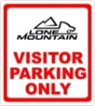
A. Anybody can park here.
B. You can park here if you are not visitors.
C. Only the visitor living in this country can park here.
D. Parking in this space for visitor only

Choose the word or phrase that best fits the blank space in the following passage
Nowadays our environment (23) . Do you know that protecting our environment is our responsibility? For me we can protect our environment by following these rules.
Firstly, we can use banana leaves (24) food because plastic bags are very (25) .
We can also reuse and recycle bottles and cans (26) reduce garbage.
Secondly, we shouldn’t throw trash onto the water to keep water cleaner. We should put garbage bins around the
school yard (27) lazy students from throwing trash and to keep the schoolyard clean.
Finally, we should go to school or to work on foot or by bicycle to reduce exhaust fume and to keep our air cleaner.
In conclusion, If you follow these rules (28) keep the air clean but you also save energy.
23. A.are seriously polluted B. is seriously polluted C. has serious pollution D. is polluting seriously
24. A. wrapping B. to wrap C. be wrapped D. by wrapping
25. A. hard to decompose B. hardly decompose C. easy to dissolve D. difficult to save
26. A. so that B. in order to C. because D. in case
27. A. to help B. to prevent C. to assist D. to fine
28. A. not only you will B. only not you will C. will you not only D. not only will you
Read the passage and then decide whether the statements that follow are True or False
Father's Day, contrary to popular misconception, was not established as a holiday in order to help greeting card manufacturers sell more cards. In fact when a "father's day" was first proposed there were no!
Mrs. John B. Dodd, of Washington, first proposed the idea of a "father's day" in 1909. Mrs. Dodd wanted a special
day to honor her father, William Smart. William Smart, a Civil War veteran, was widowed when his wife (Mrs. Dodd's mother) died in childbirth with their sixth child. Mr. Smart was left to raise the newborn and his other five children by himself on a rural farm in eastern Washington state. It was after Mrs. Dodd became an adult that she realized the strength and selflessness her father had shown in raising his children as a single parent.
The first Father's Day was observed on June 19, 1910 in Spokane Washington. At about the same time in various
towns and cities across American other people were beginning to celebrate a "father's day." In 1924 President Calvin Coolidge supported the idea of a national Father's Day. Finally in 1966 President Lyndon Johnson signed
a presidential proclamation declaring the 3rd Sunday of June as Father's Day.
29. Father’s Day is celebrated on June 3rd every year. FALSE
30. William Smart was a Civil War veteran. TRUE
31. Mrs. Dodd had six brothers and sisters. FALSE
32. William Smart married another woman after his former wife died. FALSE
Read the passage again and choose the best answer ( A, B, C or D)
33. What is the passage referred to ?
A. Mrs.John B. Dodd B. Father's Day cards C. The History of Father’s day D.William Smart’s family life
34. The word realized in line 7 is closest in meaning to:
A. knew B. achieve C. received D. enhanced
Supply the correct form of the word in bracket:
35. Dressing fashionably can help you feel self-confident in public. (fashion)
36. The candidate walked away disappointedly after he had failed to answer the examiner’s question. (disappoint)
37. The __________announcement______________ of her marriage appeared in some local newspapers. (announce)
38. In the oral examination, examinees have to answer eight questions. (examine)
39. They had a lot of difficulty in designing a wedding dress with shells. (design)
40. The teacher asked her to distinguish two different meanings of the word “realize”. (distint)
41. The air is seriously polluted by exhaust fume from cars . ( pollute)
42. The UK is a multicultural society, with people from all over the world living there. (culture)
Rearrange the word given to make the meaningful sentence
43. in many countries / is a joyful /Easter/ is celebrated /festival/ which /. /
Easter is a joyful is a joyful festival which is celebrated in many countries.
44. very nervous/As Minh Trang/ felt / a speech before, / hadn’t made / /. /
As Minh Trang hadn’t made a speech before, she felt very nervous.
Rewrite the sentences so that they are nearest in meaning to the sentence printed before them
45. When did he start working?
How long is it since you started working / How long is it since you started to work? How long is it since you worked?
46. They will change the date of the graduation ceremony again
The date of the graduation ceremony will be changed again.
47. She asked me “What do you want me to help you now?”
She asked me what I wanted her to help me then.
48. By learning English, you can get access to the world’s development.
If you learn English, you can get access to the world’s development.
49. Nguyen Nhat Anh wrote Mat Biec, which is known as the most romantic story with sad ending.
Mat Biec, which was written by Nguyen Nhat Anh, is known as the most romantic story with sad ending,
Mat Biec, which Nguyen Nhat Anh wrote, is known as the most romantic story with sad ending,
50. She can’t contact her old friend because she doesn’t have his phone number.
If she had her old friend’s phone number, she could contact him.

ĐÁP ÁN ĐỀ ÔN 14
Choose the most appropriate word or phrase to fill in each blank.
- - “I suggest we go on a picnic on the other side of the river.” - “____________”
- It’s a nice day! | - Have a good trip. | - Great idea! | - Congratulations!
- Let’s get a__________ to make sure there are no cracks in the pipes.
- locksmith | - electrician | - plumber | - carpenter
- Ho Chi Minh City is the most interesting city in Vietnam; __________, it’s not the capital of the nation.
- So | - However | - Moreover | - Therefore
- Our class__________into four groups when we have English lessons.
- usually divides | - is usually divided | - is dividing usually | - be divided usually
- If the rice paddies are polluted, rice plants__________.
- will die | - would die | - won’t die | - wouldn’t die
- Tornadoes can suck up anything__________ is in their path.
- what | - who | - that | - where
- - “I wish I could visit your village again some day, Ba.” - “__________”
- Too true! | - You’re always welcome! | - Yes, let’s! | - What a day!
- Nowadays, viewers can watch a variety of local and international programs __________TV.
- in | - on | - to | - of
- Tet is a festival which occurs__________ late January or early February.
A. at | B. from | - on | - in
- Scientists can usually__________ when a volcano will erupt.
A. guess | B. estimate | - report | D. predict
Answers: 1. ____C_____ 2. ____C_____ 3. ____B_____ 4. ___B______ 5. ___A_____
6. _____C____ 7. _____B____ 8. _____B____ 9. ____D_____ 10. _____D___
Read the passage. Then decide which option best fits each blank.
The Internet has become part of our everyday life. Do you find the Internet useful? What do you use the
Internet for? How much time do you spend surfing the web a day? Please (11) ________ to these questions.
XUAN: To my mind, the Internet is a very fast and cheap way for me to get information. I can also
communicate with my friends by (12) __________ of e-mail or chatting. However, I don’t use the Internet quite often (13) __________ I don’t have much time. For me, the Internet is a wonderful invention of modern life. It makes our world a small place.
MANH: Everybody can (14) __________ from the use of the Internet in life. However, it is a pity for both me and most of my friends in the country. We cannot easily get access (15) __________ the Internet out here. I sometimes pay a visit to my uncle in the city at weekends, and this is a good (16)__________ for me to explore the net. I spend most of the time wandering because I just don’t know which website is useful for me.
 | - answer | - ask | - reply | - write
 | - means | - way | - method | - technique
 | - so | - although | - if | - because
 | - get | - benefit | - enjoy | - take
 | - to | - from | - of | - for
 | - case | - opportunity | - action | - festival
Answers: 11. __C_____ 12. ___A____ 13. _____D___ 14. ____B___ 15. ___A____ 16. ___B____
Look at the sign / picture. Choose the best answer for each sign / picture.
- What does the sign mean? ____________________________________________
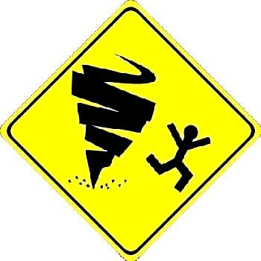 | - Be careful because of the strong wind.  - Beware of potential tornadoes.  - Run as fast as you can.  - You can play with winds.
- What does the sign mean? ____________________________________________
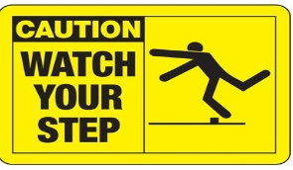 | - Pay attention to your steps when walking.  - Look at your feet when walking.  - Do not walk slowly.  - Be careful! Someone is falling down.
Answers: 17. _______B____ 18. _____A______
Use the correct form of the word given in each sentence.
- We take _______ in being students of one of the most famous schools in this city. (proud)
- What is the ______ between the ao dai nowadays and the one 100 years ago? (different)
- The government has plans to _______ this city. (modern)
- Those boys are _______ to talk to. (interest)
- The earthquake in Kobe in 1995 caused _______ damage. (disaster)
- _______, people eat sticky rice cakes at Tet. (tradition)
Answers: 19. ___pride_______ 20. _____difference_____ 21. ___modernise_______
22. ___interesting______ 23. ____disastrous_____ 24. ___traditionally______
Read the passage, then choose TRUE or FALSE, A, B, C or D for each sentence.
I am writing to introduce to you a language school where you can improve your English. Instead of
learning on your own, as you are doing now, you should learn to speak English with others. The Academy of Language offers you a good and friendly environment to practice your English. They also have well-qualified teachers. There are classes at different levels in the afternoon and evening, and courses begin in the first week this November. If you are interested, you can phone 38765432 for further information.
Best of luck!
Hoang
- Minh is now learning English with a tutor.
- The teachers at the Academy of Language are young and inexperienced.
- Learners can take courses in the morning.
- People who want to attend classes there can phone the school to get information.
- The main purpose of the letter is ____________: | - The advantages of the above language school are:
- to introduce Hoang to a language school.  - to advertise a language school.  - to classify learners into suitable groups.  - to encourage leaners to study on their own. | - friendly environment and well-qualified teachers.  - different classes and courses.  - chance to practice English with others.  - All above are correct.
Answers: 25. ___FALSE_____26. ___FALSE_____ 27. ___FALSE_____ 28. ___TRUE_____
29. ___B_______ 30. _D_______
Rearrange the words, phrases and the punctuation marks to make sentences.
- me / went / I / camping / my / with / wish / a / friends / trip / on /. /
- every / and / one / weeks / to / Lan / usually / another / two / write / . / Maryam
Answers: 31. I wish my friends went on a camping trip with me.
32. Lan and Maryam usually write to one another every two weeks.
Write the second sentence so that it has a similar meaning to the first one.
- Try to recycle things and we will save natural resources.
- Peter is the tallest boy in his class.
- Do they have to look after the school garden every Saturday?
- It is raining hard, but they still want to go to school.
Answers:
33. If we try to recycle things, we will save natural resources.
34. No one else in Peter’s class is as tall as him. / …….as he. /……as he is.
No one else in his class is as tall as Peter.
35. Do they have to take care of the school garden every Saturday?
36. They still want to go to school although / though / even though it is raining hard.
They still want to go to school despite / in spite of being raining hard.
They still want to go to school despite / in spite of the hard rain.
Choose the word that does not have the same pronunciation of the underlined part as that in the rest
37. A. return B. product C. summer D. unpopular
38. A. thank B. they C. than D. these
Choose the word that does not have the same stressed syllable as that of the rest.
39. A. important B. structural C. chocolate D. national
40. A. develop B. generous C. adjective D. popular
Answers: 37. ___A_____ 38. ____A____ 39. _____A___ 40. __A______

ĐÁP ÁN ĐỀ ÔN 15
Choose the most appropriate word or phrase to fill in each blank.
1. “May I go out for just a while?” – “_________________”
- It’s a nice day! | - That’s great! | - Go ahead! | - Yes, you could!
2. Tidal waves are the result of an abrupt shift in the underwater________ of the earth.
- movement | - moment | - pollution | - celebration
3. Thousands of lives were saved________ the scientists had warned them about the tsunami.
- although | - however | - because | - therefore
4. Jane often drinks coffee in the evening, ________?
- doesn’t jane | - does not she | - does she | - doesn’t she
5. I suggest that you ________ buy a present for her on her birthday.
- may | - can | - should | - will
6. He wants to know________ we will have the seminar at the Town Hall.
- what | - when | - that | - where
7. - “Rita, I’d like________ a friend of mine, Lucie.” – “Pleased to meet you, Lucie!”
- to meet you | - introduce you to | - you see | - you to meet
8. The match takes place________ Saturday afternoon this week.
- of | - on | - after | - to
9. She is the girl ________ eyes are beautiful.
- her | - whom | - whose | - those
10. - “Why don’t we go to the cinema now?” – “________________”
- Will you join us? | - Yes, let’s! | C. I’d like it. | D. What play is it?
Answers: 1. ___C______ 2. _____A____ 3. ____C_____ 4. ____D_____ 5. ___C_____
6. ____B_____ 7. ____D_____ 8. ___B______ 9. ____C_____ 10. ____B____
Read the passage. Then decide which option best fits each blank.
One good reason for people to learn a foreign language is work. If your work involves regular contact with (11) ________ of foreign languages, being able to talk to them in their own languages will help you to communicate with them. It may also help you to make sales and to negotiate and secure contracts. Knowledge of foreign language may also increase your chances of (12) ________ a new job, getting a promotion or a transfer overseas, or of going on foreign business (13) ___________.
Many English-speaking business people don’t bother to learn other languages because they believe (14) ________ most of the people they do business with in foreign countries can speak English, and if they don’t speak English, interpreters can help. The (15) ________ of foreign language knowledge puts the English speakers at a disadvantage. In meetings, for example, the people on the other side can discuss things among themselves in their own language without the English speakers understanding, and using interpreters slows everything down. In any socializing after the meetings, the locals will probably (16) ________ more comfortable using their own language rather than English.
 | 11. A. talkers | B. sayers | C. tellers | D. speakers
 | 12. A. looking | B. finding | C. applying | D. offering
 | 13. A. trips | B. journeys | C. tours | D. holidays
 | 14. A. what | B. when | C. that | D. how
 | 15. A. use | B. study | C. fluency | D. lack
 | 16. A. now | B. feel | C. behave | D. come
Answers: 11. ___D____ 12. __B_____ 13. ___A_____ 14. ___C____ 15. ___D____ 16. ___B___
Look at the sign / picture. Choose the best answer for each sign / picture.
- What does the sign mean? ____________________________________________
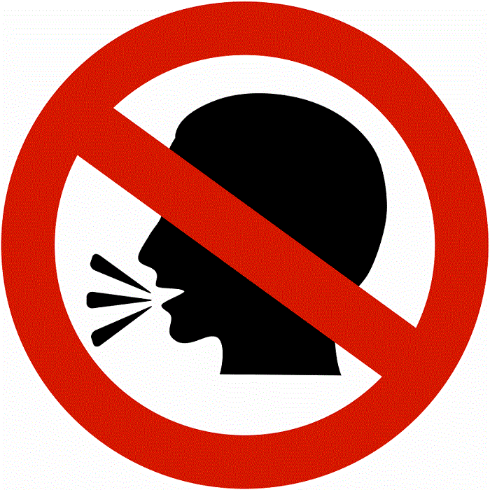 | A. You can shout here.  B. You should sing here.  C. You must keep quiet here.  D. You can talk here.
- What does the sign mean? ____________________________________________
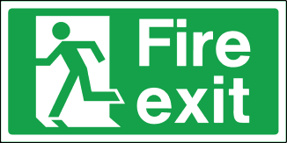 | - You should follow this way in case of fire.  - You must follow this way in case of fire.  - You ought to follow this way in case of fire.  - You can follow this way in case of fire.
Answers: 17. ______C_____ 18. __B_________
Use the correct form of the word given in each sentence.
- Their time spent in the countryside provided the ___________ for their novels. (inspire)
- The newspaper is published . You can get it everyday. (day)
- I never receive any to my email from her. (respond)
- Many walked around the tourist attraction to take photos. (sight)
- What were the reasons for the worldwide ___________ crisis? (economy)
- We should make the most efforts to stop . (forest)
Answers: 19. __inspiration________ 20. ____daily______ 21. ____response (s)______
22. ___sightseers______ 23. ___economic______ 24. ____deforestation_____
Read the passage, then choose TRUE or FALSE, A, B, C or D for each sentence.
My name is Phat, an exchange student. Here I am in America. My host family lives in Tucson, Arizona. I’m attending high school, seeing the country and studying lots of different subjects. As you know, I love athletics, so I’m doing some serious running, as the school sports facilities here are excellent. I’m also learning how to play baseball and American football.
I’m finding the high school environment very relaxed and quite different from school back home: no uniform, not many rules, and you can even eat and drink in class. We start school at 8 am and finish at 3 pm, so we have lots of time for sports and other activities. We take eight subjects in the semester and have one lesson in each subject every day. I can choose seven of the subjects myself – the only compulsory one is American history.
- Phat is now staying in Arizona on a study exchange program.
- Phat has been playing baseball for a long time and is very good at it.
- Students in his school wear nice uniforms.
- American history is an optional subject at his school.
- The sentence I’m doing some serious running means: | - The passage mainly discusses________:
- The writer is doing a lot of running.  - The writer is doing running seriously.  - The writer is interested in running.  - The writer is not really fond of running. | - The life in America of Phat.  - The education system of America.  - Phat’s studies in America.  - Phat’s study in America.
Answers: 25. ___TRUE_____ 26. __FALSE______ 27. ___FALSE_____ 28. __FALSE______
29. ___B_______ 30. ___C_____
Rearrange the words, phrases and the punctuation marks to make sentences.
- wearing / clothes / casual / makes / more / school / colorful / and / lively /. /
- has / the / the / subject / been / of / long / for / a / poems / time . / Ao dai
Answers: 31. Wearing casual clothes makes school more colorful and lively. (…makes school more lively and colorful.)
32. The Ao dai has been the subject of poems for a long time.
Write the second sentence so that it has a similar meaning to the first one.
- The exercise was so difficult that we couldn’t do it.
- He is sorry he is not able to speak English well.
- Tom passed the test easily.
- My friend cannot run as fast as me.
Answers:
33. It was such a difficult exercise that we couldn’t do it. / It was so difficult an exercise that we couldn’t do it.
34. He wishes he could speak English well. / … he was / were able to speak English well.
35. Tom had no difficulty (in) passing the test.
36. I can run faster than my friend.
Choose the word that does not have the same pronunciation of the underlined part as that in the rest
37. A. love B. united C. country D. unlike
38. A. control B. remote C. folk D. documentary
Choose the word that does not have the same stressed syllable as that of the rest.
39. A. policy B. element C. believing D. regularly
40. A. industrial B. possession C. property D. already
Answers: 37. ___B_____ 38. ____D____ 39. ___C_____ 40. ____C____

