UNIT 4 : LEARNING A FOREIGN LANGUAGE
PERIOD 5: READ ( HỌC SINH TỰ HỌC)
Task 1: Identified the types of these samples

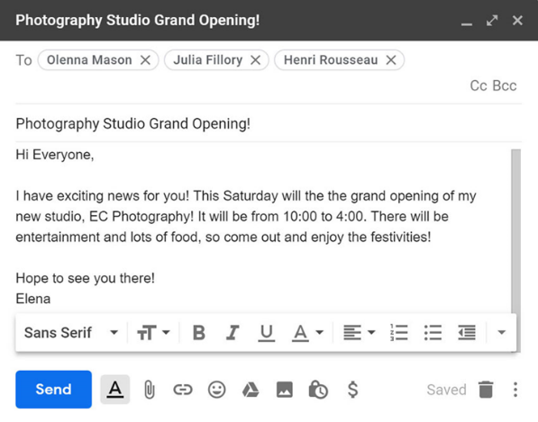
- 2.

3. 4.

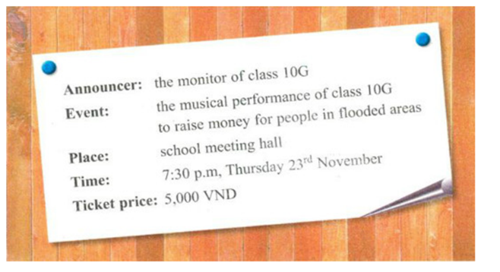

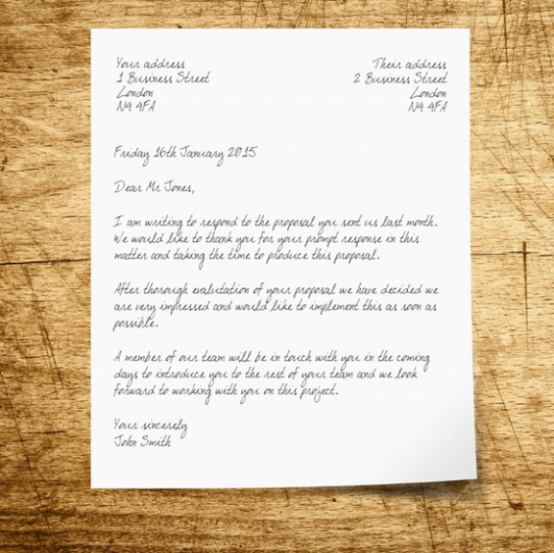
5.
Answer: 1. ____________ 2. ___________
3. ___________ 4. ____________
5. ____________

VOCABULARY:
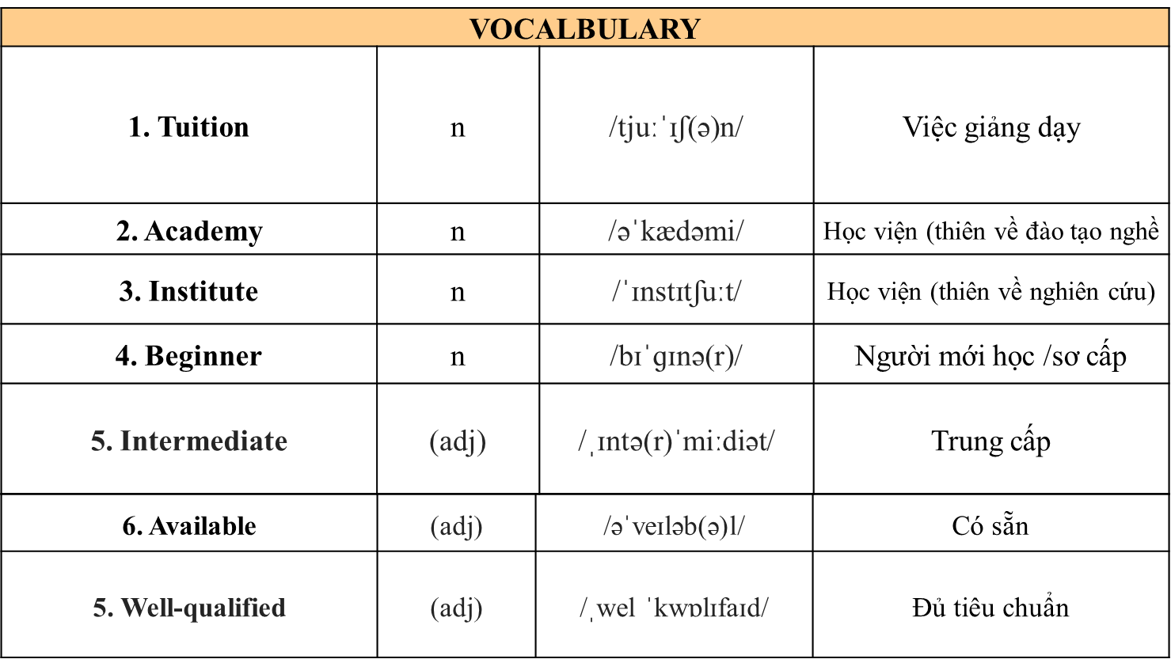

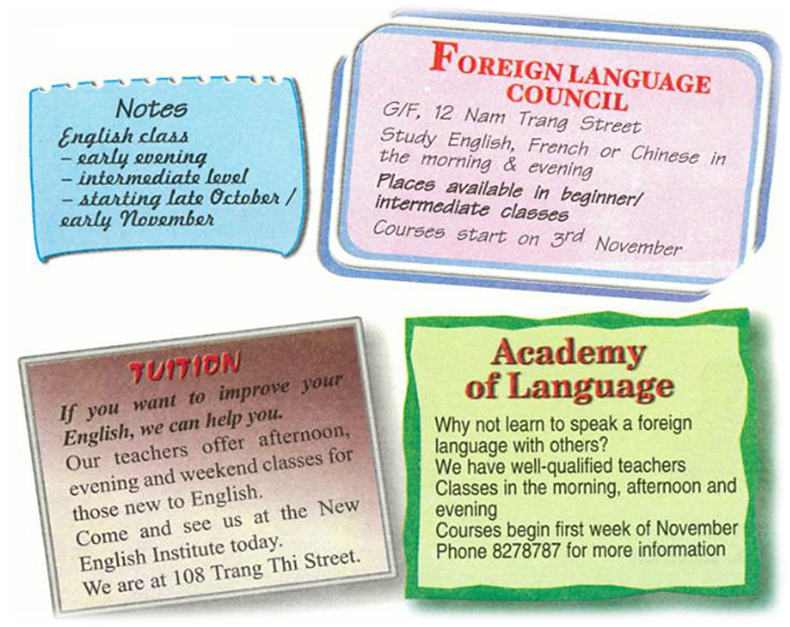
Task 2 : Read

a. Note down information about the English classes from the advertisenments.
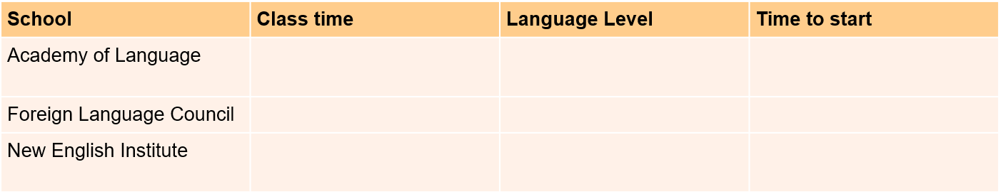

b. Read the notes Mr.Lam made. Then look at the advertisements and choose a suitable language school for him. Give reasons for your choice

Task 3 : Watch a short video then decide if the information is True or False
