1. Chọn câu đúng mô tả cho các bức tranh sau.
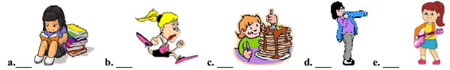
1. She is running very fast in order to win the race.
2. She plays the guitar so as to relax and make friends.
3. She ate a lot in order to gain weight.
4. She is putting on a jacket so as to keep herself warm.
5. She studied hard in order to pass the university entrance exam.
* Words and phrases:
- win (v) thắng - race (n) cuộc đua
- relax (v) thư giãn - make friends(v) kết bạn
- gain(v) tăng lên, đạt - weight (n) trọng lượng, cân nặng
- keep herself warm (v) giữ cho chính cô ấy ấm - pass (v) vượt qua, đỗ (kỳ thi)
- entrance exam (n) kỳ thi đầu vào - university (n) trường đại học
II-2. Chọn câu đúng mô tả cho các bức tranh sau.
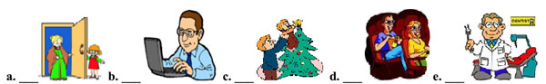
1. They are decorating a pine tree so as to celebrate Christmas.
2. We go to the cinema in order to watch a 4D film.
3. I go to the dentist twice a year so as to check my teeth.
4. Jane opened the door to welcome her grandma.
5. He works hard so as to support his family.
* Words and phrases:
- pine tree (n) cây thông - celebrate (v) tổ chức kỷ niệm
- decorate (v) trang trí, trang hoàng - film (n) bộ phim
- check (v) kiểm tra - dentist (n) nha sỹ
- welcome (v) chào đón - grandma (n) bà ngoại
- support (v) ủng hộ, giúp đỡ - cinema (n) rạp chiếu phim

II. Chọn đáp án đúng để hoàn thành câu.
1. My mother went to London ________ see my aunt's family.
A. in order to B. so that C. not to
2. Julie saves money ________ buy a new motorbike.
A. not in order to B. as so to C. so that she can
3. Sarah went to the photocopy shop ______ print out her research report.
A. so that B. to C. in order for
4. Concentrate on your exercise ___________make any mistakes.
A. not to B. so as to not C. in order not to
5. He is looking for a part time job _________ gain some hands-on experience.
A. so as to B. so as for C. so that

III. Change sentences into the passive (Present simple): (CÂU BỊ ĐỘNG)
1. Mr Hai delivers the letters everyday.
- ....................................................................................................
2. The children often buy the tickets at the box office.
- ....................................................................................................
3. They usually finish their homework before bed time.
- ..................................................................................................
4. The teacher corrects our exercises today.
- ..................................................................................................
5. We often watch the shows of music on TV .
- ..................................................................................................

IV. Change sentences into the passive ( Past simple).
1. Mrs Allen wrote that novel in 1998.
- ..................................................................................................
2. Nam borrowed the reference book from the shelf yesterday.
- ..................................................................................................
3. The boy ate two loaves of bread last sunday.
- ..................................................................................................
4. He left the letter on the desk some minutes ago.
- ..................................................................................................
5- My mother bought a new bike for me last month.
- ..................................................................................................

V- Complete the sentences, using "BE + ADJ + TO V ":
Ex: It/ lovely/ see/ you/ again. -> It is lovely to see you again.
1- I/ too execited/ do/ anything.
....................................................................................................
2- Lan / glad / see / her old friend again.
....................................................................................................
3- The students / worried / hear / the new information.
....................................................................................................
4- She / strong enough / carry / all those heavy bags.
....................................................................................................
5-Tam / intelligent enough / finish / the test / an hour.
....................................................................................................

