ĐỀ ON THI GIUA KY 2-TIENG ANH 7- from unit 5, 6, 7

- Choose the word whose underlined part is pronounced differently.(1pt)
- A. before B. report C. homework D. uniform
- A. excited B. annoyed C. pleased D. surprised
- A. subway B. luggage C. public D. support
- A. backpacks B. tickets C. customs D. passports
- A. tablespoon B. hamburger C. sandwich D. pancake
- A. pleased B. passed C. asked D. missed
- Choose the correct option to complete the sentences (3.5pts) :
7. Sammy studied really hard, so she ______________ all of her tests.
A. passed | B. failed | C. got | D. did
8. Student A: How’s the course going?
Student B: I’m ______________ enjoying it.
A. very | B. much | C. really | D. a lot
9. Ivy was so ______________ because she failed two tests last semester.
A. pleased | B. delighted | C. relaxed | D. upset
10. We ______________ buy lunch in the canteen. There’s a shop next to the school and it sells sandwiches and other snacks.
A. have to | B. don’t have to | C. mustn’t | D. should
11. The teacher asked us to choose a book from the list, read it at home and then write a ______________ about it.
A. project | B. presentation | C. report | D. revision
12. Our math teacher, Mr. Thomas, is funny and friendly, but he gives us too much ______________ to do after school.
A. homework | B. exams | C. essays | D. exercise
13. Nick got 100% on his physics test. His twin brother, Adam, ______________, had to retake the test.
A. although | B. but | C. so | D. however
12. I’m really ______________ with Nick. We have an important biology project, but he doesn’t do his part.
A. hopeful | B. annoyed | C. pleased | D. excited
13. Yesterday, I wrote a(n) ______________ about the benefits of studying overseas, and the teacher said it was good.
A. homework | B. test | C. essay | D. paper
14. Student A: I’m going to the movies this evening. Do you want to join me?
Student B: ______________. I have too much homework to do.
A. Sure, I can. | B. Thanks, but I don’t think I can. | C. Of course, I will. | D. Thanks, but sorry, I’m not.

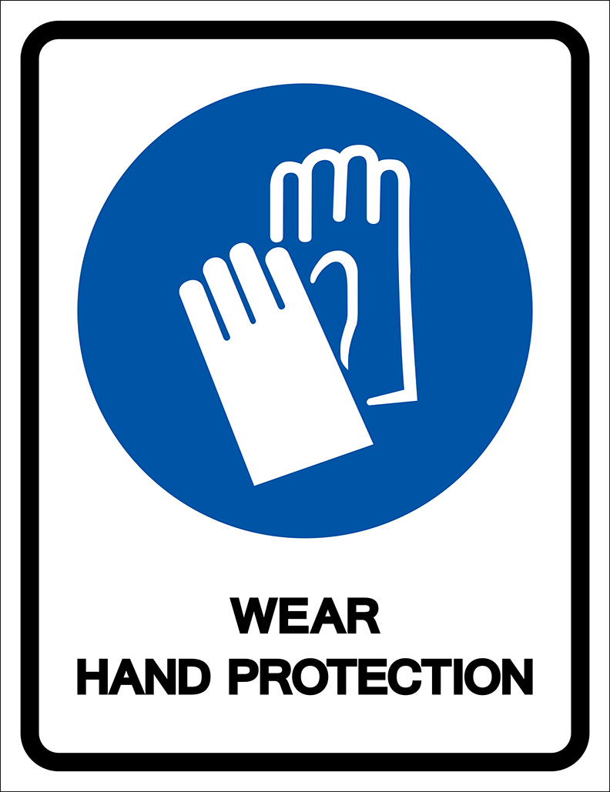
15. Read the notice and choose the correct statement.
A. You have to wear gloves when you enter this place. | B. You don’t have to wear gloves in this place. | C. It’s a good idea to wear gloves in this place. | D. You need to bring gloves to this area.

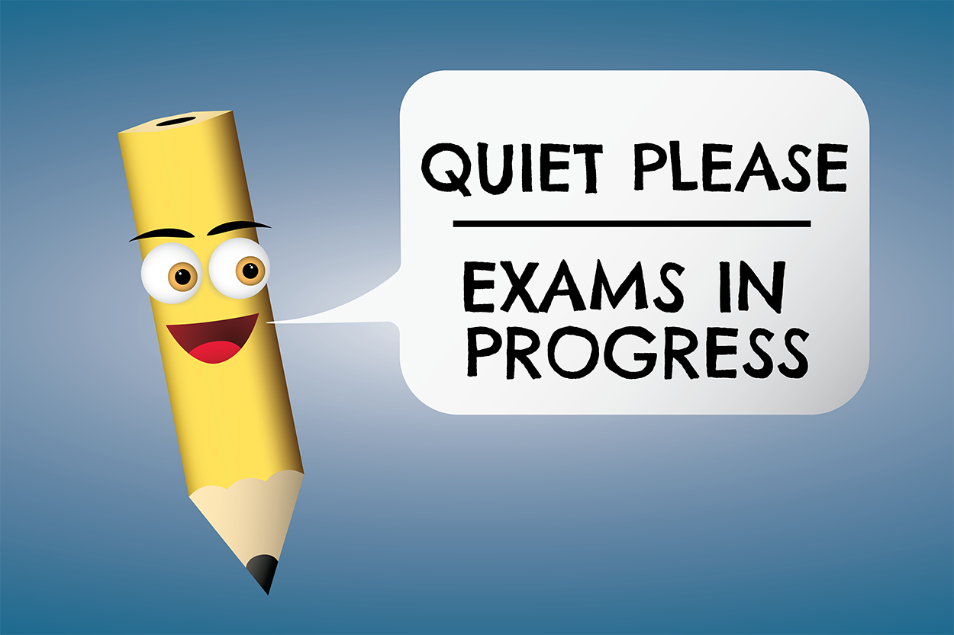
16. What does this sign mean?
A. You don’t have to talk in this area. | B. You have to keep silent in this area. | C. You have to take the exam in this area. | D. You don’t have to make any noise during the exam.

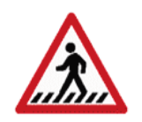
- What does the sign say? Choose the best option.
A. Cross the street here.
B. Walk slowly.
C. Don't run.
D. walk on the grass.
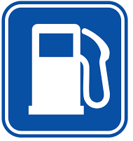
- What does the sign say? Choose the best option.
A. You can buy water here.
B. A petrol station is nearby.
C. Be careful. It can cause fire.
D. you can watch the TV.
19. . Make sure you don’t take the wrong bag at the ______________.
A. custom | B. security | C. boarding | D. baggage claim
20. Bicycles are ______________ for the environment than cars.
A. better | B. more | C. as good | D. the best
21. For commuting in our city, ______________ form of transportation is the bus because it’s ______________ than going by car or taxi.
A. the most popular / the cheapest | B. the most popular / cheaper | C. more popular / cheaper | D. more popular / the cheapest
22. There are ______________ buses from Tân Sơn Nhất airport to the city center. Buses depart every 15 minutes.
A. friendly | B. public | C. easy | D. frequent
23. Korea has excellent ______________. The buses are regular and the trains are on time.
A. vehicle | B. transport system | C. public transportation | D. moving system
24. Person A: Is this Andy’s backpack?
Person B: No, it isn’t. He has a ______________ backpack.
A. new big dark blue | B. big new dark blue | C. dark blue big new | D. new dark blue big
25. Person A: Whose suitcase is this?
Person B: It has Jodie and Jack’s names on it, so it must be ______________.
A. their | B. they | C. them | D. theirs
26. Officers will check your luggage when you go through ______________.
A. airport | B. baggage claim | C. customs | D. check-in
27. It’s very important to keep your ______________ in a safe place. You need this document to enter or leave a foreign country.
A. passport | B. boarding pass | C. ticket | D. luggage
28. Person A: Excuse me, does this bag belong to you?
Person B: ______________. Thank you a lot.
A. Yes, it’s my. | B. Yes, it’s mine bag. | C. Yes, my bag is this. | D. Yes, it’s mine.
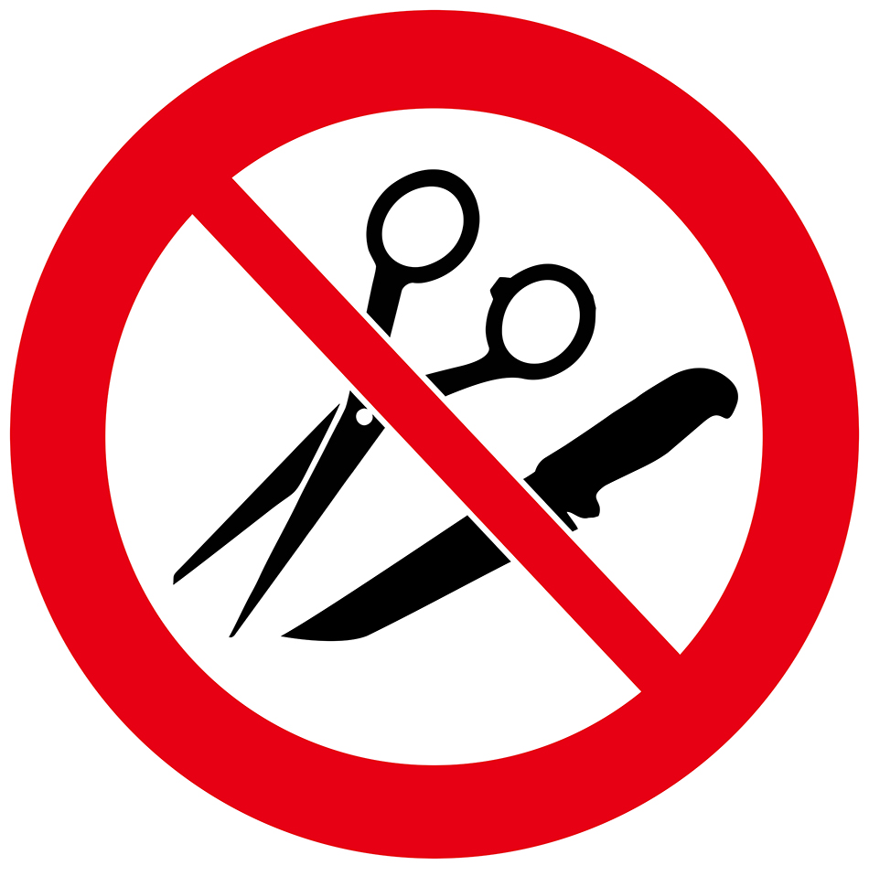
29. What does this sign on the plane mean?
A. You can’t use scissors and knives at the same time on the plane. | B. You can’t buy any scissors or knives on the plane. | C. You can’t bring any sharp objects on the plane. | D. You can’t use scissors or knives because they are sharp.

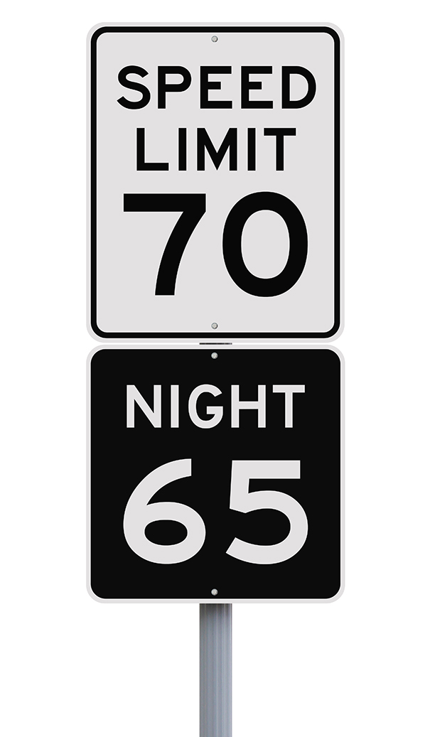
30. What does this sign mean?
A. You have to drive slower at night than during the day. | B. You can’t drive faster than 70 miles per hour at night. | C. You have to go at 65 kilometers per hour at night. | D. The fastest speed you can drive is 65 miles per hour.

- Does she have . . . . . . eggs left in your fridge? ( many/ any/ much/ how )
- Some fruit growing together, like bananas or grapes ( flour/ bunch/ tablespoon/ butter )
- People in my town, Vinh long, eat . . . . ( grill bats/ worms/ fried crickets/ grill mice)
- He didn’t study hard, so he . . . . some tests. ( passed/ surprised/ failed/ reported )
- Mary studied really hard, so she . . . . . all of her tests. ( pleased/ failed/ go/ passed )
- Ivy was so . . . . because she failed two tests last semester. ( pleased/ delighted/ relaxed/ upset )
- The teacher asked us to choose a book from the list, read it at home and then write a . . . . about it ( project/ presentation/ report/ revision )
- Our math teacher Mr. Hai, is funny and friendly, but he gives us too much . . . to do after school ( homework/ exams/ essays/ exercise )
- I’m really . . . . . . with Nick. We have an important biology project and he does his part. ( hopeful/ annoyed/ pleased/ excited )
- Yesterday, I wrote a (n) . . . about the benefits of studying overseas, and the teacher said it was good. ( homework/ test/ essay/ paper )
- He’s so . . . . . because he passed his test. ( happy/ annoyed/ disappointed/ upset )
- The bus isn’t as . . . . . . . . .. as a taxi. ( expensive/ cheap/ eco-friendlier/ quicker )

- Read the following passage. For each question, choose the correct option that best suits each blank. (5 questions)
Studying abroad is becoming popular for many students looking to learn more about other languages and countries. Sometimes, students (23)___________ work with an online exchange organization to make travel arrangements and make sure they have a wonderful and safe experience while away.
Studying abroad is also a (24)___________ way to meet new friends, visit new places, and experience different things. Students are (25)___________ to learn about new opportunities and meet people from other cultures. (26)___________ learning in a foreign country can be difficult, they are pleased when they (27)___________ their first test, complete their first project, or meet amazing new people. Overall, it’s a great way to travel to other countries and learn more about the world.
(23) | A. have | B. have to | C. to have | D. has to
(24) | A. great | B. terrible | C. pleased | D. surprised
(25) | A. upset | B. disappointed | C. annoyed | D. delighted
(26) | A. Because | B. Although | C. However | D. So
(27) | A. present | B. fail | C. pass | D. make

- Read the following passage. For each question, choose the correct option. (5 questions)
Last summer, I was planning on taking an airplane for the first time, but there were many things I didn’t know. For example, how many suitcases should I take or what can I bring in my backpack? So, I asked my mom for help, and she told me that the more luggage you bring, the more expensive the ticket is. So, she suggested bringing only the things I needed. She also told me not to take dangerous items like large batteries or sharp objects because I’ll have to go through customs. My mom also said not to lose my boarding pass or passport because I’d need them to get on the plane. Finally, she told me I needed to find the baggage claim after the airplane landed to pick up my suitcases. I’m happy my mom was able to help me know more about air traveling because it made the experience better.
Questions:
28. The more luggage you bring,…
A. the more expensive the ticket is. | B. the more it weighs. | C. the more trouble you can get in. | D. the less you carry.
29. Why do you need a boarding pass and passport?
A. to leave the airport | B. to get on the airplane | C. to bring your luggage | D. to purchase food
30. Where do you pick up your suitcases after the airplane lands?
A. the ticket counter | B. the lounge | C. the security office | D. the baggage claim
31. Why is it important to know how to travel on an airplane?
A. The ticket is expensive. | B. It makes the experience better. | C. Taking an airplane is faster. | D. Bringing extra luggage costs more.
32. What is true about the story?
A. It’s important to use the seatbelt. | B. There are many places to eat at the airport. | C. There are many things to know about flying on an airplane. | D. You can get lost at the airport.

- Read the following passage. For each question, write T if the statement is TRUE, F if the statement is FALSE, and NI if there is NO INFORMATION on it. (5 questions)
When Sophie was a little girl, she dreamed about visiting another country. One day, while looking on the internet, she was surprised to learn about a way to travel and study abroad. First, Sophie would have to decide which country to visit. She would also need to learn a foreign language to take tests and write essays. Sophie quickly knew it would take a lot of work to make her dreams come true, so she began working with her parents on making plans.

Sophie was so excited about her future that she spent an entire summer working with her dad to save money. She also took French lessons because she always dreamed about traveling to Paris. The following summer, Sophie was accepted into an exchange program and spent a year traveling and studying abroad.

Answers | True | False | Not given
28. Sophie made her dreams of traveling abroad come true by working hard. | ◯ | ◯ | ◯
29. Sophie didn’t have to learn a foreign language. | ◯ | ◯ | ◯
30. Sophie planned to take a train to Paris. | ◯ | ◯ | ◯
31. Sophie worked with her dad to save money. | ◯ | ◯ | ◯
32. Sophie spent one whole summer studying abroad. | ◯ | ◯ | ◯

VI. Write the correct form of the words in brackets.
17. I was so ___________ because I got an A plus on my English test. (SURPRISE)
18. In my English class, we have to give ___________ about various topics. (PRESENT)
19. Philip was really ___________ when he got a D on his math test. He studied very hard for it.
(DISAPPOINT)
17. I think electric cars are more ___________ than petrol cars because they don’t produce air pollution.
(FRIEND)
18. Buses in this country aren’t ___________. They’re often late.
(RELY)
19. Traveling by train is the best option for long-distance travel. They are clean, ___________ and punctual.
(COMFORT)
20. MTR (Mass Transit Railway), with ten lines and more than 70 stations, is the most ___________ way of traveling in Hongkong.
(CONVENIENCE)
21. I like traveling by motorbike because it’s a great way to get around Hồ Chí Minh city ___________.
(QUICK)

VII. Rewrite each of the following sentences in another way so that it means almost the same as the sentence printed before. (2.5pts)
1. Although / Ann / not like / sports / she / have / play / basketball / P.E. lessons.
→Although . . . .
2. I / pass / all / exams / so / parents / were / so / delighted.
→ I . . .
3. The boys find playing soccer interesting.
The boys are interested in playing soccer.
4. It is so annoying when people don’t listen to me.
I feel annoyed when people don’t listen to me.
- The reason why many people like using the subway is that it is fast.
Because the subway is fast, many people like using it
- How fast can the airship travel?
What's the speed of the airship?
- The subway can help solve traffic problems in this city.
The subway is a solution to traffic problems in this city
- are/Buses/because/more people/carry/eco-friendly/they/can
- Buses are eco-friendly because they can carry more people
- are/ my/ because/ so/ I/ passed/ parents/ exams. / all/ My/ delighted.
My . . . .
- his/ test. / math/ annoyed/ failed/ very/ because/ He’s/ he.
He’s . . .

END

