BÀI TẬP ANH 8 – TUẦN 18
I/ Choose the most appropriate word or phrase to fill in each blank:
- Could you do me a favor? - ____________________________
Certainly. | No, thank you. | I’m busy. | You’re welcome.
- Let me help you! - Yes, that’s very kind _________________________ you.
in | for | of | from
- The prince immediately fell in love _________________________ Little Pea.
about | of | with | for
- He decided _________________________ a new car for his daughter.
buy | buying | bought | to buy
- She arrived early _________________________ the whole film.
so that to see | so as to see | in order see | in order that to see
- They _________________________ talk loudly in the library.
mustn’t | have to | should | shouldn’t to
- The farmer said he had something called _________________________, but he left it at home.
wise | intelligent | good | wisdom
- He usually _________________________ or highlights only the words he wants to learn.
underlines | underlined | understands | understood
- We receive 400 _________________________ for the job every day.
hobbies | activities | favors | applicants
- Students should _________________________for the activities for this summer before June.
encourage | participate | enroll | join
- Choose the right statement of the picture: ________________________________________________
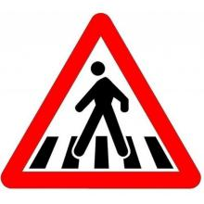 |  | Walkers can use this road.  Walkers mustn’t go on this road.  Cars can use this road.  Cars are not allowed to go on this road.
- Choose the right statement of the picture: ___________________________________
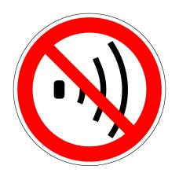 |  | You should hear noise every day.  Noise is good for our ears.  You mustn’t make noise.  You must make a lot of noise.

II/ Word form
- Chatting is the most popular _________________________ at recess. (act)
- Last summer, my family had an _________________________ holiday in Nha Trang. (enjoy)
- She should _________________________ her English pronunciation. (improvement)
- Students may get good _________________________ in famous university. (educate)
- My grandmother can read magazines _________________________ without glasses. (good)
- She was _________________________ enough to believe him. (fool)
III/ Sentence transformation
- The doctor said to Tim, “You should go to bed soon”.
=> The doctor told ___________________________________________
- The teacher said to her students, “Do all your exercises before going to school”.
=> The teacher ordered_______________________________________
- Most people love sending cards to their friends at Christmas.
=> Most people are___________________________________________
- He intends to travel around America next month.
=> He is____________________________________________________

