HELLO EVERYONE, ĐÂY LÀ BÀI HỌC HÔM NAY, CÁC EM NHỚ GHI VÀO TẬP
TUESDAY, JANUARY 2 ND, 2021
UNIT 10(CONT)
SECTION C: MY FAVORITE FOOD
+ NEW WORDS:
- carrot (n) củ cà rốt
- tomato (n) quả cà chua
- lettuce (n) rau diếp
- bean (n) hạt đậu
- potato (n) củ khoai tây
- cabbage (n) bắp cải
- onion (n) củ hành
- favorite = favourite (adj) ưa thích
- lemonade (n) nước chanh
- tea (n) trà
-> iced tea : trà đá
- apple juice (n) nước táo
- soda (n) sô đa
+ Grammar: LIKE (THÍCH)
(+) S + like/ likes + Noun/Ving/to V
(-) S + don’t/doesn’t + like
(?) Do/Does + S + like?
-> Yes, S + do/does
No, S + don’t/doesn’t.
Example:
My brother likes playing/ to play video games. ( Ving/to V)
I don’t like fish. (N)
Does she like chicken?
-> Yes, she does.
Lưu ý: chúng ta có thể dùng very much với like. Very much đứng trước like hoặc sau tân ngữ.
Ex: I very much like ice-cream.
I like ice-cream very much.

Các em vào link dưới để nghe đọc và lặp lại nha.
https://vietjack.com/tieng-anh-6/unit-10-my-favorite-food.jsp
Hỏi và trả lời: What are these? -> They are .....
What are those? -> They are........
- Cũng file nghe đó, các em nghe và lặp lại đoạn hội thoại ở task 2 và 3
- Task 4: hỏi và trả lời về thức uống ưa thích của bạn
+ Do you like cold drink?
-> Yes, I do.
+ What do you like?
-> I like iced tea. It’s my favorite drink.

HOMEWORK:
- Learn by heart new words and grammar.
- Copy them,
- Prepare unit 11 section A1

ĐÂY LÀ BÀI TẬP NHA. CÁC EM LÀM TRONG HÔM NAY, MAI CÔ GỬI ĐÁP ÁN CHO NHA

MULTIPLE CHOICE:
- Would you like …………..chicken? –No, thanks .I’m full
A. a B. an C. some D. any
2. I like ........................... because I like reading stories
- literature B. math C. physics D. P.E
- I’m …………………..I would like to eat some bread .
- Hungry B. thirsty C. full D. tired
- Tomatoes, potatoes, lettuce, carrots, beans are …………………..
- drinks B. fruit C. food D. vegetables
- Tea, milk, soda, coffee, fruit juice is cold ………………..
- food B. drink C. fruit D. vegetables
- Oranges, bananas, apples, grapes are………………….
A. food B. drinks C. vegetables D. fruit
- Ba is tired. He would like ……………..down.
A. sit B. to sit C. sits D. sitting
- Mary doesn’t want …………….apples.
- a B. an C. some D. any
- Mary eats some bread with …………..egg.
- a B. an C. some D. any
- . …………….does Mary feel?
- What B. How C. Who D. Where
- . I love to learn about mountains and rivers, so I like .....................
- geography B. physics C. math D. I.T
- What is there …………………? There are some bananas.
A. to drink B. to read C. to watch D. to eat
- There ………………..any coffee in the cup.
- isn’t B. is C. are D. aren’t
- …………………there any fruit?
A. am B. is C. are D. does
- Studying ...............helps me learn about countries around the world and famous people in the past
- music B. history C. biology D. physics
- What …………we ……………….for dinner?
- do/ have B. do/ has C. does/ has D. does/ have
- What‘s the matter ……………..Dung?
A.in B. for C. to D. with
- There are some noodles ……………..the bowl.
- on B. in C. for D. of
- There are four bowls ……………..fried rice.
- of B. in C. on D. with
- What …………Mr. and Mrs. Ba……………..? – They want some noodles

would/ likes B. do / like C. do/ want D. does/ want
IV. CAUTION SIGNS- WARNINGS:

- This sign means:
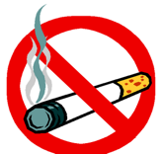

A. You can’t buy cigarettes here. B. We can smoke here.
C. You can’t smoke here. D. You can walk here.
- This sign means:
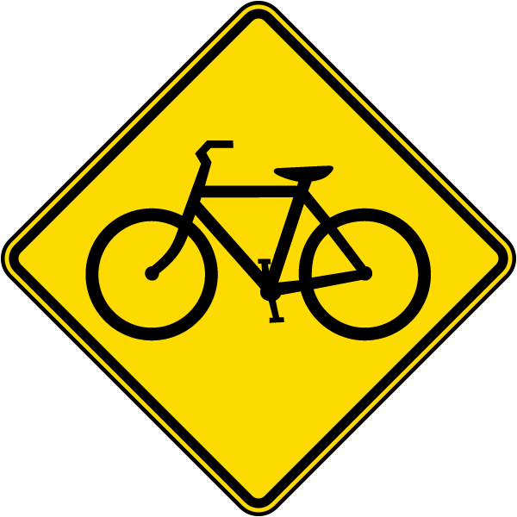
A. Trucks are allowed. B. Bicycles are allowed.
C. Motor vehicles are allowed. D. Bikes are not allowed.

- This sign means:

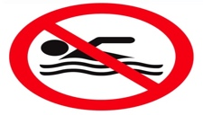
A. No jogging. B. No chatting.
C. No walking. D. No swimming.

- What does the sign say?

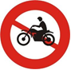
A. Motorbike can stop.
B. Motorbike isn’t allowed to ride.
C. Motorbike can’t stop.
D. Motorbike is allowed to ride.

- Where can we see this sign?

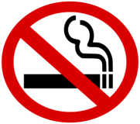
A. In public areas.
B. At school.
C. In the hospital.
. D. All are correct.

V. GUIDED CLOZE TEST:
Choose A, B, C or D that fit best fits the blank space in the following passage:
1. My sister and I like Chinese noodles very much. We often eat it in a (1)................... with (2)..................... friends. Sometimes, our mom cooks for (3).............. at home. Her (4)................... food is Kebab, a Korean dish. However, we (5).................. it. It (6) ………….. strange.
1. A. drugstore B. bookstore C. clinic D. restaurant
2. A. our B. your C. his D. her
3. A. we B. they C. them D. us
4. A. possible B. favorite C. likely D. interesting
5. A. not like B. don’t like C. doesn’t like D. aren’t like
6. A. taste B. tastes C. tasting D. to taste

2. Today, (1).............. the canteen, there are a lot of dishes: soup, noodles, fruits and drinks. Ba is (2)................., so he only gets a soda. Han and Lan are hungry, so they call 3 plates of dry (3) …………….. I don’t call anything, because I am (4)................ Then, we get three (5).............. of snacks before (6) ……… back in class.

1. A. in B. at C. on D. within
2. A. thirsty B. tired C. hungry D. cold
3. A. potatoes B. rice C. meat D. noodles
4. A. tired B. cold C. hot D. sad
5. A. boxes B. packs C. cups D. bags
6. A. coming B. comes C. to come D. are coming

