NỘI DUNG HỌC TẬP TUẦN 5
MÔN: TIẾNG ANH KHỐI: 8
TIẾT 1
UNIT 3: AT HOME
I. VOCABULARY
# | Word |  | Meaning | Example
1 | Base | beneath /bɪˈniːθ/ (adv.) | ở dưới | Her eyes had dark shadows beneath them.
2 | Base | chore /tʃɔːr/ (n) | công việc trong nhà, việc vặt | I'll go shopping when I've done my chores.
3 | Base | coffee table /ˈkɒfi ˈteɪbl̩/ (n) | bàn uống nước | The coffee table is in the middle of the living room.
4 | Base | cupboard /ˈkʌbərd/ (n) | tủ chạn, tủ li | It's in the kitchen cupboard.
5 | Base | cushion /ˈkʊʃn/ (n) | cái nệm, gối tựa | She sank into the cushions.
6 | Base | frying pan /ˈfraɪɪŋ pæn/ (n) | chảo | Frying pans with the durable non-stick coating are preferred by most housewives.
8 | Base | garbage /ˈɡɑːbɪdʒ/ (n)  = trash | rác | Don't forget to take out the garbage.
9 | Base | magazine /ˌmæɡəˈziːn/ (n) | tạp chí | She has written articles for several women’s magazines.
10 | Base | rug /rʌɡ/ (n) | tấm thảm | My dog loves lying on the rug in front of the fire.
11 | Base | saucepan /ˈsɔːspæn/ (n) | cái xoong | Heat the oil and garlic in a large saucepan.
 | steamer | / ˈstiːmər/ (n) | nồi hấp, nồi đun hơi | A steamer is the kitchen appliance used to cook food with steam.
12 | Base | sink /sɪŋk/ (n) | bồn rửa bát | Put all these dirty plates in the sink!
II. LISTEN & READ
Exercise 1: Listen and practice the conversation above:
Exercise 2: Read the dialogue again. Complete the list of the things Nam has to do
- cook dinner
- …………………….
- …………………….
- …………………….
- …………………….
Exercise 3: Answer the following questions:
1. Is Nam’s mother going to be home early?
………………………………………………………………………………
2. Where is she going to after work?
………………………………………………………………………………
3. Can Nam cook?
………………………………………………………………………………
4. What does Nam need to buy?
………………………………………………………………………………
5. Where is steamer?
………………………………………………………………………………
6. Where is the rice cooker?
………………………………………………………………………………
7. Who is Nam going to call?
………………………………………………………………………………

TIẾT 2
III. SPEAK (Học sinh tự học)
Exercise 4: Look at the picture below and practice telling the position of the objects in the room.
Trong bài tập này, học sinh phải ôn tập lại kiến thức về giới từ chỉ nơi chốn, từ vựng về các vật dụng trong gia đình. Sau đó đặt câu miêu tả về vị trí của các vật đó.
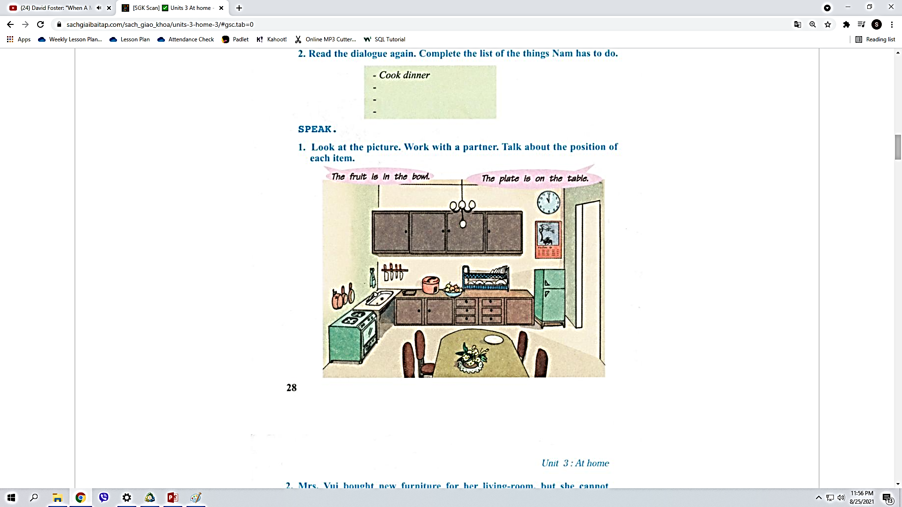
Exercise 5: Look at the picture below and complete the conversation below with your arrangements.
Xem tranh ở phía dưới, điền vào các từ trong khung màu xanh vào đoạn hội thoại ở phía dưới.

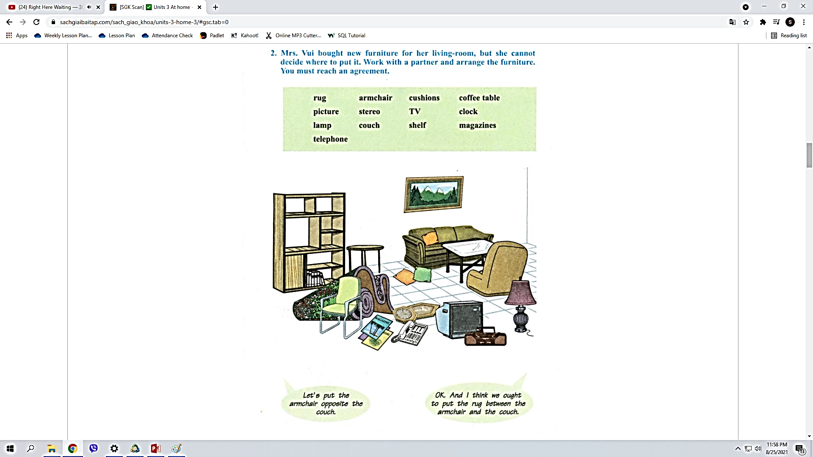
A: Let's put the couch against the wall.
B: OK. I think we ought to put the (1) ________ opposite the couch.
A: OK. And think we ought to put the (2)________in front of the armchair and the couch. How about the (3) ________ ?
B: I think we ought to put it on the floor under the coffee table.
A: Good idea! Let's hang the (4) ________ on the wall above the couch.
B: OK. And I think we ought to put the lamp in the corner next to the couch.
A: How about the shelves?
B: I think the shelves ought to be on the wall opposite the couch.
A: Great! And I think the TV and the stereo should be on the opposite wall across from the shelves.
B: Let's hang the (5) ________ on the wall to left of the picture.
A: I think we should hang it on the wall above the shelves.
B: OK. Let's put the telephone on one of the shelves. How about the cushions?
A: I think we should put them on the (6) ________.
B: Let's put the magazines on the coffee table.
A: OK.

TIẾT 3
III. Listen
* Vocabulary
New word | Part of speech | Pronunciation | Meaning | Example
Special Chinese fried rice | noun | / ˈspeʃl ˌtʃaɪˈniːz fraɪd raɪs/ | Fried rice made in China includes rice, meat and vegetables, soy sauce and garlic. | My favorite dish is Special Chinese fried rice.
Pan | noun | / pæn / | a round metal container that you use for cooking | My mother uses a frying pan to make fried rice.
Ham | noun | / hæm / | pig's meat from the leg or shoulder, preserved with salt or smoke. | I usually have a breakfast of ham and eggs.
Exercise 6: Post listening – Answer the questions
In your opinion, what is the ingredients of fried rice?
…………………………………………………………………………………………………………..…………………………………………………………………………………………………………..
…………………………………………………………………………………………………………..
…………………………………………………………………………………………………………..
…………………………………………………………………………………………………………..
…………………………………………………………………………………………………………..
…………………………………………………………………………………………………………..
Exercise 7: Rearrange the recipe of making delicious fried rice in the correct order?
a/ Use the big pan and put a little oil in.
b/ Put the rice and a teaspoon of salt in.
c/ Cook rice.
d/ Wait until it’s hot and then fry the garlic, green pepper, ham and the peas.
e/ Serve the dish.
The correct order is: _______________________________________________
* Bổ sung video tự học từ vựng:
https://www.youtube.com/watch?v=5TMfrIvewN0
Trong tuần này, học sinh sẽ tương tác trực tiếp với giáo viên trong 2 tiết: tiết 1+2 sẽ thực hiện nội dung mục I: Listen and read và III: Listen. Tiết 3 học sinh sẽ tự học và hoàn thành nội dung trong mục II: Speak và xem thêm link tự học từ vựng ở trên.

