Unit 10:
HEALTH AND HYGIENE

B. A BAD TOOTHACHE
Lesson 2:

Review: Irregular Verbs

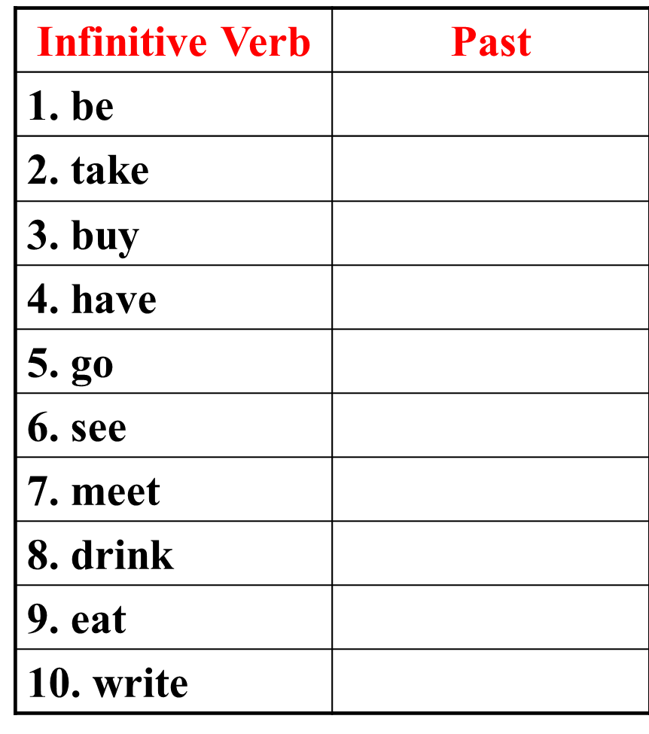

Simple past tense
Review:

Affirmative:
1.
S + V2/ V-ed + O .

S + didn’t + V1 + O.
Negative:
2.

3.
Yes/ No Question:
Did + S + V1 + O?

4.
Wh-word + did + S + V1 + O?
Wh- Question:
Key Words:
yesterday, ago, this morning, last week, ...
Ex: Hoa made a skirt yesterday.

What did Hoa make yesterday?
Did Hoa make a skirt yesterday?
Hoa didn’t make a skirt yesterday.

I. New words:
- matter (n)
- toothache (n)
: vấn đề
- scared of (a)
- stomachache (n)
: đau bụng
- backache (n)
: đau lưng
- cavity (n)
- surgery (n)
- drill (n)
: máy khoan
: đau răng
- appointment (n)
: cuộc hẹn
: phòng khám
: (sự) khó khăn

: sợ hãi
: lỗ răng sâu

- difficult (a)
difficulty (n)

: quên
: cảm thấy
- feel (V₁)
(V₂): felt
- forget (V₁)
- feed (V₁)
(V₂): fed
(V₂): forgot
: cho ăn
- remind (V₁)
(V_{-ed}): reminded
: nhắc nhở
: sửa chữa
(V_{-ed}): fixed
- fix (V₁)

- regular (a)
regularly (adv)
- sensible (a)
sensibly (adv)
- fill (V₁)
(V_{-ed}): filled
: trám, lắp đầy
- check (V₁)
(V_{-ed}): checked
: kiểm tra
- serious (a)
seriously (adv)

: (một cách) nghiêm trọng
: (một cách) thường xuyên

: (một cách) điều độ

Fill in the blanks
1. I have an ........................ with the dentist at 8 a.m
2. Dr. Lai filled the …………… in Minh’s tooth.
3. Don’t forget to brush your teeth …………….. .
4. She ......……… her students to practise English.
5. Remember to eat …………..... .
reminded
regularly
cavity
appointment
sensibly
sew

II. Grammar:
Why (Tại sao)
Because (Bởi vì)
Ex1: Why was she absent from class yesterday?
Because she was sick.
Ex2: He went to see the dentist because he had a toothache.
(Make question with underlined words.)
Why did he go to see the dentist?

- Learn by heart the new words.
- Do exercises in workbook / Unit 10 / B and Test for Unit 10.
Homework

