NỘI DUNG BÀI HỌC MÔN TIẾNG ANH LỚP 9
Tuần 12: 21/11/2022-26/11/2022
UNIT 4: LISTEN AND WRITE
Lesson 2
No | Words | Class | Transcription | Meaning
13 | clean up | (v) | /klin ʌp/ | dọn dẹp
14 | donate | (v) | /ˈdoʊˌneɪt/ | ủng hộ
15 | plant | (v) | /plænt/ | trồng cây
16 | raise | (v) | /reɪz/ | gây quỹ
17 | recycle | (v) | /riˈsaɪkəl/ | tái chế
18 | soup kitchen | (n) | /sup ˈkɪʧən/ | súp gà
19 | volunteer | (v) | /ˌvɑlənˈtɪr/ | tình nguyện làm gì

Lesson 3
No | Words | Class | Transcription | Meaning
20 | clean-up | (n) | /klin ʌp/ | buổi dọn dẹp
Lesson 2
I. Look at the words in the box and write the suitable word for each picture.
boring interesting fun terrible exciting beautiful

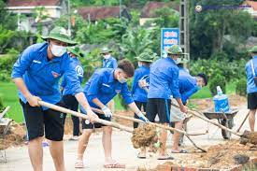 |  | 
1. __________ | 2. __________ | 3. __________
 |  | 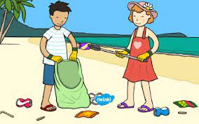
4. __________ | 5. __________ | 6. __________

7. __________

II. Give the correct form of the verbs in brackets.
1. Last Saturday, Anna and his friends (volunteer)__________ at the soup kitchen.
2. We (clean up)__________ the park near our school last weekend.
3. My parents (raise)__________ money to help the local children's hospital two years ago.
4. Last week, lots of students (donate)__________ books and clothes they (not use)__________ any more to poor children in their town.
5. Our school (collect)__________ all of the donations and sent them to poor people.
6. They (plant)__________ frees in the streets to make their town cleaner.
7. Jenny (take)__________ a lot of photos last week.
8. My brother (wash)__________ his car yesterday morning.
9. We (help)__________ some poor children in our neighborhood study English last year.
10. We (plan)__________ to recycle all those papers two weeks ago.

