NỘI DUNG BÀI HỌC MÔN TIẾNG ANH LỚP 7
Tuần 14: 05/12/2022-10/12/2022
UNIT 5: FOOD AND DRINKS
A. VOCABULARY
Lesson 1
No | Words | Class | Transcription | Meaning
1 | flour | (n) | /ˈflaʊər/ | bột (mì, ngũ cốc)
2 | gram | (n) | /græm/ | gam
3 | lemon | (n) | /ˈlɛmən/ | quả chanh
4 | milliliter | (n) | /ˈmɪləˌlitər/ | mi-li-lít
5 | onion | (n) | /ˈʌnjən/ | củ hành
6 | spaghetti | (n) | /spəˈgɛti/ | mì ống
7 | tablespoon | (n) | /ˈteɪbəlˌspun/ | thìa (muỗng) canh thìa
8 | teaspoon | (n) | /ˈtiˌspun/ | (muỗng) cà phê
9 | tomato | (n) | /təˈmeɪˌtoʊ/ | cà chua
B. GRAMMAR
I. Much and many
Much: We can use much for uncountable nouns (things you can’t count, like milk and sugar…)
How much milk do you need?
How much sugar do you want?
How much water do you drink?
We need much milk for the child now.
We don’t have much cold water left in the fridge.
Many: We can use many for countable plural nouns (things you can count, like eggs and tomatoes…)
How many eggs do you need?
How many tomatoes do we want?
How many bananas do you eat?
She has many apples in her basket.
We don’t have many eggs left in the fridge.

II. Indefinite and definite articles
We use a/ an with singular nouns when we talk about something for the first time.
After that we use the.
We use an before nouns beginning with the vowel letters: a, e, i, o, u.
My mother bought a bag of rice. She put the bag of rice in the bucket.
I ate an apple. The apple was so sweet.

C. PRACTICE
Lesson 1
I. Look at the words in the box and write the suitable word for each picture. (Vocabulary)
spaghetti milliliters lemon chopsticks tablespoon grams onions teaspoon tomato
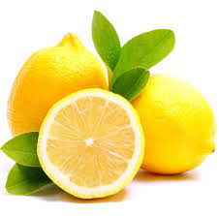 | 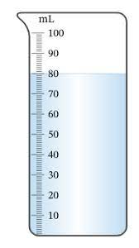 | 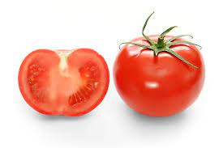
1. __________ | 2. __________ | 3. __________
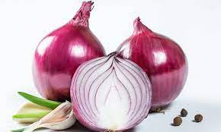 | 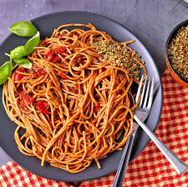 | 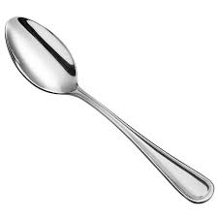
4. __________ | 5. __________ | 6. __________
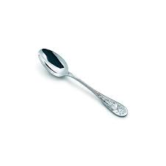 | 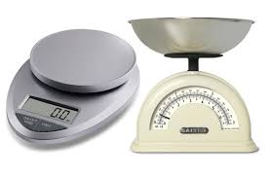 | 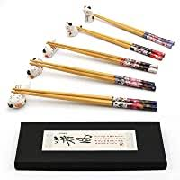
7. __________ | 8. __________ | 9. __________
II. Write the suitable word from its definition or each blank. (Vocabulary)
1. It’s a small measurement for liquid.
__________.
2. I take one__________ of sugar in my coffee.
3. It is a famous noodle dish from Italy.
__________.
- This vegetable make you cry.
__________.
5. It’s a small yellow fruit with a sour taste.
__________.
6. We need 20 __________ of salt to make the cake.
7. It’s red and juicy. We use it in salad.
__________.
8. It’s a large spoon.
__________.
9. Vietnamese usually use clean__________ to pick up food for others who sit near them in the meal.

III. Circle the correct word. (Grammar)
1. How much/ many apples do we need?
2. Do you have much/ many bananas left?
3. How much/ many tomatoes do you have?
4. How much/ many eggs this hen produced in this week?
5. How much/ many flour is there in this bag?
6. How much/ many onions do you need?
7. Don’t use too much/ many sugar every day.
8. How much/ many lemons does your mother want?
9. How much/ many butter do you need for making this cake?
10. Don’t use too much/ many spaghetti. We have some other food left.

