NỘI DUNG BÀI HỌC MÔN TIẾNG ANH LỚP 7
Tuần 15: 12/12/2022-17/12/2022
UNIT 5: FOOD AND DRINKS
Lesson 2
No | Words | Class | Transcription | Meaning
10 | bag | (n) | /bæg/ | túi, giỏ
11 | bottle | (n) | /ˈbɑtəl/ | chai, lọ
12 | box | (n) | /bɑks/ | hộp, thùng
13 | bunch | (n) | /bʌnʧ/ | bó, buồng, chùm
14 | can | (n) | /kæn/ | lon, lọ
15 | carton | (n) | /ˈkɑrtən/ | hộp bằng bìa cứng
16 | container | (n) | /kənˈteɪnər/ | vật chứa
17 | groceries | (n) | /ˈgroʊsəriz/ | thực phẩm và đồ dùng gia đình
18 | stick | (n) | /stɪk/ | thanh, thỏi (kẹo, sô cô la)

Lesson 3
No | Words | Class | Transcription | Meaning
19 | barbecue | (n) | /ˈbɑrbɪˌkju/ | vỉ nướng, buổi nướng
20 | chef | (n) | /ʃɛf/ | đầu bếp
21 | crunchy | (a) | /ˈkrʌnʧi/ | giòn
22 | grill | (v) | /grɪl/ | nướng
23 | taste | (v) | /teɪst/ | có vị
24 | tasty | (a) | /ˈteɪsti/ | ngon
25 | worm | (n) | /wɜrm/ | con sâu
Lesson 2
I. Look at the words in the box and write the suitable word for each picture. (Vocabulary)
bag bunch can bar bottle stick carton (x2) box
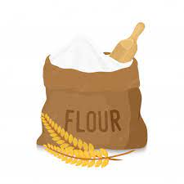 | 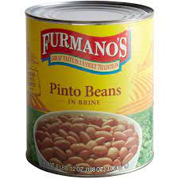 | 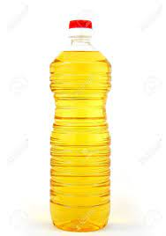
1. a______ of flour | 2. a______ of beans | 3. a______ of oil
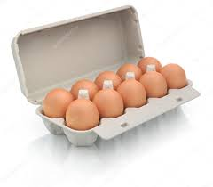 | 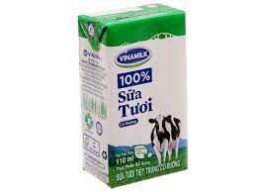 | 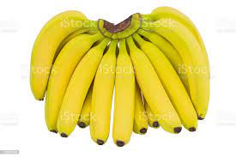
4. a______ of eggs | 5. a______ of milk | 6. a______ of bananas
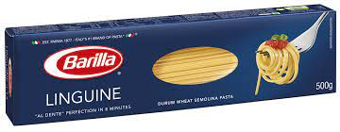 | 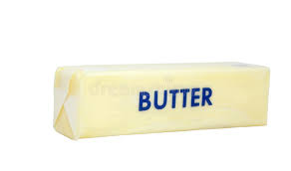 | 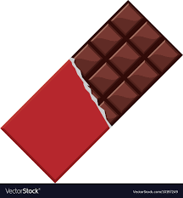
7. a______ of spaghetti | 8. a______ of butter | 9. a______ of chocolate

II. Fill in the blanks using the correct article “a/ an/ the”. (Vocabulary)
1. My mother bought me__________ interesting book about Geography.
2. There is__________ can of peas in the cupboard.
3. My little son likes eating__________ ice cream right now. __________ ice cream tastes strawberry.
4. There is__________ big bottle of milk in the fridge.
5. She bought some coffee for me.__________ coffee tasted chocolate.
6. There is__________ bag of rice under the table.
7. My father bought__________ carton of eggs. He put__________ carton in the fridge.
8. There is__________ bunch of bananas. My mom put__________ bunch of bananas on the table.
9. My daughter bought__________ can of beans. I put __________ can of beans in the cupboard.
10. I need__________ box of chocolate. __________ box of chocolate is black.

