NỘI DUNG BÀI HỌC TIẾNG ANH LỚP 7
Tuần 2: 12/9/2022-17/9/2022
UNIT 1: FREE TIME
Lesson 2
No | Words | Class | Transcription | Meaning
10 | bowling alley | (n) | /ˈboʊlɪŋ ˈæli/ | Khu trò chơi bowling
11 | fair | (v) | /fɛr/ | Hội vui chơi giải trí, phiên chợ
12 | ice rink | (n) | /aɪs rɪŋk/ | Sân trượt băng
13 | market | (n) | /ˈmɑrkət/ | Chợ
14 | sports center | (n) | /spɔrts ˈsɛntər/ | Trung tâm thể thao
15 | theater | (n) | /ˈθiətər/ | Nhà hát
16 | water park | (n) | /ˈwɔtər pɑrk/ | Công viên nước

Lesson 3
No | Words | Class | Transcription | Meaning
17 | availability | (n) | /əˌveɪləˈbɪləti/ | Khả năng và thời gian để làm việc gì
18 | extreme sport | (n) | /ɛkˈstrim spɔrt/ | Thể thao mạo hiểm
19 | invitation | (n) | /ˌɪnvɪˈteɪʃən/ | Sự mời gọi, lời mời
20 | rock climbing | (n) | /rɑk ˈklaɪmɪŋ/ | Trò leo núi đá (hoặc leo tường có gắn đá)
21 | safety equipment | (n) | /ˈseɪfti ɪˈkwɪpmənt/ | Thiết bị an toàn
22 | skateboarding | (n) | /ˈskeɪtˌbɔrdɪŋ/ | Trò trượt ván
23 | surfing | (n) | /ˈsɜrfɪŋ/ | Trò lướt sóng
24 | zorbing | (n) | /ˈzɔːrbɪŋ/ | Trò lăn xuống dốc hoặc lăn trên mặt nước trong một quả cầu nhựa trong suốt
Lesson 2
I. Look at the words in the box and write the suitable word for each picture.
sport center bowling alley theater
ice rink | water park | market | fair
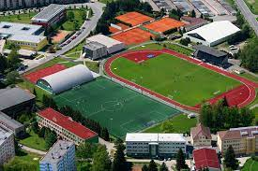 | 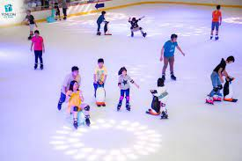 | 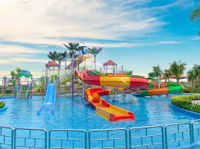
1. | 2. | 3.
 | 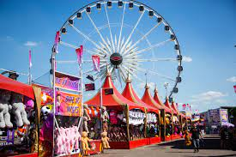 | 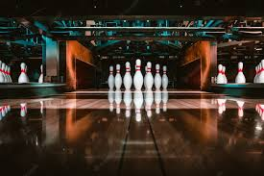
4. | 5. | 6.
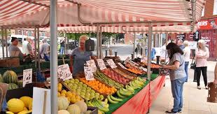
II. Fill in the blanks using the words in the box from exercise I.
1. We like going to the _______________ to play ten-pin bowling.
2. She goes to the_______________ every weekend to play badminton.
3. We enjoyed lots of rides at the_______________.
4. The_______________ is a great place to go swimming in the summer.
5. Do you like to buy your clothes at the_______________?
6. I like to watch plays at the_______________.
7. The_______________ is very popular during the winter.
III. Fill in the blanks with the collect form of the verbs.
1. My sister (take)__________ an examination next week.
2. Teacher Thi (have)__________ a talk about studying English to his students tomorrow.
3. My friend (visit)__________ me this weekend.
4. We (play)__________ table tennis tonight.
5. My children (go)__________ swimming on Sunday.
6. I (catch)__________ the bus number 6 to the city center tomorrow.
7. My husband (water)__________ these plants this evening.
8. I (not go)__________ shopping with her tonight.
9. My students (plant)__________ some trees around our school next Sunday.
10. Mr. Thi (make)__________ a big cake tomorrow.

IV. Write sentences using the Present Continuous tense and prompts
1. My sister/ visit/ Ho Chi Minh city/ next Sunday.
______________________________________________________________________________
2. We/ have/ small party/ the weekend.
______________________________________________________________________________
3. They/ going/ swimming/ this afternoon?
______________________________________________________________________________
4. John/ going/ rock climbing/ his classmates/ next Saturday.
______________________________________________________________________________
5. My brother/ use/ my bike/ this evening.
______________________________________________________________________________
6. Jenny/ Mary/ going/ skating/ together tonight.
______________________________________________________________________________

