NỘI DUNG BÀI HỌC TIẾNG ANH LỚP 7
Tuần 5: 3/10/2022-8/10/2022
UNIT 2: HEALTH

Lesson 2
No | Words | Class | Transcription | Meaning
10 | feel | (v) | /fil/ | có cảm giác, cảm thấy
11 | fever | (n) | /ˈfivər/ | cơn sốt
12 | get rest | (v) | /gɛt rɛst/ | nghỉ ngơi
13 | have | (v) | /hæv/ | sở hữu, có
14 | keep | (v) | /kip/ | giữ, duy trì
15 | late | (a) | /leɪt/ | trễ
16 | lazy | (a) | /ˈleɪzi/ | lười
17 | medicine | (n) | /ˈmɛdəsən/ | thuốc
18 | sore throat | (n) | /sɔr θroʊt/ | đau họng
19 | stay up late | (v) | /steɪ ʌp leɪt/ | thức khuya
20 | take | (v) | /teɪk/ | ăn uống
21 | vitamin | (n) | /ˈvaɪtəmən/ | vitamin
22 | warm | (a) | /wɔrm/ | ấm
23 | weak | (a) | /wik/ | yếu

Lesson 3
No | Words | Class | Transcription | Meaning
24 | cafeteria | (n) | /ˌkæfəˈtɪriə/ | quán ăn, căn tin
25 | effectively | (a) | /ɪˈfɛktɪvli/ | hiệu quả
Lesson 2
I. Look at the words/ phrases in the box and write the suitable word for each picture.
feel weak have a sore throat get some rest take vitamins
have a fever take medicine stay up late keep warm have a stomachache
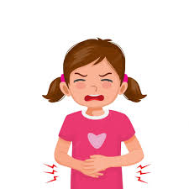 | 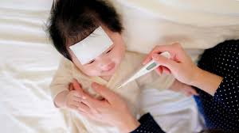 | 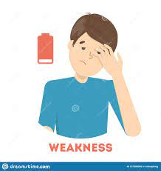
1. | 2. | 3.
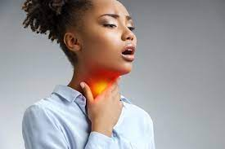 | 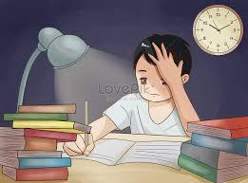 | 
4. | 5. | 6.
 | 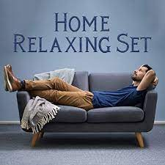 | 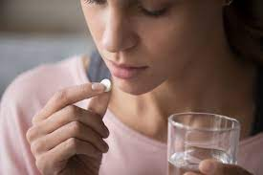
7. | 8. | 9.
.
II. Fill in the blanks using the words in the box from exercise I.
1. I have no energy and can't do any work. I feel__________.
2. I feel very hot and sick. I think I have a__________.
3. The doctor told me to__________ __________ after eating, three times a day.
4. If you eat a healthy diet, you don't need to__________ __________.
5. You should wear a thick jacket and scarf to__________ __________ in winter.
6. I have a cough and a__________ __________. It hurts when I drink.
7. Many teens__________ __________ __________ to do homework or watch TV. That's bad for their health because they won't get enough sleep.
8. You look tired. You should__________ __________ __________.
9. My little daughter ate some strange seafood at the restaurant yesterday. So she __________ __________ __________now.

III. Use should/ shouldn’t to complete the sentences.
1. She has a toothache. She should/ shouldn’t eat so much candy.
2. I have a headache. I should/ shouldn’t take some medicine.
3. Mary wants to lose weight. She should/ shouldn’t eat junk food more.
4. What should I do to lose weight? - You should/ shouldn’t eat more fruit and vegetables.
5. You look very tired. You should/ shouldn’t get some rest.
6. Linda has a stomachache. - She should/ shouldn’t drink so much soda.
7. I feel tired. You should/ shouldn’t take a rest and sleep enough.
8. I have a sore eye. You should/ shouldn’t play a lot of video games.
9. I am putting on weight. You should/ shouldn’t do more exercise.
10. This food contains a lot of fat and sugar. You should/ shouldn’t eat too much.

