THE CHANGE CURRENT QUICK STYLE SET

O
n the Insert tab, the galleries include items that are designed to coordinate with the overall look of your document. You can use these galleries to insert tables, headers, footers, lists, cover pages, and other document building blocks. When you create pictures, charts, or diagrams, they also coordinate with your current document look.
You can easily change the formatting of selected text in the document text by choosing a look for the selected text from the Quick Styles gallery on the Home tab. You can also format text directly by using the other controls on the Home tab. Most controls offer a choice of using the look from the current theme or using a format that you specify directly.
To change the overall look of your document, choose new Theme elements on the Page Layout tab. To change the looks available in the Quick Style gallery, use the Change Current Quick Style Set command. Both the Themes gallery and the Quick Styles gallery provide reset commands so that you can always restore the look of your document to the original contained in your current template.
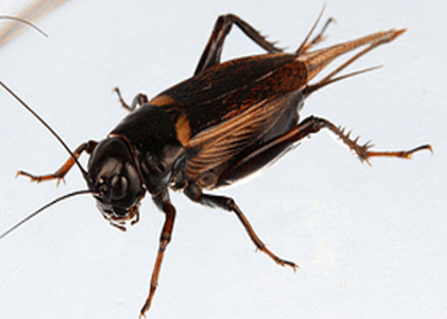

CÁC BƯỚC LÀM BÀI THỰC HÀNH WORD
Dạng 1: Văn bảng dạng cột
B1: Gõ thô văn bản
B2: Định dạng chữ: kích thước, kiểu,.. canh lề.
B3: WordArd cho tiêu đề
Ribbons Insert - Group Text – WordArt (hoặc Insert-Text-WordArt)
Chọn dạng WordArt, sau đó di chuyển Tựa bài vị trí yêu cầu.
B4: Chia cột
Ribbons Page Layout – Group Page Setup – Columns (hoặc Page Layout-Page Setup- Columns)
Chọn More Columns- Chọn dạng chia cột-Chọn Line between (đường giữa)
B5: Chữ lớn đầu đoạn
Chọn đoạn cần chữ lớn, Ribbons Insert - Group Text – Drop Cap (hoặc Insert-Text- Drop Cap)
Chọn dạng Drop Cap
B6: Chèn ảnh
Ribbons Insert – Group Illustraions - Clip Art (hoặc Insert-Illustrations-Clip Art)
Chọn Go rồi chọn hình ảnh phù hợp, nhấp phải chuột vào ảnh rồi chọn Insert
Nhấp chọn ảnh vừa chèn, chọn Picture Tools, sdau đó chọn Warp text, sau đó diều chỉnh kích thước ảnh, đưa ảnh đến đúng vị trí.

The Change Current Quick Style Set

Y
ou can easily change the formatting of selected text in the document text by choosing a look for the selected text from the Quick Styles gallery on the Home tab. You can also format text directly by using the other controls on the Home tab. Most controls offer a choice of using the look from the current theme or using a format that you specify directly.
To change the overall look of your document, choose new Theme elements on the Page Layout tab. To change the looks available in the Quick Style gallery, use the Change Current Quick Style Set command. Both the Themes gallery and the Quick Styles gallery provide reset commands so that you can always restore the look of your document to the original contained in your current template.
On the Insert tab, the galleries include items that are designed to coordinate with the overall look of your document. You can use these galleries to insert tables, headers, footers, lists, cover pages, and other document building blocks. When you create pictures, charts, or diagrams, they also coordinate with your current document look.

