UNIT 2 : CLOTHING
Lesson 2: Speak

I. VOCABULARY:
1.stripe /straɪp/ (n) : sọc
+ striped (adj) : có sọc
2. - sleeve /sliːv/ (n) : tay áo
+ sleeved /sliːvd/ (adj) : có tay áo
+ sleeveless /ˈsliːvləs/ (adj) : không có tay
+ short-sleeved (adj) : tay ngắn
3. plaid /plæd/ (adj) : có ca-rô, kẻ ô vuông
4. fade /feɪd/ (v) : làm nhạt
Ex: If you hang your clothes out in the bright sun, they will fade.
+ fade away : mất dần
+ faded /ˈfeɪ.dɪd/ (adj) : phai màu
5: sweater /ˈswetən(r)/ (n) : áo len
6: baggy /ˈbæɡi/ (adj) : rộng thùng thình
7: plain /pleɪn/ (adj) : trơn
8. casual clothes /ˈkæʒuəl kləʊðz/ (n) : quần áo thông thường
9. occasion /əˈkeɪ.ʒən/ (n) : thời điểm một sự việc xảy ra, dịp
+ occasional /əˈkeɪ.ʒənəl/ (adj) : dành cho một dịp đặc biệt
+ on the occasion of st (phr) : vào thời điểm sự kiện nào đó
Ex: He visited England on the occasion of his daughter’s wedding.

II. PRACTICE
1: Match the phrases to the pictures on the page 14:

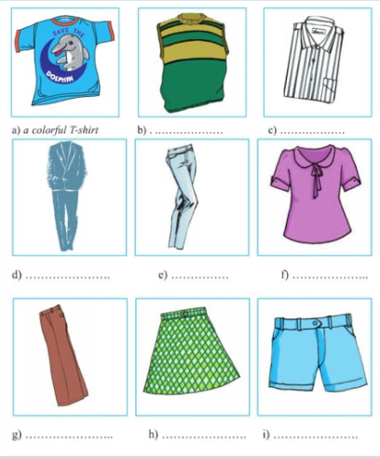
1. a colorful T-shirt
2. a plaid skirt
3. a plain suit
4. a short-sleeved blouse
5. a sleeveless sweater
6. a striped shirt
7. baggy pants
8. faded jeans
9. blue shorts

2 Complete the conservation with given words in the box:
A/ casual clothes B/. What’s your favorite type of clothing?
C/. It’s simple and beautiful D/.Why do you wear these clothes?
E/. I don’t like colorful clothes F/.It makes students to be more polite at school.

-Erik: What do you usually wear on the weekend?
-Son Tung MTP(STMTP): I usually wear (1)_________________________________, for example a T-shirt and shorts or pants.
-Erik: (2)_____________________________________________________________?
-ST MTP: It’s convenient for me at home.
-Erik: (3)_____________________________________________________________?
-ST MTP: I like the simple clothes: white shirts and dark trousers. (4)________________________________________________because they are not suitable for the Vietnamese people, especially for girls and young women.
-Erik: What do you think of your school uniform?
-ST MTP: (5)____________________________ white shirts and dark pants for boys and white shirt and plain skirts for girls. (6)________________________________________

3. TAKE A SURVEY:
NAME | ST1 | ST2 | ST3 | ST4
What do you usually wear on the weekend? Why?
What’s your favorite type of clothing ? Why?
Do you like school uniform?
What do you think of your school uniform?
Report the results of your survey ________________________________________________________________________________________________________________________________________________________________________________________________________________________________________________________________________________________________________________________________________________________________________________________________________________________________________________________________________________________________________________________________________________________________________________________________________________________________________________________________________
III. Homework:
-Learn new words by heart.
-Practice the survey.
-Prepare lesson 3: Listen.

