TIẾNG ANH 6  FRIENDS PLUS | Final Second term - Test 1  Thời gian làm bài: 45 phút (Không kể thời gian giao đề)  -------------------------
I. Pronunciation
Câu 1. Which word has the underlined part pronounced differently from that of the others?
A. actor B. collect
C. information D. go
Câu 2. Which word has the underlined part pronounced differently from that of the others?
A. bin B. promise C. cyclist D. icy
Câu 3. Which word has a different stress pattern from that of the others?
A. moment B. concert
C. qualification D. average
Câu 4. Which word has a different stress pattern from that of the others?
A. outdoor B. subway
C. overweight D. probably
II. Choose the answer (A, B, C or D) that best fits the space in each question.
Câu 5. Why don’t we meet at the entrance to the mall today?
A. Thanks a lot. B. It’s very kind of you to buy me this.
C. The weather is really nice today. D. Is 3 p.m. ok?
Câu 6. There is a bus station directly ______ the entrance.
A. beside B. on C. opposite D. of
Câu 7. What time _____ the party start? – “At 3:00 tomorrow.”
A. started B. will C. starts D. starting
Câu 8. Where were you yesterday?
A. I was sick, so I had to stay in bed. B. I agree with you.
C. That’s a good idea. D. I will travel to Phu Quoc this summer.
Câu 9. If it _____ tonight, we _____ a snowman tomorrow.
A. will snow / will build B. snowed / built
C. snows / built D. snows / will build
Câu 10. I _____ my homework yesterday.
A. does B. doing C. do D. did
Câu 11. I ride my __________ to work every day.
A. bus B. car C. train D. bicycle
Câu 12. Someone is waiting ______ the library.
A. out of B. through C. outside D. on
Câu 13. The _____________ takes off from the helipad.
A. helicopter B. rocket
C. plane D. jetpack
Câu 14. She is __________ because she eats healthy food.
A. fat B. weak C. big D. slim
III. Look at the signs. Choose the best answer (A, B, C or D).
Câu 15.
What does this note mean?
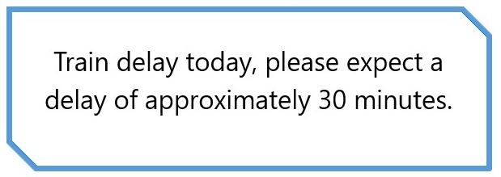
A. The train is on time today.
B. The train is expected to arrive later in about 30 minutes.
C. The train is expected to arrive earlier by about 30 minutes.
D. The train is delayed every day.
Câu 16.
What does this note mean?
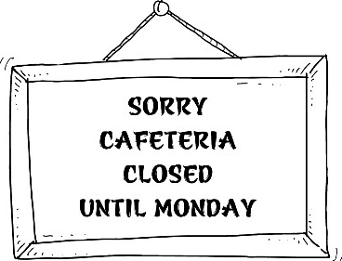
A. You can buy food and drink here on Monday.
B. Please come back on Sunday.
C. The cafeteria is closed on Monday.
D. The cafeteria opens on weekdays.
IV. Read the following passage and do as direct.
Last summer, I had an amazing trip abroad. I went to Europe and visited a few countries. My favorite was France. I spent most of my time in Paris, where I saw the Eiffel Tower and walked around the city. The food was incredible, especially the croissants and cheese. I also went to Amsterdam and visited some museums and did a canal tour. It was very easy to get around as most people speak English. Overall, it was a fantastic trip, and I can't wait to go back and explore more of Europe.
Câu 17. The trip abroad took place last winter.
A. True B. False
Câu 18. The friend visited several countries during the trip.
A. True B. False
Câu 19. The friend's favorite country was Germany.
A. True B. False
Câu 20. It was difficult to speak to locals due to different languages.
A. False B. True
Câu 21. Which country was the friend's favorite during the trip?
A. Italy B. Germany C. Spain D. France
Câu 22. Which activity did the friend do in Amsterdam?
A. Went to a music festival B. Went to the beach
C. Visited some museums D. Did a hiking trail
V. Choose the word (A, B, C or D) that best fits the blank space in the following passage.
Dear Susan,
I hope this email finds you well. I wanted to let you _____23____ that I am going to the mountains next Sunday and I was wondering if you would _____24____ to join me. We are going to hike to the top and have a _____25____ with a great view.
We are leaving early ____26_____ the morning, around 8 am, and we should be back by late afternoon. We are going to _____27____ some sandwiches, fruit, and drinks, but you can bring your own food if you prefer.
It's going to be a fun and ____28_____ day, and I hope you can come with me. Let me know if you're interested, and we can make arrangements.
Best regards,
Mary
Câu 23. Choose the correct option.
A. knowing B. known C. knows D. know
Câu 24. Choose the correct option.
A. like B. want C. wish D. wants
Câu 25. Choose the correct option.
A. picnic B. supper C. burger D. dinner
Câu 26. Choose the correct option.
A. in B. by C. on D. at
Câu 27. Choose the correct option.
A. bring B. create C. design D. set up
Câu 28. Choose the correct option.
A. exciting B. stressful C. tiring D. boring
VI. Supply the correct form of the word given in each sentence.
Câu 29. It's always a good idea to bring an umbrella on a ______________ day. [rain]
Câu 30. Playing board games with my friends is always __________. [enjoy]
Câu 31. I can only ______________ what it's like to live in a big city. [imagination]
Câu 32. We went ______________ on the lake last weekend and had a great time. [boat]
Câu 33. The museum had many ______________ over the weekend. [visit]
Câu 34. There are many outdoor ______________ to do in the summer, such as hiking and biking. [act]
VII. Rearrange the groups of words in a correct order to make complete sentences.
Câu 35. travel to a/me when I/a guidebook with/new place./I always take
_________________________________________________________________________
Câu 36. all his weekends/surfing and spends/He loves/at the beach.
_________________________________________________________________________
VIII. Rewrite each of the following sentences in another way so that it means almost the same as the sentence printed before it.
Câu 37. When did Tom lend you this book?
When did you __________________________ ?
Câu 38. The red bike is hers.
The red bike belongs _________________________________
Câu 39. Marry was really into folk music when she was ten.
Marry really ____________________________________
Câu 40. Revise the lessons carefully or you will get bad marks.
If you
----HẾT---
Word | IPA | Word Class | Vietnamese Meanings
Last summer | læst ˈsʌmər | n | mùa hè năm trước
Amazing | əˈmeɪzɪŋ | adj | tuyệt vời, kỳ diệu
Trip | trɪp | n | chuyến đi, du lịch
Abroad | əˈbrɔd | adv | ở nước ngoài
Europe | ˈjʊrəp | n proper | Châu Âu
Favorite | ˈfeɪvərɪt | adj/n | ưa thích
Paris | ˈpærɪs | n proper | Paris
Eiffel Tower | ˈaɪfəl ˈtaʊər | n | Tháp Eiffel
Cheese | tʃiz | n | phô mai
Museum | mjuːˈziəm | n | bảo tàng

